Just In Time Quick Check
Standard of Learning (SOL) AII.4
Strand: Equations and Inequalities

Standard of Learning (SOL) AII.4
The student will solve systems of linear-quadratic and quadratic-quadratic equations, algebraically and graphically.

Grade Level Skills:
- Determine the number of solutions to a linear-quadratic and quadratic-quadratic system of equations in two variables.
- Solve a linear-quadratic system of two equations in two variables algebraically and graphically.
- Solve a quadratic-quadratic system of two equations in two variables algebraically and graphically.
- Solve systems of equations and verify solutions of systems of equations with a graphing utility.

Just in Time Quick Check

Just in Time Quick Check Teacher Notes

Supporting Resources:
- VDOE Mathematics Instructional Plans (MIPS)
  - AII.4 – Nonlinear Systems of Equations (Word)/PDF Version
- VDOE Word Wall Cards: Algebra II (Word) | (PDF)
  - System of Linear Equations (Graphing)
  - System of Linear Equations (Substitution)
  - System of Linear Equations (Elimination)
  - System of Linear Equations (Number of Solutions)
  - System of Linear Equations (Linear - Quadratic)
- Desmos Activity
  - Solving Systems of Equations

Supporting and Prerequisite SOL: AII.1c, AII.6a, AII.6b, A.4a, A.4b, A.4d, A.6c, 8.14b, 8.16d, 8.17

SOL AII.4 - Just in Time Quick Check

- The graph of functions f(x) and g(x) are shown. How many solutions does the system have? Explain your thinking.

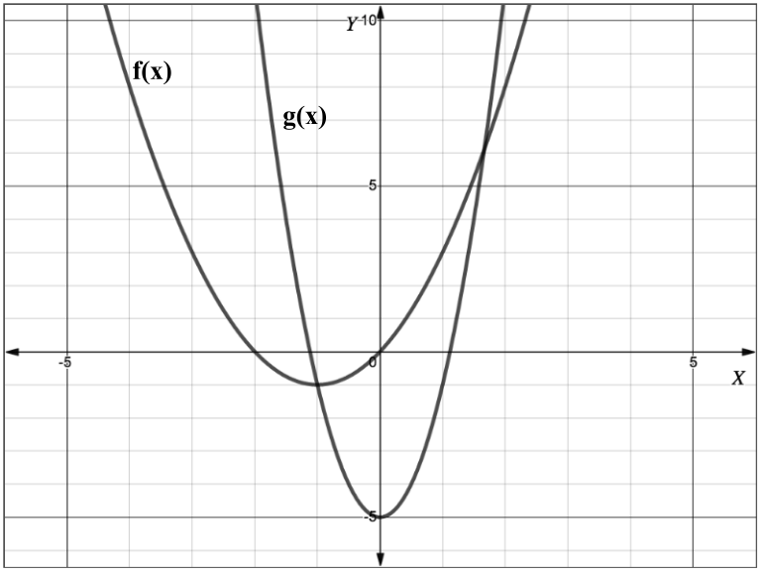

- Student A used the substitution method to find all possible solutions to the following system of equations.

$$\left\{\begin{aligned}y=x^{2}-2x+1 \\ y=3-x\end{aligned}\right.$$
Their work is shown below.

$$(3-x)^{2}-2(3-x)+1=0$$

$$(9-6x+x^{2})-6+2x+1 =0$$

$$x^{2}-4x+4=0$$

$$(x-2)(x-2)=0$$

$$\left(x-2\right)=0$$

$$x=2$$

$$y=3-x$$

$$y= 3-2$$

$$y=1$$

Solution = $(2, 1)$

Describe and correct the errors made.

- How many solutions does the following system of equations have?

$$\left\{\begin{aligned}y={\left(x-3\right)}^{2}-1 \\ y=-{\left(2x+9\right)}^{2}-5\end{aligned}\right.$$

- What are the y-coordinates for the solutions to the system of equations shown? Show your work/thinking.
$$\left\{\begin{aligned}2x=-y+4 \\ y+8=x^{2}+2x\end{aligned}\right.$$

SOL AII.4 - Just in Time Quick Check Teachers Notes
Common Errors/Misconceptions and their Possible Indications

1. The graph of functions f(x) and g(x) are shown. How many solutions does the system have? Explain your thinking.

A common error some students may make is to base the number of solutions on the x-intercepts of the system of equations resulting in an answer of 4 solutions. This may indicate that students consider the x-intercepts as the solutions rather than the points of intersections of the two functions as solutions. It would be beneficial to have students circle or highlight the points of intersection to help them identify the solutions to the system of equations. In addition, teachers may find it beneficial to have students create linear-quadratic and quadratic-quadratic graphic organizers to highlight the possible number of solutions.

2. Student A used the substitution method to find all possible solutions to the following system of equations.

$$\left\{\begin{aligned}y=x^{2}-2x+1 \\ y=3-x\end{aligned}\right.$$
Their work is shown below.

$$(3-x)^{2}-2(3-x)+1=0$$

$$(9-6x+x^{2})-6+2x+1 =0$$

$$x^{2}-4x+4=0$$

$$(x-2)(x-2)=0$$

$$\left(x-2\right)=0$$

$$x=2$$

$$y=3-x$$

$$y= 3-2$$

$$y=1$$

Solution = $(2, 1)$

Describe and correct the errors made.

A common error some students may make is to substitute an expression for the wrong variable in an equation. This may indicate that some students do not understand how to correctly use the substitution method when attempting to solve a system of equations. Teachers may want to show students that both equations are defined in terms of x and set up as “y =” therefore students can set the two expressions equal to each other $x^{2}-2x+1=3-x$ and solve for x. It may be beneficial for students to graph the functions in Desmos to verify their solutions after solving algebraically. When utilizing a graphing utility, students will notice that there are two points of intersection and thus they should find two solutions.

3. How many solutions does the following system of equations have?

$$\left\{\begin{aligned}y={\left(x-3\right)}^{2}-1 \\ y=-{\left(2x+9\right)}^{2}-5\end{aligned}\right.$$

A common error some students may make is to state that there are two solutions to this system of equations. This may indicate that some students believe that since the system consists of quadratic equations, the graphs must intersect in two locations and the number of solutions should be two. It would be beneficial to have students graph the system of equations using Desmos to represent the system visually to verify the correct number of solutions.

4. What are the y-coordinates for the solutions to the system of equations shown? Show your work/thinking.
$$\left\{\begin{aligned}2x=-y+4 \\ y+8=x^{2}+2x\end{aligned}\right.$$

A common error some students may make is to provide the x-coordinate for the solutions stating -6 and 2, versus 16 and 0. This may indicate students can find the solutions but inadvertently state the x-coordinates rather than the y-coordinates of the points of intersection. Teachers may want to have students write the ordered pair solutions first and then identify the y-coordinate of each point of intersection.

