Just In Time Quick Check

Standard of Learning (SOL) A.8
Strand: Statistics

Standard of Learning (SOL) A.8
The student, given a data set or practical situation, will analyze a relation to determine whether a direct or inverse variation exists, and represent a direct variation algebraically and graphically and an inverse variation algebraically.

Grade Level Skills:
- Given a data set or practical situation, determine whether a direct variation exists.
- Given a data set or practical situation, determine whether an inverse variation exists.
- Given a data set or practical situation, write an equation for a direct variation.
- Given a data set or practical situation, write an equation for an inverse variation.
- Given a data set or practical situation, graph an equation representing a direct variation.
Just in Time Quick Check
Just in Time Quick Check Teacher Notes

Supporting Resources:
- VDOE Mathematics Instructional Plans (MIPS)
  - A.8 - Direct Variation (Word) / PDF Version
  - A.8 - Inverse Variation (Word) / PDF Version
- VDOE Algebra Readiness Formative Assessments
  - A.8 (Word) / PDF
- VDOE Word Wall Cards: Algebra I (Word) | (PDF)
  - Direct Variation
  - Inverse Variation
Supporting and Prerequisite SOL: A.1a, A.4a, A.6a, A.6b, A.6c, 8.16b, 8.16c, 8.16d, 8.16e, 8.17, 7.3, 7.10a, 7.10b, 7.12

SOL A.8 - Just in Time Quick Check
- A relation is shown in the table below. Determine if the relation is a direct variation or an inverse variation. How do you know? Write an equation to model the data.
x | y
2 | 7.5
3 | 5
6 | 2.5
10 | 1.5

- The point (2, 1) plotted on the graph is a data value of a direct variation. Plot two other points with integral coordinates that lie on the graph of the direct variation.
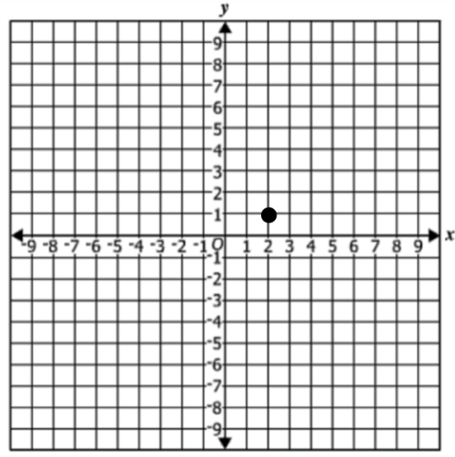
- The points (-2, 6) and (3, y) are data values of an inverse variation. What is the value of y? Explain your thinking.

- Emilee labeled the equations below as direct variation, inverse variation, or neither. She correctly labeled all but one. Which equation did she incorrectly label and why?

$y=5x$ $y=\frac{5}{x}$ $y=\frac{1}{5}x$
Direct Inverse Inverse

- If Isaiah babysits 12 hours he earns $72. If he babysits 18 hours he earns $108. Let y represent the total amount of money that Isaiah earns working x number of hours. Determine if this is a direct or inverse variation and write an equation to model the relationship.

SOL A.8 - Just in Time Quick Check Teacher Notes
Common Errors/Misconceptions and their Possible Indications
- A relation is shown in the table below. Determine if the relation is a direct variation or an inverse variation. How do you know? Write an equation to model the data.
x | y
2 | 7.5
3 | 5
6 | 2.5
10 | 1.5

A common mistake a student may make is to apply the incorrect relationship when the data represented does not have a context. Teacher may want to encourage students to plot the data on a coordinate grid or enter the data into a table in Desmos, helping students to visualize the relationship in order to determine if the relationship is a direct or inverse variation. They might want to ask questions like, “What appears to be happening to the output as the input is increasing?” Teachers might encourage students to put the data in context (“write a story”) to help build a deeper understanding of direct and inverse variations.
- The point (2, 1) plotted on the graph is a data value of a direct variation. Plot two other points with integral coordinates that lie on the graph of the direct variation.
A common error a student may make is to plot other points that lie on a line passing through (2, 1) but that line does not pass through the origin. Teachers may want to have students use Desmos to plot the given point along with the origin (0, 0) and then write the equation of the line that goes through these points. The table feature in Desmos could be used to identify additional points that lie on the line representing the direct variation.

- The points (-2, 6) and (3, y) are data values of an inverse variation. What is the value of y? Explain your thinking.
A common error students may make is to calculate the value of y as -9. This would indicate that a student has calculated the value of y using a relationship that represents direct variation. A strategy, when solving similar problems with ordered pairs may be to have students find the missing value for BOTH relationships (direct and inverse) and then engage in meaningful mathematical discourse about the differences in these two relationships.

- Emilee labeled the equations below as direct variation, inverse variation, or neither. She correctly labeled all but one. Which equation did she incorrectly label and why?
$y=5x$ $y=\frac{5}{x}$ $y=\frac{1}{5}x$
Direct Inverse Inverse
A common error that students make is assuming that a rational coefficient implies that the relationship is an inverse variation. This may indicate that a student confuses the 5 in the denominator with a variable in the denominator. Teachers may want to review the concepts of coefficients and variables as a first strategy and then have students compare multiple representations of different algebraic models including tables and graphs. Some examples include: a) compare the graphs of y = 5x with y = $\frac{1}{5}$ x; b) compare yx = 5 with y = $\frac{5}{x}$; c) compare y = $\frac{5}{x}$ with y =$\frac{1}{5}$ x.
- If Isaiah babysits 12 hours he earns $72. If he babysits 18 hours he earns $108. Let y represent the total amount of money that Isaiah earns working x number of hours. Determine if this is a direct or inverse variation and write an equation to model the relationship.
A common error in the equation might be to write y = $\frac{6}{x}$ thinking that since they divided 72 by 12 to find Isaiah’s hourly rate of $6 then the equation would need to include the division operation. A strategy might be to have students justify the equations they write by plugging their original input values into the equation to see if the correct output values are generated.

