Just In Time Quick Check

Standard of Learning (SOL) A.7f
Strand: Functions

Standard of Learning (SOL) A.7c

The student will investigate and analyze linear and quadratic function families and their characteristics both algebraically and graphically, including connection between and among multiple representations of functions using verbal descriptions, tables, equations, and graphs.

Grade Level Skills:
- Represent relations and functions using verbal descriptions, tables, equations, and graph. Given one representation, represent the relation in another form.
- Investigate and analyze characteristics and multiple representations of functions with a graphing utility.
Just in Time Quick Check
Just in Time Quick Check Teacher Notes

Supporting Resources:
- VDOE Mathematics Instructional Plans (MIPS)
  - A.7abef - Functions 1: Investigating Relations and Functions (Word) / PDF Version
  - A.7aef- Square Patios (Word) / PDF Version
- VDOE Algebra Readiness Formative Assessments
  - A.7f (Word) / PDF
- VDOE Word Wall Cards: Algebra I (Word) | (PDF)
  - Function Notation
  - Parent Functions - Linear, Quadratic
  - Multiple Representations of Functions
- VDOE Rich Mathematical Tasks: The Soccer Competition
  - A.7 The Soccer Competition Task Template (Word) / PDF Version
- Desmos Activities
  - Transforming Lines, Card Sort: Linear Functions
  - Two Truths and a Lie: Quadratics, Will It Hit the Hoop?
  - What’s my Transformation?
  - Function Carnival, Function Carnival Part 2
  - Graphing Stories, Transform a Parabola
Supporting and Prerequisite SOL: A.1a, A.6b, A.6c, A.7a, 8.16e, 7.10e

SOL A.7f - Just in Time Quick Check
- Create a graph and table that represent the linear equation: $x+2y=-6$.
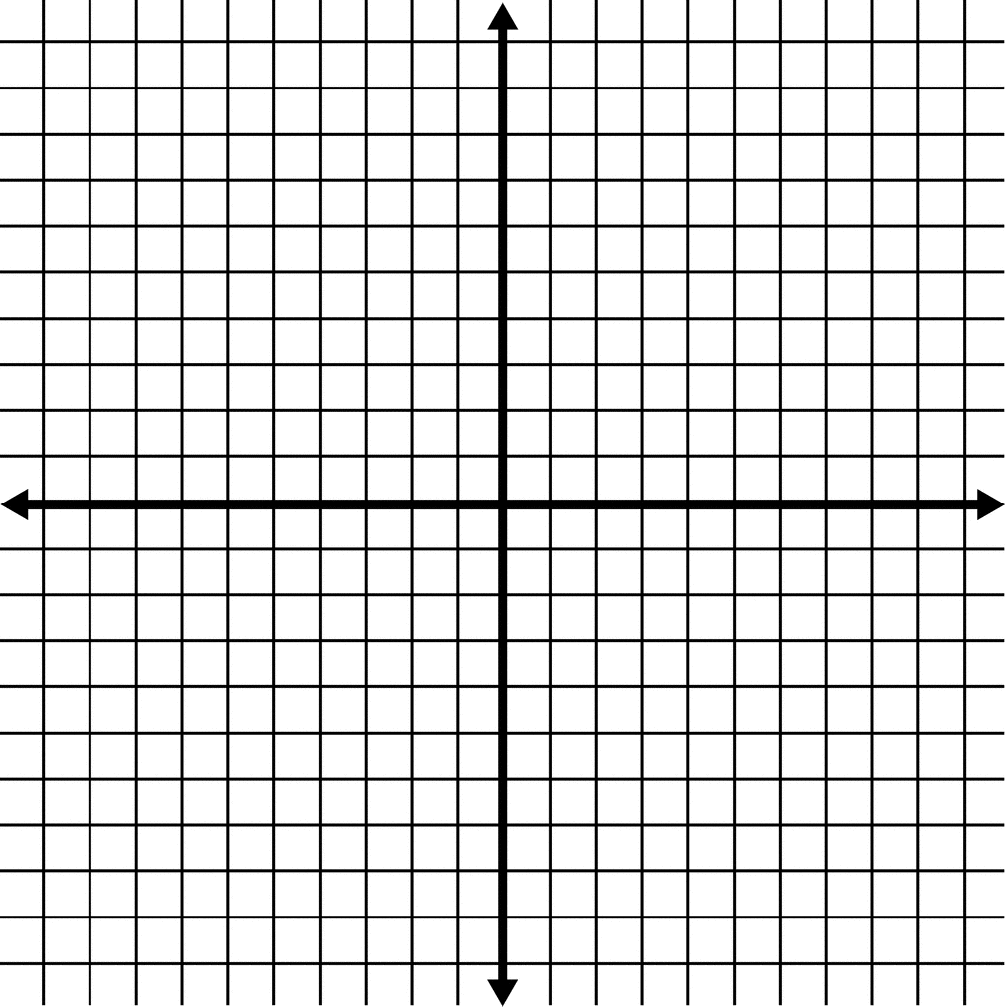
$$x$$
$$y$$
x | y

- Write the equation represented by this rule:
Four less than the square of x is y

- Which table of values is best represented by the verbal sentence below?
One half the sum of x and 3 is equal to y

x | y
-2 | -2.5
0 | -1.5
1 | -1
x | y
-2 | 0.5
0 | 1.5
1 | 2
A. B.

x | y
-2 | 0.5
0 | 3
1 | -1
x | y
-2 | 2
0 | 3
1 | 3.5
C. D.

- Draw the graph of a function that can be represented by the following table of values.

x | y
-1 | 3
0 | 0
1 | -1
2 | 0
3 | 3
$$x$$
$$y$$

SOL A.7f - Just in Time Quick Check Teacher Notes
Common Errors/Misconceptions and their Possible Indications
- Create a graph and table that represent the linear equation: $x+2y=-6$.
A common error a student may make is to write the equation as $y=-x-3$. This may indicate a student needs additional practice rewriting equations in slope-intercept form. One strategy that might be helpful is to have a student use Desmos to verify the table and graph both represent the same equation.
- Write the equation represented by this rule:
Four less than the square of x is y
A common error a student may make is to write $y=4-x^{2}$. This may indicate that a student may need additional practice conceptualizing the translation of less than when writing an expression. The teacher should provide additional practice with numerical and practical situations that involve the use of less than and show the relationship between the verbal description and the algebraic expression.
- Which table of values is best represented by the verbal sentence below?
One half the sum of x and 3 is equal to y

A common error a student may make is to choose answer D. This indicates the student calculated half of each input and then added 3 instead of calculating one half of the sum of each input and 3. The teacher should review concepts of translating equations and provide additional practice involving operations on quantities.
- Draw the graph of a function that can be represented by the following table of values.
x | y
-1 | 3
0 | 0
1 | -1
2 | 0
3 | 3

A common error a student may make is to graph each ordered pair backwards. For example plotting (3, -1) instead of (-1, 3). This may indicate that a student would benefit from a review of plotting points. A strategy that might be helpful for students is to graph the points provided in the table using Desmos and then verify the graph associated with those points.

