Just In Time Quick Check

Standard of Learning (SOL) A.7d
Strand: Functions

Standard of Learning (SOL) A.7d

The student will investigate and analyze linear and quadratic function families and their characteristics both

algebraically and graphically, including intercepts.

Grade Level Skills:
- Identify the domain, range, zeros, and intercepts of a function presented algebraically or graphically.
- Use the x-intercepts from the graphical representation of a quadratic function to determine and confirm its factors.
- Investigate and analyze characteristics and multiple representations of functions with a graphing utility.
Just in Time Quick Check
Just in Time Quick Check Teacher Notes

Supporting Resources:
- VDOE Mathematics Instructional Plans (MIPS)
  - A.7bcd - Functions 2: Exploring Quadratic Functions (Word) / PDF Version
  - A.7cd - Quadratic Connections (Word) / PDF Version
  - A.7cd - Solving Linear Equations Using Functions with Desmos (Word) / PDF Version
- VDOE Algebra Readiness Formative Assessments
  - A.7c,d (Word) / PDF
- VDOE Word Wall Cards: Algebra I (Word) | (PDF)
  - x-Intercepts
  - Parent Functions - Linear, Quadratic
- VDOE Rich Mathematical Tasks: The Soccer Competition
  - A.7 The Soccer Competition Task Template (Word) / PDF Version
- Desmos Activities
  - Transforming Lines
  - Two Truths and a Lie: Quadratics
  - What’s my Transformation?
  - Polygraph: Parabolas, Polygraph: Parabolas Part 2
  - Polygraph: Quadratics
  - Will It Hit the Hoop?
Supporting and Prerequisite SOL: A.1b, A.4a, A.6c, 8.16b, 8.16d, 8.17, 7.10c, 7.12

SOL A.7d - Just in Time Quick Check
- Circle all of the following functions that have an x-intercept of 3.
$$f\left(x\right)=x^{2}-2x+3$$
$g\left(x\right)=2x-6$
$h\left(x\right)=x^{2}-9$
$p\left(x\right)=-\frac{1}{2}x+3$
$q\left(x\right)=-3x^{2}+10x-3$
- Let $g\left(x\right)=-\frac{2}{3}x+5$ and $h\left(x\right)=\frac{4}{5}x+k$. For which value of $k$ will the x-intercept of $g(x)$ be
equivalent to the x-intercept of $h(x)$?

- Write the x- and y-intercept of the function $f\left(x\right)=3x-4$ each as an ordered pair.

- Circle the y-intercept of the function shown on the graph.
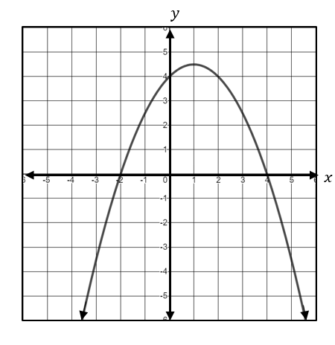
- Which of the following functions have exactly one x-intercept?
$f\left(x\right)=4x(x-5)$
$g\left(x\right)=x^{2}-6x+9$
$h\left(x\right)=2x^{2}+4x+3$
$j\left(x\right)=-3(x+1)$

SOL A.7d - Just in Time Quick Check Teacher Notes
Common Errors/Misconceptions and their Possible Indications
- Circle all of the following functions that have an x-intercept of 3.
$$f\left(x\right)=x^{2}-2x+3$$
$g\left(x\right)=2x-6$
$h\left(x\right)=x^{2}-9$
$p\left(x\right)=-\frac{1}{2}x+3$
$q\left(x\right)=-3x^{2}+10x-3$
A common error a student may make is to select the functions with a y-intercept of 3, such as f(x) and p(x). This may indicate that a student has difficulty differentiating between an x-intercept and y-intercept using an algebraic approach. A strategy that might be useful is to have a student represent the functions visually and determine which functions have an x-intercept of 3 then make the connection algebraically. Desmos is a powerful tool that can be used to show connections between algebraic forms, graphs, and intercepts.
- Let $g\left(x\right)=-\frac{2}{3}x+5$ and $h\left(x\right)=\frac{4}{5}x+k$. For which value of $k$ will the x-intercept of $g(x)$ be equivalent to the x-intercept of $h(x)$?
A common error that a student may make is to say that $k=7.5$, which is the x-intercept of $g(x)$. This indicates the student would benefit from additional practice in comparing functions and working with constant variable terms. A strategy that could be used is for the students to experiment with the slider feature in Desmos to demonstrate what happens to the graph and equation of $h(x)$ as $k$ changes in value.
- Write the x- and y-intercept of the function $f\left(x\right)=3x-4$ each as an ordered pair.
A common error a student may make is to write the x-intercept as (0, $\frac{4}{3}$) or the y-intercept as (-4, 0). This may indicate a misunderstanding of representing x- and y-intercepts as ordered pairs. A strategy that might be helpful for students is to verify the intercepts using a graphing utility such as Desmos. In addition, a student might find helpful to use the table feature in Desmos to verify intercepts.
- Circle the y-intercept of the function shown on the graph.
A common error a student may make is to circle both the x- and y-intercepts or to circle only the x-intercepts. This may indicate that a student has difficulty distinguishing between x- and y-intercepts and a misunderstanding between intercepts and solutions of a function. A strategy that might be helpful for students is to represent the x- and y-intercepts as a set of ordered pairs or as a table to show the similarities and differences between the coordinates.
- Which of the following functions have exactly one x-intercept?
$f\left(x\right)=4x(x-5)$
$g\left(x\right)=x^{2}-6x+9$
$h\left(x\right)=2x^{2}+4x+3$
$j\left(x\right)=-3(x+1)$
A common error a student may make is to select f(x) as having only one x-intercept because it is written in factored form and appears to have one binomial factor. This may indicate that a student does not recognize that the GCF of 4x is also a factor of the function and constitutes a unique x-intercept. A strategy that might be helpful for students is to verify the intercepts using a graphing utility such as Desmos. In addition, a student might find helpful to use the table feature in Desmos to verify the x-intercepts a function.

