Just In Time Quick Check

Standard of Learning (SOL) A.7b
Strand: Functions

Standard of Learning (SOL) A.7b

The student will investigate and analyze linear and quadratic function families and their characteristics both algebraically and graphically, including domain and range.

Grade Level Skills:
- Identify the domain, range, zeros, and intercepts of a function presented algebraically or graphically.
- Investigate and analyze characteristics and multiple representations of functions with a graphing utility.
Just in Time Quick Check
Just in Time Quick Check Teacher Notes

Supporting Resources:
- VDOE Mathematics Instructional Plans (MIPS)
  - A.7abef - Functions 1: Investigating Relations and Functions (Word) / PDF Version
  - A.7bcd - Functions 2: Exploring Quadratic Functions (Word) / PDF Version
- VDOE Algebra Readiness Formative Assessments
  - A.7a,b,e (Word) / PDF
- VDOE Word Wall Cards: Algebra I (Word) | (PDF)
  - Domain
  - Range
- VDOE Rich Mathematical Tasks: The Soccer Competition
  - A.7 The Soccer Competition Task Template (Word) / PDF Version
- Desmos Activities
  - Transforming Lines
  - Two Truths and a Lie: Quadratics
  - What’s my Transformation?
  - Free-Range Functions
  - Function Representation Card Sort
  - Polygraph: Parabolas
  - Polygraph: Parabolas Part 2
  - Polygraph: Quadratics
  - Will It Hit the Hoop?
Supporting and Prerequisite SOL: 8.15b

SOL A.7b - Just in Time Quick Check
- What appears to be the domain of the relation shown?
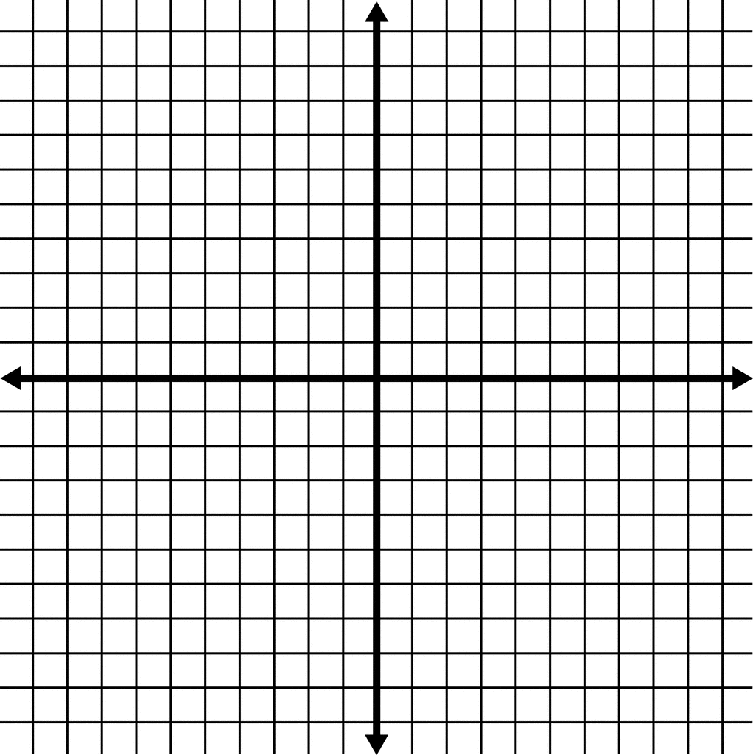
$$x$$
$$y$$

- $\{y|-8≤y≤5\}$
- $\{x|-7≤x≤7\}$
- $\{y|y=-8, -4, 1, 2, 5\}$
- $\{x|x=-7, -3, 0, 4, 7\}$

2) What is the domain of the function shown?
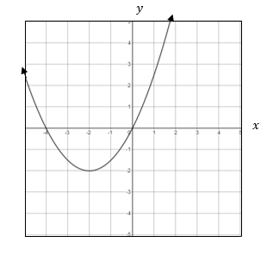

3) Write the range of the function $f\left(x\right)=-{\left(x+4\right)}^{2}-3$ using set notation below.
The range of $f(x)$ is $\{y|y___________\}$.

4) Draw a line segment that represents a relation with:
Domain: the set of all real numbers greater than or equal to -3 and less than
or equal to 2
Range: the set of all real numbers greater than or equal to -4 and less than
or equal to 1

$$x$$
$$y$$

SOL A.7b - Just in Time Quick Check Teacher Notes
Common Errors/Misconceptions and their Possible Indications

1) What appears to be the domain of the relation shown?
$$x$$
$$y$$

- $\{y|-8≤y≤5\}$
- $\{x|-7≤x≤7\}$
- $\{y|y=-8, -4, 1, 2, 5\}$
- $\{x|x=-7, -3, 0, 4, 7\}$

A common error a student may make is to list the domain as $-7≤x≥7$ instead of as discrete values. This indicates the student does not recognize the difference between a list of discrete values and a range of values. A strategy that could be used is to review inequalities on a number line to indicate how they cover a range of values. Desmos could be used as a visual representation of how the range of values covers more than just the discrete list would.

2) What is the domain of the function shown?
A common error would be for a student to list the domain as -4 and 0 or between -4 and 0. This indicates a misunderstanding of domain for x-intercepts. The teacher should review with the student that while x-intercepts are part of the domain, the domain is the set of all possible values of the independent variable. Listing additional ordered pairs from the graph in a set or table may help visualize this.

3) Write the range of the function $f\left(x\right)=-{\left(x+4\right)}^{2}-3$ in set notation below.
The range of $f(x)$ is $\{y|y___________\}$.

A common error a student may make is to say the range is less than or equal to -4, the x-coordinate of the vertex. This indicates the student has a misconception in associating domain and range with the independent and dependent variables respectively. A strategy that could be used is to have the student practice with discrete points in identifying the domain and range and then continue practice with continuous graphs.

4) Draw a line segment that represents a relation with:
Domain: the set of all real numbers greater than or equal to -3 and less than
or equal to 2
Range: the set of all real numbers greater than or equal to -4 and less than
or equal to 1

A common error a student may make is to use the restricted domain and range intervals as coordinates and plot (-3, 2) and (-4, 1) as the endpoints of the line segment. This indicates the student understands the association of the domain with the x-coordinate and range with the y-coordinate, but does not understand how to apply domain and range restrictions to a line segment. A strategy that could be used is to use graph paper and post-its or graphing technology to visualize restricting the domain and range one interval at a time to show how the line segment endpoints need to be where the restrictions coincide.

