Just In Time Quick Check

Standard of Learning (SOL) A.7a
Strand: Functions

Standard of Learning (SOL) A.7a

The student will investigate and analyze linear and quadratic function families and their

characteristics both algebraically and graphically, including determining whether a

relation is a function.

Grade Level Skills:
- Determine whether a relation, represented by a set of ordered pairs, a table, a mapping, or a graph is a function.
- Investigate and analyze characteristics and multiple representations of functions with a graphing utility.
Just in Time Quick Check
Just in Time Quick Check Teacher Notes

Supporting Resources:
- VDOE Mathematics Instructional Plans (MIPS)
  - A.7abef - Functions 1: Investigating Relations and Functions (Word) / PDF Version
  - A.7aef- Square Patios (Word) / PDF Version
- VDOE Algebra Readiness Formative Assessments
  - A.7a,b,e (Word) / PDF
- VDOE Word Wall Cards: Algebra I (Word) | (PDF)
  - Relations (definition and examples)
  - Function (definition)
  - Functions (examples)
- VDOE Rich Mathematical Tasks: The Soccer Competition
  - A.7 The Soccer Competition Task Template (Word) / PDF Version
- Desmos Activities
  - Transforming Lines
  - Two Truths and a Lie: Quadratics
  - What’s my Transformation?
Supporting and Prerequisite SOL: 8.15a, 8.15b

SOL A.7a - Just in Time Quick Check

x | y
-1 | -1
2 | -1
9 | -1
0 | -1
- Circle the tables that represent y as a function of x.
x | y
-3 | 1
1 | -2
5 | -4
-3 | -5
x | y
-1 | 3
-2 | 6
-2 | 0
-5 | 8
x | y
-1 | -5
0 | 5
1 | -2
2 | -5

- Relation H is shown. Does Relation H represent y as a function of x? Explain why or why not.
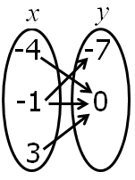
Relation H
- Six points of a relation are shown. Remove one point on the graph so that the resulting relation represents y as a function of x.
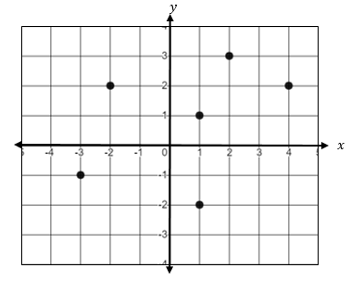

- What are all of the values of x that would result in this relation NOT representing y as a function of x?
$\{\left(-3, 2\right), \left(0, 2\right), \left(x, -2\right), \left(3, -2\right), \left(2, 3\right), \left(-2,5\right)\}$

SOL A.7a - Just in Time Quick Check Teacher Notes
Common Errors/Misconceptions and their Possible Indications

x | y
-1 | -1
2 | -1
9 | -1
0 | -1
- Circle the tables that represent y as a function of x.
x | y
-3 | 1
1 | -2
5 | -4
-3 | -5
x | y
-1 | 3
-2 | 6
-2 | 0
-5 | 8
x | y
-1 | -5
0 | 5
1 | -2
2 | -5

A common error a student may make is to select the tables where the y-value is repeating. This indicates a misunderstanding of the definition of a function. The teacher should review mathematical vocabulary of “y as a function of x” and input/output. The table feature of Desmos or graph paper can be used to graph the points from each table to help students understand how in a function the y-values can repeat.

- Relation H is shown. Does Relation H represent y as a function of x? Explain why or why not.
Relation H
A common error a student may make is to say the relation is a function because the x-value repeats. This indicates the student has a misconception of the definition of a function. The teacher should reinforce why the inputs cannot repeat for a relation to be a function using multiple representations and counterexamples. One strategy is to list the ordered pairs shown as a table or set of ordered pairs and then use Desmos to create a graph. This will demonstrate the relationship between the input and output in the mapping.

- Six points of a relation are shown. Remove one point on the graph so that the resulting relation represents y as a function of x.
A common error a student may make is to remove either (-2, 2) or (4, 2) because they lie on the same horizontal line. This indicates that a student thinks a relation is a function when two ordered pairs cannot lie on the same horizontal line rather than a vertical line. The teacher should make sure the student understands ordered pairs and that the x-coordinate comes first. Writing out the graphed coordinates as a table or set of ordered pairs may help make this connection with functions. The vertical line test can be used to verify the resulting relation represents y as a function of x.

- What are all of the values of x that would result in this relation NOT representing y as a function of x?
$\{\left(-3, 2\right), \left(0, 2\right), \left(x, -2\right), \left(3, -2\right), \left(2, 3\right), \left(-2,5\right)\}$
A common error a student may make is to list the range values of -2, 2, 3, and 5. This indicates a misconception of the definition of a function. One strategy would be to have the student graph each ordered pair in Desmos and use the slider feature to help the student visualize what happens to the relation as any value is put in place of the missing value. Also, highlighting the x-values may help students organize the information provided in the list.

