Just In Time Quick Check

Standard of Learning (SOL) A.6c
Strand: Equations and Inequalities

Standard of Learning (SOL) A.6c

The student will graph linear equations in two variables.

Grade Level Skills:
- Graph a linear equation in two variables, including those that arise from a variety of practical situations.
- Use the parent function y = x and describe transformations defined by changes in the slope or y-intercept.
Just in Time Quick Check
Just in Time Quick Check Teacher Notes

Supporting Resources:
- VDOE Mathematics Instructional Plans (MIPS)
  - A.6abc - Slope-2-Slope with Desmos (Word) / PDF Version
  - A.6c - Rate of Change of Practical Situations (Word) / PDF Version
  - A.6c - Transformation Investigation (Word) / PDF Version
- VDOE Algebra Readiness Formative Assessments
  - A.6c (Word) / PDF
- VDOE Word Wall Cards: Algebra I (Word) | (PDF)
  - Coordinate Plane
  - Linear Equation (standard form)
  - Linear Equation (slope intercept form)
  - Linear Equation (point-slope form)
  - Equivalent Forms of a Linear Equation
  - Slope
  - Slope Formula
  - Slopes of Lines
  - Perpendicular Lines
  - Parallel Lines
- Desmos Activity
  - Coin Capture: Lines
  - Linear Transformations
Supporting and Prerequisite SOL: A.6a, A.4c, 8.16a, 8.16c, 8.16d, 8.16e, 7.10b, 7.10d, 7.10e

SOL A.6c - Just in Time Quick Check

- Graph the equation 3x + 4y = 8. Show your work/thinking.
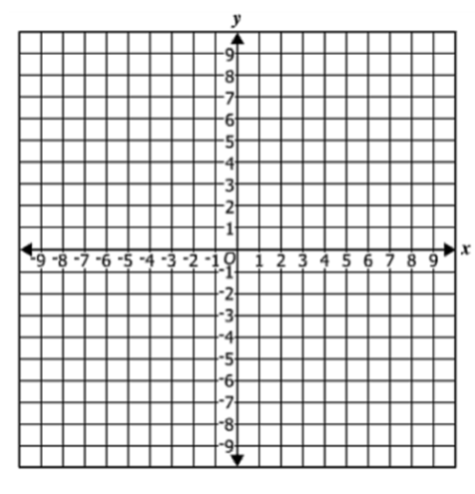

- Many cities are using electric scooters to help people get around town. The rental price for a scooter has a start-up fee of $1.00 and then $0.25 for every minute you use the scooter. Graph the linear equation that models this situation and label the axes. Show your work/thinking.

- The graph of the parent function y = x is translated 3 units to the right. Identify the slope and the y-intercept of the new line.

- The graph of the parent function y = x is dilated by a factor of 2. Identify the slope and the y-intercept of the new line and sketch the graph.

- The graph of the parent function f(x) = x is transformed to the new function g(x) = 3x + 4.

  - Describe the change in the slope of g(x) compared to f(x).

b) Describe the change in the y-intercept of g(x) compared to f(x).

SOL A.6c - Just in Time Quick Check Teacher Notes
Common Errors/Misconceptions and their Possible Indications

1) Graph the equation 3x + 4y = 8. Show your work/thinking.

A common error that students make is identifying the incorrect slope and y-intercept when attempting to solve the equation for y. This may indicate that the student assumes all forms of the equation readily provide the slope and the y-intercept. Teachers may want to have students graph an equation in standard form using multiple strategies including a) converting to slope/intercept form, b) plotting 2 or more points by setting up a table of values or c) calculating and plotting the x and y intercepts. Desmos will graph the linear equation in any form typed and can be used to verify the students’ graph.

2) Many cities are using electric scooters to help people get around town. The rental price for a scooter has a start-up fee of $1.00 and then $0.25 for every minute you use the scooter. Graph the linear equation that models this situation and label the axes. Show your work/thinking.

A common error that students might make is to include (0, 0) as part of the graph of this line. This may indicate that the student has focused on the rate of change without considering the fixed cost. Teachers may want to use the strategy of having students set up a table of values, plot some points, and sketch the graph to see the relationship between the y intercept and the fixed cost. Another strategy is to provide students with graphs that could model a practical situation and then have the students “tell the story” and provide the context.

3) The graph of the parent function y = x is translated 3 units to the right. Identify the slope and the y-intercept of the new line.

A common error that a student might make is to say that the y-intercept is positive 3. This may indicate that the student has visualized the transformation, moving the point at the origin to the right and then focusing on the new x-intercept rather than what is happening to the new y-intercept. Teachers may want to use Desmos to explore transformations asking students to identify both new intercepts when given either a horizontal or a vertical translation. The Desmos procedure shown below can provide students with a tool to explore the changes in both intercepts as a graph is shifted in a specific direction by dragging the moveable point or using the h and v sliders.

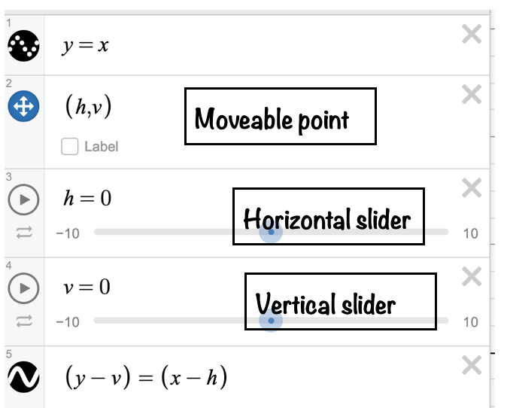

4) The graph of the parent function y = x is dilated by a factor of 2. Identify the slope and the y-intercept of the new line and sketch the graph.

A common error that a student might make is to say the y-intercept is (0, 2) while correctly identifying the new slope as 2. This may indicate that the students are not differentiating between a transformation affecting slope and a transformation affecting the y-intercept. Teachers may want to have students use Desmos to compare the graphs of linear equations under different transformations; eg. y = x + 3, y = 3x and y = 3x + 3. The addition of a few more steps to the Desmos procedure in question 3 can provide opportunities to compare these different transformations.
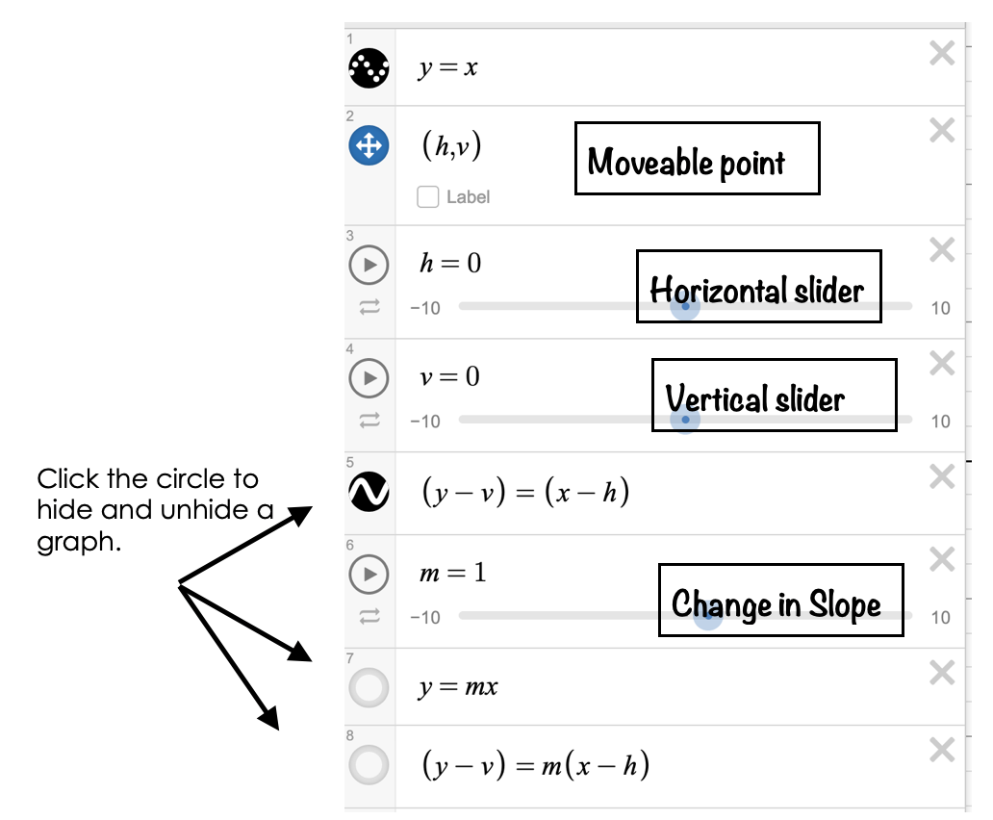

5) The graph of the parent function f(x) = x is transformed to the new function g(x) = 3x + 4.

a) Describe the change in the slope of g(x) compared to f(x).
b) Describe the change in the y-intercept of g(x) compared to f(x).

A common error might be to say that the slope is “3 more than” and the y-intercept is “4 times”. This may indicate that the student is confusing the appropriate language for the transformations. Teachers may want to be sure to connect the change in the slope with mathematical language including “dilation”, “reflection”, “steep and less steep,” and “times.” Mathematical language for changes in the y-intercept should include “translate”, ”shift up or shift down”, and “more than or less than”.

