Just In Time Quick Check

Standard of Learning (SOL) A.6b
Strand: Equations and Inequalities

Standard of Learning (SOL) A.6b

The student will write the equation of a line when given the graph of the line, two points on the line, or the slope and a point on the line.

Grade Level Skills:
- Write the equation of a line when given the graph of a line.
- Write the equation of a line when given two points on the line whose coordinates are integers.
- Write the equation of a line when given the slope and a point on the line whose coordinates are integers.
- Write the equation of a vertical line as x = a.
- Write the equation of a horizontal line as y = c.
- Write the equation of a line parallel or perpendicular to a given line through a given point.
Just in Time Quick Check
Just in Time Quick Check Teacher Notes

Supporting Resources:
- VDOE Mathematics Instructional Plans (MIPS)
  - A.6abc - Slope-2-Slope with Desmos (Word) / PDF Version
  - A.6ab - Writing Equations of Lines (Word) / PDF Version
- VDOE Co-Teaching Mathematics Instruction Plans (MIPS)
  - A.6 - Writing Equations for Lines (Word) / PDF Version
- VDOE Algebra Readiness Formative Assessments
  - A.6b (Word) / PDF
- VDOE Word Wall Cards: Algebra I (Word) | (PDF)
  - Linear Equation (standard form, slope intercept form, point-slope form)
  - Equivalent Forms of a Linear Equation
- Desmos Activities
  - Marbleslides: Lines
  - Coin Capture: Lines
  - Linear Transformations
Supporting and Prerequisite SOL: A.6a, A.6c, 8.16b, 8.16d, 8.16e, 7.10a, 7.10c

SOL A.6b - Just in Time Quick Check

- Write an equation in slope-intercept form of the line graphed below. Show your work/thinking.

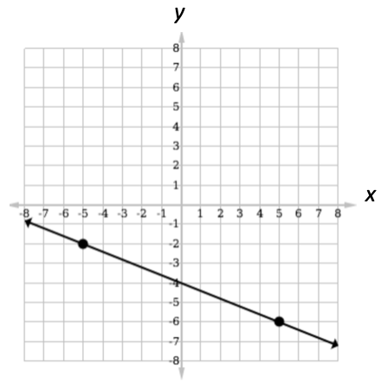

- A line passes through the point (-4, 3) and has a slope of $\frac{1}{2}$. Write the equation of the line in -
  - Slope-intercept form

  - Standard form

- Line t passes through the points (3, -7) and (-3, -3). Write an equation of a line (in any form) that is perpendicular to line t and passes through the point (3, 2). Show your work/thinking.

- Write the equation of a vertical line through the point (4, 5). Show your work/thinking.

SOL A.6b - Just in Time Quick Check Teacher Notes
Common Errors/Misconceptions and their Possible Indications

1) Write an equation in slope-intercept form of the line graphed below. Show your work/thinking.

A common mistake students may make is to write the equation as $y=\frac{2}{5}x-4$. This may indicate that a student has used the visual representation to determine the y-intercept but has not used it to determine if the line is increasing or decreasing from left to right to determine the slope of the line. When given the graph of a line, teachers may want to encourage students to always first ask, “Is the graph increasing or decreasing from left to right?” “Will the slope be positive or negative?” Teachers may also want to encourage students to use Desmos to verify the equation they have written.

2) A line passes through the point (-4, 3) and has a slope of $\frac{1}{2}$. Write the equation of the line in -
  - Slope-intercept form
A common error a student might make is to incorrectly substitute the x and y values into the slope-intercept equation. This may indicate students need practice with plotting ordered pairs and identifying the x and y coordinate. Teachers may want to have students check their final equation by graphing both the point and the line in Desmos to ensure the line passes through the given point.
  - Standard form
A common error that students make is to make an algebraic error as they convert the equation from point-slope or slope-intercept form in to standard form. Teachers may want to ensure that students understand that the different forms of the equation are equivalent and their graphs are the same. To help students to identify any algebraic mistakes, teachers may have students graph their different forms of the equation in Desmos to verify that they are equivalent and that they all pass through the given point with the given slope.

3) Line t passes through the points (3, -7) and (-3, -3). Write an equation of a line (in any form)
that is perpendicular to line t and passes through the point (3, 2). Show your work/thinking.

A common error that students may make is to take the reciprocal of the slope of line m but not negate the reciprocal. This may indicate that students think that the phrase “negative reciprocal” means the answer is negative or they may just forget that they need to change the sign. Teachers may want to explore perpendicular lines using Desmos in order to help students visualize and then compare 2 lines whose slopes are the opposite reciprocals of one another. Care should be taken in Desmos to make sure that the ZOOM SQUARE option has been selected using the wrench to ensure that lines that are perpendicular look perpendicular.

4) Write the equation of a vertical line through the point (4, 5). Show your work/thinking.

A common error a student might make is to say the vertical line is y = 5. This may indicate that the student thinks a vertical line is a “y=” line since the y-axis is vertical. Teachers may ask students to plot multiple points on a vertical or horizontal line, determine which variable in the ordered pairs stays constant and connect the variable to the equation of the line. Teachers may also want to encourage students to use Desmos to explore vertical and horizontal lines. (Extension: Once students have been introduced to A.7b, domain and range, students can continue their exploration with line segments (including horizontal and vertical) to draw simple pictures in Desmos).

