Just In Time Quick Check

Standard of Learning (SOL) A.6a
Strand: Equations and Inequalities

Standard of Learning (SOL) A.6a

The student will determine the slope of a line when given an equation of the line, the graph of the line, or two points on the line.

Grade Level Skills:
- Determine the slope of the line, given the equation of a linear function.
- Determine the slope of a line, given the coordinates of two points on the line.
- Determine the slope of a line, given the graph of a line.
- Recognize and describe a line with a slope or rate of change that is positive, negative, zero, or undefined.
Just in Time Quick Check
Just in Time Quick Check Teacher Notes

Supporting Resources:
- VDOE Mathematics Instructional Plans (MIPS)
  - A.6a - Slippery Slope (Word) / PDF Version
  - A.6abc - Slope-2-Slope with Desmos (Word) / PDF Version
  - A.6ab - Writing Equations of Lines (Word) / PDF Version
- VDOE Co-Teaching Mathematics Instruction Plans (MIPS)
  - A.6 - Writing Equations for Lines (Word) / PDF Version
- VDOE Algebra Readiness Formative Assessments
  - A.6a (Word) / PDF
- VDOE Word Wall Cards: Algebra I (Word) | (PDF)
  - Slope, Slope Formula, and Slopes of Lines
  - Perpendicular Lines and Parallel Lines
  - x-Intercepts
  - Coordinate Plane
  - Vertical Line and Horizontal Line
- Desmos Activities
  - Parallel and Perpendicular Linear Part 1 and Parallel and Perpendicular Linear Part 2
  - Lego Prices
  - Linear Systems Gym Membership
  - Which is Steepest?
  - Marbleslides: Lines and Coin Capture: Lines
  - Linear Transformations
Supporting and Prerequisite SOL: 8.14a, 8.14b, 8.16a, 8.16b, 8.16d, 8.16e, 7.10a, 7.11

SOL A.6a - Just in Time Quick Check

- The line graphed below passes through the points (-2, -1) and (2, -7). Find the slope of the line.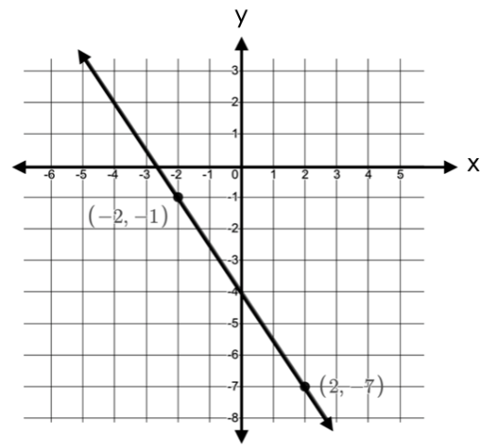

- The graph below shows the line x = 3. Describe the slope of the line.

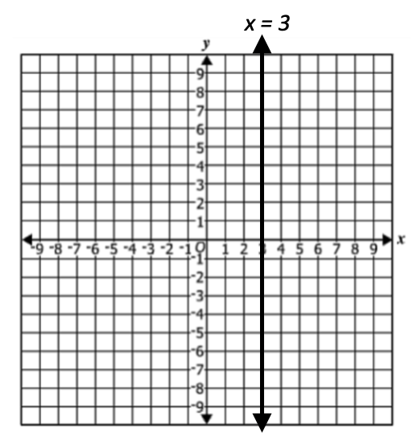

- What is the slope of the line represented by the equation $\frac{2}{5}y=2x+4$ ? Show your work/thinking.

- What is the slope of the line that passes through the points (5, 2) and (3, -1)? Show your work/thinking.

- A line passes through the points (2, a) and (4a, 5) and has a slope of $\frac{1}{2}$. Find the value of a.

SOL A.6a - Just in Time Quick Check Teacher Notes
Common Errors/Misconceptions and their Possible Indications
- The line graphed below passes through the points (-2, -1) and (2, -7). Find the slope of the line.
A common error might be to say the slope is $\frac{3}{2}$ rather than $-\frac{3}{2}$. This might indicate that visually students see all slopes as increasing by reading the graph from left to right OR from right to left. When exploring the slope of a line given the graph, a teacher might always want to start with the questions, “Is the slope positive or negative? How do you know?” Teachers may benefit from using the Mathematics Instructional Plan (MIP) Slippery Slope to facilitate exploring the relationship between the graph of a line and its slope. Desmos could also be used to explore the difference in positive and negative slopes.
- The graph below shows the line x = 3. Describe the slope of the line.

A common error that students might make is to say the slope of a vertical line is 0. This might indicate that the student does not have a good understanding of the difference between lines with a slope of zero and an undefined slope. Teachers may want to reinforce the idea that division by zero is undefined. They might have students explore the slope of vertical and horizontal lines by plotting any two points on the line and using rise over run or a slope formula to explore the difference between a numerator of 0 and a denominator of 0.
- What is the slope of the line represented by the equation $\frac{2}{5}y=2x+4$ ? Show your work/thinking.
A common error might be to say the slope is 2. This might indicate that the student sees slope as the coefficient of x regardless of whether the equation has been solved for y. Teachers may want to have students explore and compare the graphs of two linear equations where one is solved for y and the other is not (eg. y = 4x + 3 and 2y = 4x + 3). Teachers may benefit from using the Desmos Activity Marbleslides: Lines and Coin Capture: Lines to facilitate exploring the relationship between the equation and the slope of a line.

- What is the slope of the line that passes through the points (5, 2) and (3, -1)? Show your work/thinking.
A common error students may make is to say the slope is $\frac{2}{3}$ rather than $\frac{3}{2}$. This might indicate that a student (using the slope formula or plotting points on a coordinate grid) has calculated slope as the change in x over the change in y. When exploring slope, teachers may want to help students to understand slope in real world problems as both “rate of change” and as a measure of “steepness.” Using Desmos, students can compare the steepness of two lines whose slopes are reciprocals to the parent function (y = x) whose slope is 1.

5) A line passes through the points (2, a) and (4a, 5) and has a slope of $\frac{1}{2}$. Find the value of a.
A common error might be when using the slope formula to set up an equation writing the change in x-values over the change in y-values equals ½ and calculating to find a to equal 1. This may indicate that students are procedurally using the slope formula and may benefit from a review of slope triangles to calculate slope. A strategy might be to have the students plot the points created by substituting the value of a in each coordinate to ensure that a line with the desired slope is obtained. Students who struggle with the use of variables may benefit from being provided similar problems with only one of the coordinates having a missing variable. Teachers may benefit from using the Desmos Activity Marbleslides: Lines and Coin Capture: Lines to facilitate exploring the relationship between the ordered pairs and the slope of a line.

