Just In Time Quick Check

Standard of Learning (SOL) A.5d
Strand: Equations and Inequalities

Standard of Learning (SOL) A.5d

The student will represent the solution to a system of inequalities graphically.

Grade Level Skills:
- Represent the solution of a system of two linear inequalities graphically.
- Determine and verify algebraic solutions using a graphing utility.
Just in Time Quick Check
Just in Time Quick Check Teacher Notes

Supporting Resources:
- VDOE Mathematics Instructional Plans (MIPS)
  - A.5d - Graphing Systems of Linear Inequalities in Two Variables with Desmos (Word) / PDF Version
- VDOE Co-Teaching Mathematics Instruction Plans (MIPS)
  - A.5d - Graphing Systems of Linear Inequalities (Word) / PDF Version
- VDOE Algebra Readiness Formative Assessments
  - A.5b,d (Word) / PDF
- VDOE Word Wall Cards: Algebra I (Word) | (PDF)
  - System of Linear Inequalities
- Desmos Activity
  - Polygraph: Systems of Inequalities
Supporting and Prerequisite SOL: A.4d, A.6b, A.6c, 8.16b, 8.16d, 8.18, 7.10b, 7.10d, 7.13

SOL A.5d - Just in Time Quick Check

- Avery has correctly started to the graph of the system of inequalities $\left\{\begin{aligned}y≥4x+3 \\ y<-x-2\end{aligned}\right.$ . Which region would Avery need to shade to complete the graph of this system? How do you know?
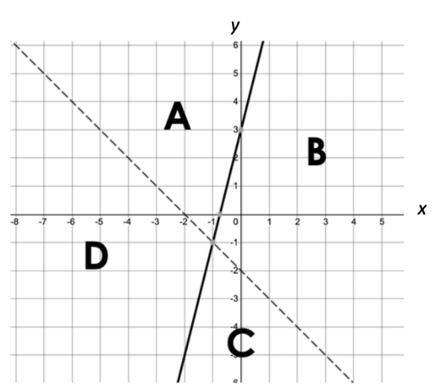

- Graph the solution to this system of inequalities: $\left\{\begin{aligned}2x+4y≤12 \\ 5x-2y<6\end{aligned}\right.$
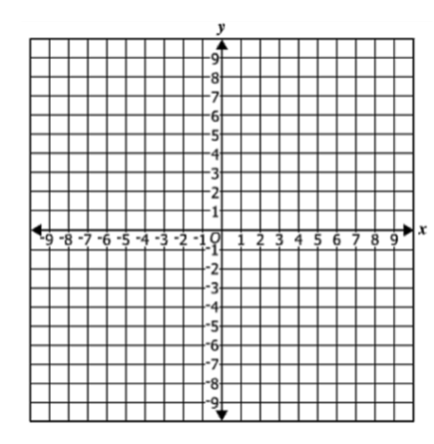

- The graph of a system of inequalities is shown below.
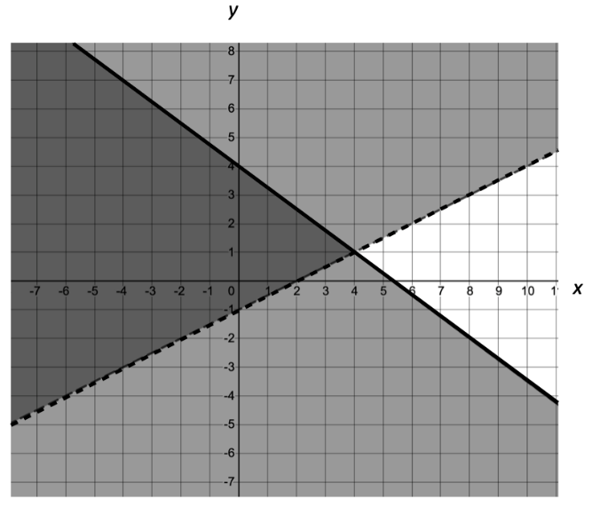

Select all the points listed in the chart that are solutions to this system of inequalities.
(-4,-3) | (4, 1) | (-4, -1)
(3, 4) | (8, -2) | (-4, 7)

SOL A.5d - Just in Time Quick Check Teacher Notes
Common Errors/Misconceptions and their Possible Indications

- Avery has correctly started the graph of the system of inequalities $\left\{\begin{aligned}y≥4x+3 \\ y<-x-2\end{aligned}\right.$. Which region would Avery need to shade to complete the graph of this system? How do you know?

A common error a student may make is to select region B. This may indicate that the student has confused which inequality goes with a dashed line and which goes with a solid line. Teachers may want to continue to make connections between inequalities with two variables and inequalities with one variable, connecting dashed lines to open circles and solid lines to closed circles. Allowing students to use Desmos to check their graphs will also help reinforce the meaning of dashed and solid lines.

- Graph the solution to this system of inequalities: $\left\{\begin{aligned}2x+4y≤12 \\ 5x-2y<6\end{aligned}\right.$
A common error a student may make is to incorrectly graph the second equation shading below the line. This may indicate that the student does not understand that the inequality symbol is reversed when solving for y requires dividing by a negative. Teachers may want to encourage students to select a test point from the region they shaded and substitute it into both inequalities to verify that they have shaded the correct area. Allowing students to use Desmos to check their graphs will also help reinforce the need to reverse the inequality.

- The graph of a system of inequalities is shown below.

Select all the points listed in the chart that are solutions to this system of inequalities.
(-4,-3) | (4, 1) | (-4, -1)
(3, 4) | (8, -2) | (-4, 7)

A common error a student may make is to select (4, 1) as a solution. This may indicate that the student assumes that systems of inequalities behave like systems of equations and that the point of intersection is always a solution. Teachers may want to have students explore and contrast the point of intersection of four different systems including one system of equations and three systems of inequalities (2 solid lines, 2 dashed lines, 1 solid and 1 dashed). In addition, testing the solution point in the systems of inequalities will help students verify if the point is a solution.

