Just In Time Quick Check

Standard of Learning (SOL) A.5c
Strand: Equations and Inequalities

Standard of Learning (SOL) A.5c

The student will solve practical problems involving inequalities.

Grade Level Skills:
- Solve practical problems involving linear inequalities.
- Determine whether a coordinate pair is a solution of a linear inequality or a system of linear inequalities.
- Determine and verify algebraic solutions using a graphing utility.
Just in Time Quick Check
Just in Time Quick Check Teacher Notes

Supporting Resources:
- VDOE Mathematics Instructional Plans (MIPS)
  - A.5ac - Lemonade Stand: Solving Practical Problems Using Linear Inequalities in One Variable (Word) / PDF Version
- VDOE Algebra Readiness Formative Assessments
  - A.5a,c (Word) / PDF
- VDOE Rich Mathematical Tasks: Trampoline Party Task
  - A.5ac Trampoline Party Task Template (Word) / PDF Version
  - A.5ac Trampoline Party Student Version of Task (Word) / PDF Version
  - A.5ac Trampoline Party Anchor Papers (Word) / PDF Version
  - A.5ac Trampoline Party Anchor Papers Scoring Rationales (Word) / PDF Version
- Desmos Activity
  - Point Collector
Supporting and Prerequisite SOL: A.1a, A.4a, A.5a, 8.18, 7.13

SOL A.5c - Just in Time Quick Check

1) Cassie is planning a birthday party for her little brother and wants to rent a snow cone machine. She will also need to buy the flavored syrup, ice, and paper cones. She has at most $50 to spend.
- The rental of the snow cone machine costs $25 for the day.
- The flavored syrup, ice, and the paper cones will cost $0.70 per serving.
What is the greatest number of snow cones Cassie can serve? Show your work/thinking.

2) Jarrah needs no less than $159 to purchase a new guitar. He already has $38 in his savings account. He has a plan to rake and bag leaves in his neighborhood to make more money. He decides to charge $5 a bag. What is the minimum number of full bags of leaves that Jarrah needs to rake in order to have enough money to buy the guitar? Show your work/thinking.

3) The cheerleaders at the high school need to earn money to help pay for their uniforms. They plan to have a fundraiser selling two different types of chocolate bars.
- They need to earn at least $200.
- For every chocolate bar with a peanut butter filling (y) that they sell, they will make a profit of $0.80.
- For every chocolate bar with almonds (x) that they sell, they will make a profit of $1.00.
Write an inequality to model this situation and graph the inequality on the grid below to show all the possible solutions. Be sure to label your graph.
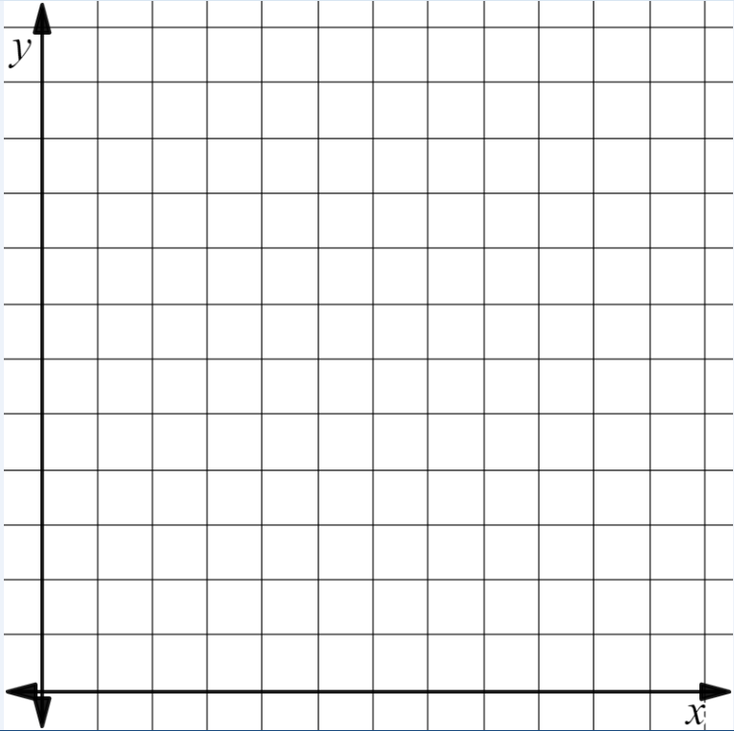

SOL A.5c - Just in Time Quick Check Teacher Notes
Common Errors/Misconceptions and their Possible Indications

1) Cassie is planning a birthday party for her little brother and wants to rent a snow cone machine. She will also need to buy the flavored syrup, ice, and paper cones. She has at most $50 to spend.
- The rental of the snow cone machine costs $25 for the day.
- The flavored syrup, ice, and the paper cones will cost $0.70 per serving.
What is the greatest number of snow cones Cassie can serve? Show your work/thinking.
A common mistake that students might make is to say that Cassie can serve 71 snow cones, forgetting to include the initial cost for renting the machine. This might indicate that the student has not completely understood the problem and ignored the fixed cost. Teachers may want to encourage students to consider different problem solving strategies including drawing a visual representation of the problem. Visualizing a problem can help students to better understand the context of the problem.
2) Jarrah needs no less than $159 to purchase a new guitar. He already has $38 in his savings account. He has a plan to rake and bag leaves in his neighborhood to make more money. He decides to charge $5 a bag. What is the minimum number of full bags of leaves that Jarrah needs to rake in order to have enough money to buy the guitar? Show your work/thinking.
A common mistake that students might make is to say the solution is 24.2. This might indicate that the student does not really understand the context of the problem. Teachers may want to require students to use different organizational strategies like the three-reads protocol when drawing information from a practical situation. Teachers might encourage students to justify their answers within the context of the problem being sure to identify the units (e.g., Does 24.2 full bags of leaves make sense?)
3) The cheerleaders at the high school need to earn money to help pay for their uniforms. They plan to have a fundraiser selling two different types of chocolate bars.
- They need to earn at least $200.
- For every chocolate bar with a peanut butter filling (y) that they sell, they will make a profit of $0.80.
- For every chocolate bar with almonds (x) that they sell, they will make a profit of $1.00.
Write an inequality to model this situation and graph the inequality on the grid below to show all the possible solutions. Be sure to label your graph.
A common error that a student might make is to write and graph the inequality as 0.80x + 1.00y ≤ 200 and then shade below the line. This may indicate that the student thinks that “at least” means less than or equal to. Teachers may want to make sure that students have an opportunity to explore and demonstrate understanding of the language of inequalities. Teachers might have students write their own practical situations given particular inequalities.

