Just In Time Quick Check

Standard of Learning (SOL) A.5b
Strand: Equations and Inequalities

Standard of Learning (SOL) A.5b

The student will represent the solution of linear inequalities in two variables graphically.

Grade Level Skills:
- Represent the solution of a linear inequality in two variables graphically.
- Determine and verify algebraic solutions using a graphing utility.
Just in Time Quick Check
Just in Time Quick Check Teacher Notes

Supporting Resources:
- VDOE Mathematics Instructional Plans (MIPS)
  - A.5b - Represent the Solution of a Linear Inequality in Two Variables Graphically Scavenger Hunt with Desmos (Word) / PDF Version
- VDOE Co-Teaching Mathematics Instruction Plans (MIPS)
  - A.5b - Graphing and Solving Inequalities (Word) / PDF Version
- VDOE Algebra Readiness Formative Assessments
  - A.5b,d (Word) / PDF
- VDOE Word Wall Cards: Algebra I (Word) | (PDF)
  - Graphing Linear Inequalities
- Desmos Activity
  - Point Collector: Lines
  - Polygraph Linear Inequalities 1
  - Polygraph Linear Inequalities 2
  - Polygraph Linear Inequalities 3
Supporting and Prerequisite SOL: A.6a, A.6c, 8.16d, 7.10b, 7.10d

SOL A.5b - Just in Time Quick Check

- Graph the solution for the linear inequality shown. State one possible solution.

$$y>\frac{1}{2}x+3$$
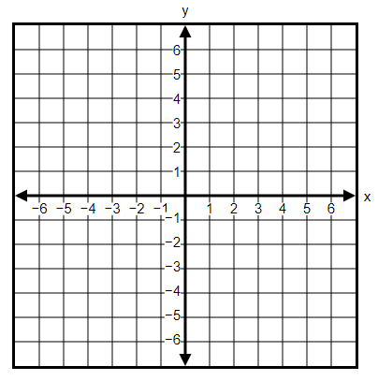

- Graph the solution for the linear inequality.

$$6x-5y≥10$$

- Is the point $\left(\frac{5}{3},-\frac{1}{4}\right)$ a solution to the inequality $3x-4y<6$ ? Explain how you know.

SOL A.5b - Just in Time Quick Check Teacher Notes
Common Errors/Misconceptions and their Possible Indications

- Graph the solution for the linear inequality shown. State one possible solution.

$$y>\frac{1}{2}x+3$$

A common mistake students may make is to draw a solid line instead of a dashed line. This may indicate that the student does not recognize that the points that lie on the line $y=\frac{1}{2}x+3$ are not solutions for the inequality. One strategy teachers may use is to give students graphs of two inequalities that have the same boundary line, but one is dashed and the other solid (ex. graphs of $y>\frac{3}{4}x-2$ and $y≥\frac{3}{4}x-2$). Ask students to identify the difference in the graphs and make a conjecture about what it means. Teachers may also want to help students make the connection between graphing inequalities with one variable and two variables, relating dashed lines and open endpoints on the number line and solid lines with filled endpoints on the number line. Allowing students to use Desmos to check their graphs will also help reinforce when lines should be dashed or solid.

- Graph the solution for the linear inequality.

$$6x-5y≥10$$

One typical error students make when representing the solution to this given inequality is to shade the area above the line on the coordinate plane. This may indicate that students do not understand that they must reverse the inequality symbol when they divide both sides of the inequality by -5. Teachers may want to encourage students to select a test point from the region they shaded and substitute it into the original inequality to verify that they have shaded the correct area. Teachers might also have students use Desmos to explore the graphs of y > 4 and -y > 4 to develop a deeper understanding of why the inequality symbol is reversed when multiplying or dividing an inequality by a negative value.

- Is the point $\left(\frac{5}{3},-\frac{1}{4}\right)$ a solution to the inequality $3x-4y<6$ ? Explain how you know.

A common mistake students make on this problem is to substitute the given values for x and y, arrive at a value of 6 for the left side, and conclude that the point is a solution for the inequality. This may indicate that the student doesn’t recognize that since the inequality symbol is less than, a value that is equal to 6 would not be a solution (i.e. a point that lies on the boundary line is not a solution since the line should be dashed). Teachers may want to encourage students to write the entire inequality (6 < 6) and determine if that statement is true or false before responding whether the point is a solution. Teachers may also encourage students to graph the inequality on Desmos to verify that their answer is correct.

