Just In Time Quick Check

Standard of Learning (SOL) A.4d
Strand: Equations and Inequalities

Standard of Learning (SOL) A.4d

The student will solve systems of two linear equations in two variables algebraically and graphically.

Grade Level Skills:
- Given a system of two linear equations in two variables that has a unique solution, solve the system by substitution or elimination to identify the ordered pair which satisfies both equations.
- Given a system of two linear equations in two variables that has a unique solution, solve the system graphically by identifying the point of intersection.
- Solve and confirm algebraic solutions to a system of two linear equations using a graphing utility.
- Determine whether a system of two linear equations has one, an infinite number, or no solutions.
Just in Time Quick Check
Just in Time Quick Check Teacher Notes

Supporting Resources:
- VDOE Mathematics Instructional Plans (MIPS)
  - A.4de - Road Trip: Applying Systems of Linear Equations (Word) / PDF Version
  - A.4de - Spring Fling Carnival: Applying Systems of Linear Equations (Word) / PDF Version
- VDOE Algebra Readiness Formative Assessments
  - A.4d,e (Word) / PDF
- VDOE Word Wall Cards: Algebra I (Word) | (PDF)
  - System of Linear Equations (graphing, substitution, elimination)
  - System of Linear Equations (number of solutions)
- VDOE Rich Mathematical Tasks: Full Parking Lot Task
  - A.4 Full Parking Lot Task Template (Word) / PDF Version
- Desmos Activities
  - Card sort: Linear Systems
  - Polygraph: Linear Systems
  - Systems of Two Linear Equations
  - Playing Catch-up
Supporting and Prerequisite SOL: A.4a, A.4c, A.6a, A.6c, 8.16b, 8.16d, 8.17, 7.10b, 7.10d, 7.12

SOL A.4d - Just in Time Quick Check

- Solve the system by substitution. Show your work/thinking.
$\left\{\begin{aligned}3x+y=5 \\ -5x+4y=3\end{aligned}\right.$

- Solve the system by graphing.
$\left\{\begin{aligned}y=-\frac{1}{2}x+5 \\ y=7-x\end{aligned}\right.$
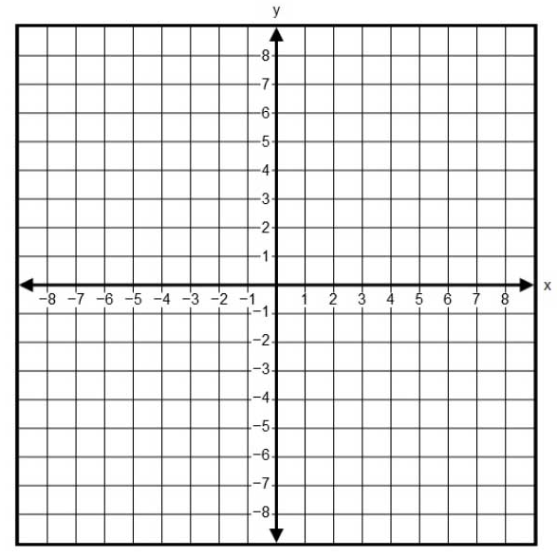

- What is the solution to the system shown? Solve using the elimination method. Show your work/thinking.
$\left\{\begin{aligned}4x+5y=6 \\ 6x-7y=-20\end{aligned}\right.$

- Is the point $\left(3,-\frac{1}{3}\right)$ a solution to the system $\left\{\begin{aligned}2x-3y=7 \\ x+6y=11\end{aligned}\right.$? Explain how you know.

- Given the equation: $3x+y=4$

  - Write an equation of a line that would create a system of equations with the given line that has infinitely many solutions. How did you decide on your equation?

  - Write an equation of a line that would create a system of equations with the given line that has no solution. How did you decide on your equation?

SOL A.4d - Just in Time Quick Check Teacher Notes
Common Errors/Misconceptions and their Possible Indications

- Solve the system by substitution. Show your work/thinking.
$\left\{\begin{aligned}3x+y=5 \\ -5x+4y=3\end{aligned}\right.$

A common error students may make is not distributing when substituting an expression into the second equation (ex. after students solve the first equation for y, they should take 5 - 3x and multiply it by 4 in the second equation). This may indicate that students do not have a full understanding of the substitution property. Teachers may want to encourage the use of Desmos for students to verify each step of their work and the solution.

- Solve the system by graphing.
$\left\{\begin{aligned}y=-\frac{1}{2}x+5 \\ y=7-x\end{aligned}\right.$

A common error students may make is to graph the second line incorrectly (ex. y-intercept of -7 and slope of 1). This may indicate that students do not have a strong understanding of graphing equations that are not in the format y = mx + b. Teachers should encourage strategies that help students to better understand the meaning of the constant and the coefficient in a linear equation. One strategy might be to rewrite the equation in slope-intercept form. Teachers may want to encourage students to verify their solutions on Desmos.

- What is the solution to the system shown? Solve using the elimination method. Show your work/thinking.
$\left\{\begin{aligned}4x+5y=6 \\ 6x-7y=-20\end{aligned}\right.$

A common error students make when solving by elimination is only identifying one variable (the first found when solving algebraically) as the solution rather than finding the ordered pair. This may indicate that students do not understand that they are finding the point of intersection of two lines. Teachers may want to have students check their solutions by graphing on Desmos. The visual provided of two lines intersecting at a point will reinforce that students should find an ordered pair as their solution.

- Is the point $\left(3,-\frac{1}{3}\right)$ a solution to the system $\left\{\begin{aligned}2x-3y=7 \\ x+6y=11\end{aligned}\right.$? Explain how you know.

A common error students make is substituting the point into only one equation and not both. In this case, the point lies on the first line but not the second. Students may incorrectly say it is a solution to the system. This may indicate that students do not understand that a solution to a system must be a point that lies on both lines. Teachers may want to encourage students to check their work by graphing on Desmos which will allow students to see that the point lies on only one line and not both.

- Given the equation: $3x+y=4$

  - Write an equation of a line that would create a system of equations with the given line that has infinitely many solutions. How did you decide on your equation?

One common misconception students make is thinking any two lines with the same slope have infinitely many solutions. This may indicate that students do not recognize the difference between parallel and coinciding lines. Teachers may encourage students to graph their system using Desmos to help them visualize that two lines must have both the same slope and the same y-intercept in order to have infinitely many solutions. Teachers may also encourage students to solve the equation for y to help identify the slope and y-intercept.

  - Write an equation of a line that would create a system of equations with the given line that has no solution. How did you decide on your equation?

A common error students make is writing the equation of a line that has a different slope than the line given. This may indicate that students do not understand that parallel lines must have the same slope and different y-intercepts. Teachers may encourage students to write the original equation in slope-intercept form. Students can then enter the system in Desmos, using sliders for the slope and y-intercept of the second line, which will allow them to experiment with various slopes and intercepts to see how they can create different lines that are parallel to the original line to build conceptual understanding.

