Just In Time Quick Check

Standard of Learning (SOL) A.2c
Strand: Expressions and Operations

Standard of Learning (SOL) A.2c

The student will perform operations on polynomials, including factoring completely first- and second-degree binomials and trinomials in one variable.

Grade Level Skills:
- Factor completely first- and second-degree polynomials in one variable with integral coefficients. After factoring out the greatest common factor (GCF), leading coefficients should have no more than four factors.
- Factor and verify algebraic factorizations of polynomials with a graphing utility.
Just in Time Quick Check
Just in Time Quick Check Teacher Notes

Supporting Resources:
- VDOE Mathematics Instructional Plans (MIPS)
  - A.2c - Factoring Polynomials (Word) / PDF Version
- VDOE Algebra Readiness Formative Assessments
  - A.2 a,b,c (Word) / PDF
- VDOE Word Wall Cards: Algebra I (Word) | (PDF)
  - Factors of a Monomial
  - Factoring (greatest common factor)
  - Factoring (by grouping)
  - Factoring (perfect square trinomials)
  - Factoring (difference of squares)
  - Difference of Squares (model)
- Desmos Activity
  - Factoring Practice
Supporting and Prerequisite SOL: A.2a, A.2b, 8.14b

SOL A.2c - Just in Time Quick Check
- Factor completely the expression below. Show your work/thinking.
$$3x^{3}y-6x^{2}y^{2}-9xy$$

- Factor completely: ${9x}^{2}-16$

- Factor the trinomial below. Show your work/thinking.
$$4x^{2}-11x+6$$

- Factor the trinomial below. Show your work/thinking.
$$x^{2}-3x-54$$

- Given the following graph, what are the factors of this function?
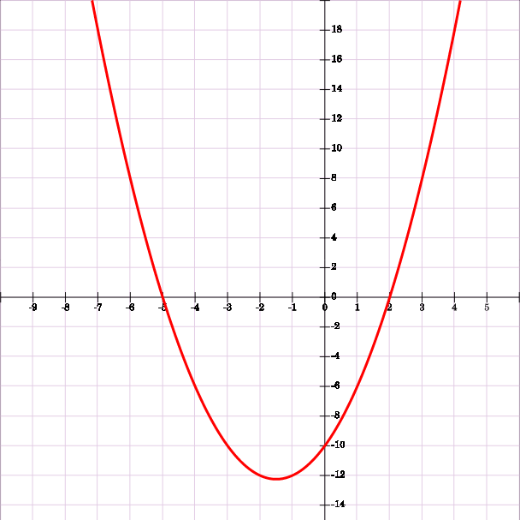
$$x$$

$$y$$

SOL A.2c - Just in Time Quick Check Teacher Notes
Common Errors/Misconceptions and their Possible Indications
- Factor completely the expression below. Show your work/thinking.
$$3x^{3}y-6x^{2}y^{2}-9xy$$
A common misconception is students do not factor out a complete GCF such as
$3x(x^{2}y-2xy^{2}-3y)$. This may indicate the student does not understand how to find the GCF. The teacher should make sure the student understands what factor “completely” means and revisit finding the GCF. Students should be encouraged to check the resulting polynomial for additional common factors.
Another misconception is that students may leave out a factor in the answer such as
$3xy(x^{2}-2xy)$ . This may indicate the student does not understand the need to leave a constant for the last term as a placeholder. In this case, the teacher may want to encourage students to check their answers by multiplying to see if it is equivalent to the original polynomial.

- Factor completely: ${9x}^{2}-16$
A common misconception in factoring the difference of two perfect squares
$a^{2}-b^{2}=\left(a+b\right)\left(a-b\right)$ is that students will not identify $a and b$ correctly resulting is
$(3x+8)(3x-8)$. This may indicate the student is confused about what it means to square a number. The teacher may want to review the perfect squares. Another strategy is to have the students multiply their factors to verify if the result is equivalent to the problem.
- Factor the trinomial below. Show your work/thinking.
$${4x}^{2}-11x+6$$
A common misconception student have is choose the incorrect factors of 24 that will add together to give them the middle term. This may indicate the student is struggling with two different mental computations. It may help for teachers to have students complete a table of factors such as the one shown below. This will help students organize their thinking and select the correct factors. Another strategy is to have the students use Desmos to graph their factors and the given expression to verify equivalence.
Factors of +24 | Sum of Factors
1 ∙ 24 | 25
-1 ∙ -24 | -25
2 ∙ 12 | 14
-2 ∙ -12 | -14
3 ∙ 8 | 11
-3 ∙ -8 | -11
4 ∙ 6 | 10
-4 ∙ -6 | -10

- Factor the trinomial below. Show your work/thinking.
$$x^{2}-3x-54$$
A common error students may make is to find the correct factors of 54, but then place the negative sign with the wrong factor (x – 6)(x + 9). This may indicate that students do not understand how the “b” term is related to the factors. Teachers may want to encourage students to check their answers by multiplying to see if it is equivalent to the original trinomial.
- Given the following graph, what are the factors of this function?
$$x$$

$$y$$

A common error students may make is to confuse the intercepts with the factors and write
(x - 5)(x + 2). This may indicate the student does not fully understand the connection between the factors and the graph. Using Desmos to investigate the connection between the intercepts and factors may help the student to develop a deeper conceptual understanding.

