Just In Time Quick Check

Standard of Learning (SOL) 8.16e
Strand: Patterns, Functions, and Algebra

Standard of Learning (SOL) 8.16e
The student will make connections between and among representations of a linear function using verbal descriptions, tables, equations, and graphs.

Grade Level Skills:
- Write the equation of a linear function in the form y = mx + b given values for the slope, m, and the y-intercept or given a practical situation in which the slope, m, and y-intercept are described verbally.
- Make connections between and among representations of a linear function using verbal descriptions, tables, equations, and graphs.
Just in Time Quick Check
Just in Time Quick Check Teacher Notes

Supporting Resources:
- VDOE Mathematics Instructional Plans (MIPS)
  - 8.16e - Matching Representations (Word) / PDF Version
- VDOE Co-Teaching Mathematics Instruction Plans (MIPS)
  - 8.16e - Matching Representations (Word) / PDF Version
- VDOE Algebra Readiness Formative Assessments
  - SOL 8.16e (Word) / (PDF)
- VDOE Algebra Readiness Remediation Plans
  - Graphing Linear Functions and Matching Representations (Word) / (PDF)
  - Practical Situations Modeled by Linear Functions (Word) / (PDF)
- VDOE Word Wall Cards: Grade 8 (Word) | (PDF)
  - Slope – Definition
  - Slope
  - Linear Function
  - Identifying Slope and y-Intercept
  - Connecting Representations
- Desmos Activity
  - Investigating T-Shirt Offers
  - Linear Slalom
  - LEGO Prices
  - How are the Patterns Changing?
  - Linear Pattern Match
  - Charge!
Supporting and Prerequisite SOL: 8.16a, 8.16b, 8.16c, 8.16d, 7.10a, 7.10b, 7.10c, 7.10d, 7.10e, 6.12a, 6.12b, 6.12c, 6.12d

SOL 8.16e - Just in Time Quick Check

- Write the equation of a linear function that has a slope of ‒3 and a y-intercept of ‒2.

- A landscaper charges each customer a flat rate of $150 to develop a plan for the landscaping of an outdoor space. The landscaper also charges $22.50 for each hour of manual labor invested in the landscaping. Write an equation to represent the relationship between the number of hours of manual labor, x, and the total cost, y, for the customer to plan and landscape an outdoor space.

- A table showing values in a linear function was provided to Tonya and Tim.
x | y
-2 | -2
0 | -1
4 | 1
Tonya and Tim each made a graph of the line that represents the values shown in the table.
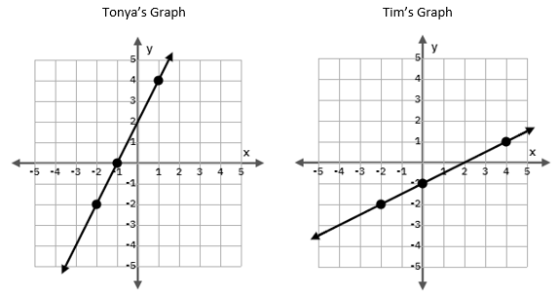
Determine which graph is correct. Explain your thinking.

- Graph the linear function represented by the algebraic sentence:
y is equivalent to three times a number, x, decreased by one.
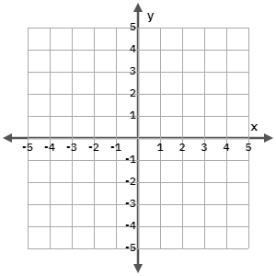

- Write a verbal sentence to represent a linear function that contains the ordered pairs shown in table.
x | y
2 | 0
3 | 2
4 | 4

SOL 8.16e - Just in Time Quick Check Teacher Notes
Common Errors/Misconceptions and their Possible Indications
- Write the equation of a linear function that has a slope of ‒3 and a y-intercept of ‒2.
A common error is for students to switch the slope and y-intercept, creating the equation $y=-2x-3$. This indicates that the student does not have a strong conceptual understanding of of slope and y-intercept in the formation of an equation, recorded in slope-intercept form. The student may benefit from referring to the Linear Function card posted in the VDOE Word Wall Cards: Grade 8.
- A landscaper charges each customer a flat rate of $150 to develop a plan for the landscaping of an outdoor space. The landscaper also charges $22.50 for each hour of manual labor invested in the landscaping. Write an equation to represent the relationship between the number of hours of manual labor, x, and the total cost, y, for the customer to plan and landscape an outdoor space.
A common error some students may make is to record the equation $y=150x+22.50$. This may indicate that the student does not understand that a flat rate represents a one-time charge that appears as the y-intercept in the equation and that an hourly charge is a rate of change that appears as the slope. The student may have also just recorded numbers in the order that they appear in the problem. This student requires additional practice identifying the slope and y-intercept in a practical situation. They may benefit from working through the first six slides of the Desmos activity, Investigating T-Shirt Offers. These slides allow students to develop equations for two different t-shirt companies based on a design fee and charge per shirt.
- A table showing values in a linear function was provided to Tonya and Tim.
x | y
-2 | -2
0 | -1
4 | 1
Tonya and Tim each made a graph of the line that represents the values shown in the table.
Determine which graph is correct. Explain your thinking.
One common misconception that may lead students to select Tonya’s graph as the correct representation is to misrepresent ordered pairs on a graph once the concept of slope is introduced. Since the first number seen in the slope ratio represents a change in y but the first number seen in an ordered pair represents an x-value, some students end up plotting points as (y, x) instead of (x, y). This indicates that the student does not have a strong conceptual understanding in regards to the relationships between ordered pairs and slope. They may benefit from additional practice plotting ordered pairs from a table and determining slope from the same table. Then, this student can use the slope determined from the table to confirm the slope seen in the graph.
- Graph the linear function represented by the algebraic sentence:
y is equivalent to three times a number, x, decreased by one.
One error commonly made by students is to create a graph that does not match the verbal description presented. This may indicate that the student needs remediation in regards to connecting verbal expressions and sentences to those represented symbolically. The student could benefit from extra practice with connecting all of the different representations (e.g., verbal to algebraic before creating a graph or verbal to a table before creating a graph). A good resource to use is the VDOE Mathematical Instructional Plan (MIP) 8.16e - Matching Representations.
- Write a verbal sentence to represent a linear function that contains the ordered pairs shown in table.
x | y
2 | 0
3 | 2
4 | 4

A common error that students make is to write a verbal sentence that does not match the values in the table. Since the y-intercept is not provided in this table, students may make the assumption that the y-intercept is 2 because of the ordered pair (2, 0). This could cause students to write a verbal description that reflects the linear function $y=2x+2$ indicating that the student needs reinforcement on the definition and location of the y-intercept on the coordinate plane. They may benefit from practice locating the y-intercept on a graph and naming it by its ordered pair.

