Just In Time Quick Check

Standard of Learning (SOL) 8.16d
Strand: Patterns, Functions, and Algebra

Standard of Learning (SOL) 8.16d
The student will graph a linear function given the equation in y = mx + b form.

Grade Level Skills:
- Given the equation of a linear function in the form y = mx + b, graph the function. The value of the y-intercept will be limited to integers.
Just in Time Quick Check
Just in Time Quick Check Teacher Notes

Supporting Resources:
- VDOE Mathematics Instructional Plans (MIPS)
  - 8.16d - Graphing Linear Functions (Word) / PDF Version
- VDOE Algebra Readiness Formative Assessments
  - SOL 8.16d (Word) / (PDF)
- VDOE Algebra Readiness Remediation Plans
  - Graphing Linear Functions and Matching Representations (Word) / (PDF)
  - Practical Situations Modeled by Linear Functions (Word) / (PDF)
- VDOE Word Wall Cards: Grade 8 (Word) | (PDF)
  - Slope – Definition
  - Slope
  - Linear Function
  - Identifying Slope and y-Intercept
  - Connecting Representations
- Desmos Activities
  - Match My Picture
  - Match My Line
  - Land the Plane
  - Investigating T-Shirt Offers
  - Linear Slalom
Supporting and Prerequisite SOL: 8.16a, 8.16b, 8.16c, 7.10a, 7.10b, 7.10c, 7.10d, 6.1, 6.8b, 6.12a, 6.12c

SOL 8.16d - Just in Time Quick Check

- Michelle and Christopher graphed the linear function $y=3x+2$ on a coordinate plane.
Michelle’s graph: Christopher’s graph:
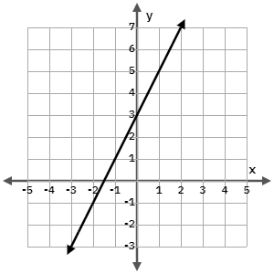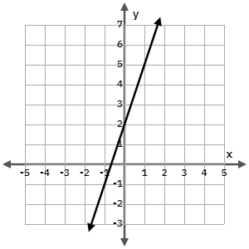
Which graph correctly represents the linear function? Justify your answer.

- Which equation represents the graph of the linear function shown below? Explain your reasoning.
$$y=-3x+3$$ | $$y=x+3$$
$$y=-x+3$$ | $$y=\frac{1}{2}x+3$$

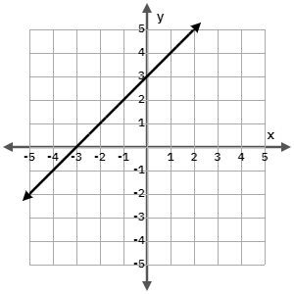

- Graph the linear function: $y=-2x+1$.
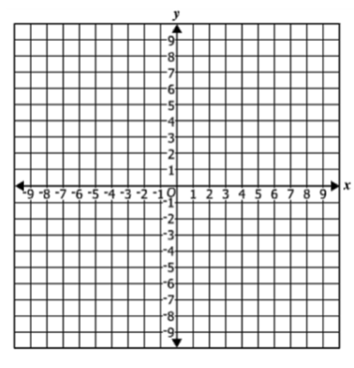
- Plot three points that lie on the line: $y=\frac{2}{3}x-4$.

SOL 8.16d - Just in Time Quick Check Teacher Notes
Common Errors/Misconceptions and their Possible Indications
- Michelle and Christopher graphed the linear function $y=3x+2$ on a coordinate plane.
Michelle’s graph: Christopher’s graph:
Which graph correctly represents the linear function? Justify your answer.
A common error is for students to say that Michelle’s work is correct because they have incorrectly reversed the values for slope and y-intercept. This may indicate that the student does not have a strong conceptual understanding of the slope-intercept form of the equation for a line. This student should revisit the Identifying Slope and y-Intercept card from the VDOE Word Wall Cards: Grade 8. They could also benefit from more exploration with linear functions that are connected to a context to reinforce that the y-intercept is represented by the constant, b, in the equation and the slope is the constant rate of change, m.
- Which equation represents the graph of the linear function shown below? Explain your reasoning.
$$y=-3x+3$$ | $$y=x+3$$
$$y=-x+3$$ | $$y=\frac{1}{2}x+3$$
A common error is for students to define the line using the equation y = x – 3. This indicates that the student is looking at the x-intercept, rather than the y-intercept. This student could benefit from exploring the first four slides of the Desmos activity Match My Picture. These slides allow the student to connect the constant, b, with the y-intercept in a series of lines that all have the same slope, m.
- Graph the line: $y=-2x+1$.
A common error is for students to graph a line with an incorrect slope. Some students will graph the line y = 2x + 1. This indicates one of two things: the student moves in two negative directions (vertical and horizontal) when using a slope triangle to plot other points on the line which, in turn, creates a positive slope. This student may also be applying a rate of change of 2 but has neglected to account for the negative. This student could benefit from exploring the first eight slides of the Desmos activity Match My Line. These slides allow students to practice identifying slope values and allow the student the opportunity to self-monitor their accuracy.
- Plot three points that lie on the line: $y=\frac{2}{3}x-4$.
A common misconception is for students to plot points that would lie on the line $y=\frac{3}{2}x-4$. This may indicate that a student does not understand that slope is a ratio of the change in y over the change in x. This student should revisit the Slope – Definition card from the VDOE Word Wall Cards: Grade 8. This student could benefit from highlighting the label on the y-axis along with the change in y portion of the slope in one color and the label on the x-axis along with the change in x portion in a second color. Then, after recording $m=\frac{change in y}{change in x}$, allow the student to use the highlighted colors to help them to accurately fill in values for the change in y and the change in x.

