Just In Time Quick Check

Standard of Learning (SOL) 8.16a
Strand: Patterns, Functions, and Algebra

Standard of Learning (SOL) 8.16a
The student will recognize and describe the graph of a linear function with a slope that is positive, negative, or zero.

Grade Level Skills:
- Recognize and describe a line with a slope that is positive, negative, or zero (0).
Just in Time Quick Check
Just in Time Quick Check Teacher Notes

Supporting Resources:
- VDOE Mathematics Instructional Plans (MIPS)
  - 8.16ab - Slope and y-intercept (Word) / PDF Version
- VDOE Algebra Readiness Formative Assessments
  - SOL 8.16a (Word) / (PDF)
- VDOE Algebra Readiness Remediation Plans
  - Identifying Slope and Y-intercept (Word) / (PDF)
- VDOE Word Wall Cards: Grade 8 (Word) | (PDF)
  - Slope – Definition
  - Slope
  - Linear Function
- Desmos Activities
  - Linear Hunch
  - Polygraph: Lines
  - Polygraph: Lines, Part 2
Supporting and Prerequisite SOL: 8.13b, 7.10a, 6.1, 6.8b, 6.12a, 6.12b

SOL 8.16a - Just in Time Quick Check
- Select the two graphs that appear to show a line with a slope of zero.
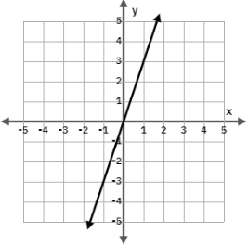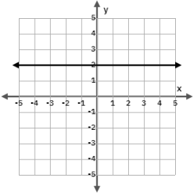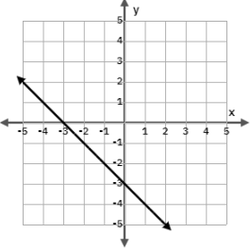
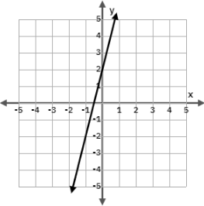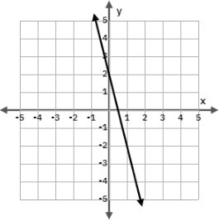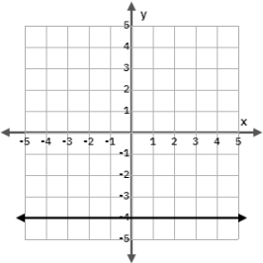
- Mr. Williams asked his students to describe the slope of the line shown.
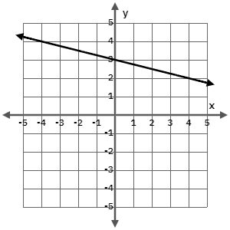
Jesse describes the slope of the line as positive because all of the x-values are positive.
Tia describes the slope of the line as negative because the line is decreasing from left to right.
Do you agree with Jesse or Tia? Explain your thinking.

- Which line (A, B or C) has a negative slope? Explain how you know.
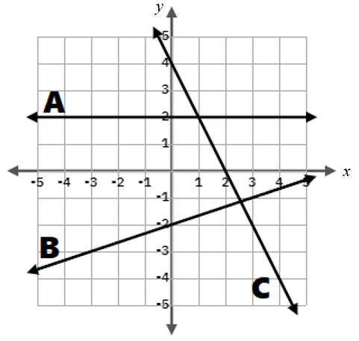

SOL 8.16a - Just in Time Quick Check Teacher Notes
Common Errors/Misconceptions and their Possible Indications
- Select the two graphs that appear to show a line with a slope of zero.
A common error students may make is incorrectly identifying lines with a positive or negative slope as having zero slope. This may indicate that students do not have an understanding of slope as a ratio of the vertical change to the horizontal change of a line and how that can be described as positive, negative, or zero slope. These students may benefit from revisiting the two slope cards in the VDOE Math Word Wall Cards: Grade 8. Students may also benefit from creating a graphic organizer with visuals of lines having positive, negative, or zero slope. Refer to the MIP on Slope and y-intercept for an example of a graphic organizer.
- Mr. Williams asked his students to describe the slope of the line shown.
Jesse describes the slope of the line as positive because all of the y-coordinates are positive.
Tia describes the slope of the line as negative because the line is decreasing from left to right.
Do you agree with Jesse or Tia? Explain your thinking.
A common error students may make is agreeing with Jesse’s reasoning. This may indicate that the student is looking at coordinates of points on the line rather than the slope of the line. Students with this misconception would benefit from extending the given line to see that the y-coordinates are not always positive. Students with this misconception would also benefit from revisiting the definition of slope as the rate of change or “steepness” of the line and describing the slope as the slant of the line (positive – “slants up to the right;” negative – “slants down to the right”). Refer to the slope definition in the VDOE Math Word Wall Cards: Grade 8.
- Which line has a negative slope? Explain how you know.
A common error students may make is to select line B as having a negative slope. This may indicate that the student is looking at the y-intercept instead of the slope. These students should revisit the VDOE Math Word Wall Cards: Grade 8 for Slope – Definition and Slope. They should also practice verbalizing the fact that lines with a negative slope are decreasing because they fall as read from left to right.

