Just In Time Quick Check

Standard of Learning (SOL) 8.15b
Strand: Patterns, Functions, and Algebra

Standard of Learning (SOL) 8.15b
The student will determine the domain and range of a function.

Grade Level Skills:
- Identify the domain and range of a function represented as a set of ordered pairs, a table, or a graph of discrete points.
Just in Time Quick Check
Just in Time Quick Check Teacher Notes

Supporting Resources:
- VDOE Mathematics Instructional Plans (MIPS)
  - 8.15 - Relations and Functions; Domain and Range (Word) / PDF Version
- VDOE Algebra Readiness Formative Assessments
  - SOL 8.15a,b (Word) / (PDF)
- VDOE Algebra Readiness Remediation Plans
  - Relations, Functions, Tables and Graphs (Word) / (PDF)
- VDOE Word Wall Cards: Grade 8 (Word) | (PDF)
  - Domain
  - Range
Supporting and Prerequisite SOL: 8.15a, 7.10b, 7.10d, 7.10e, 6.8b

SOL 8.15b - Just in Time Quick Check

- Sabrina’s teacher asked her to list the range for the function represented in the table below.

x | y
-3 | -7
-1 | -3
0 | -1
2 | 3
4 | 7

What should Sabrina write as the range of this function? Explain.

- What is the domain of the relation shown?

{(-1, 2), (-5, 3), (-1, -4), (0, -6), (4, -2)}

- The following graph shows a relation.
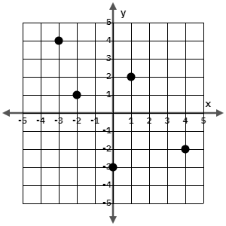
What is the range of the relation?

- Corey graphed a relation that has a domain of {-3, -2, 0, 1, 4}. Use the coordinate plane below to show one possible relation Corey could have graphed.

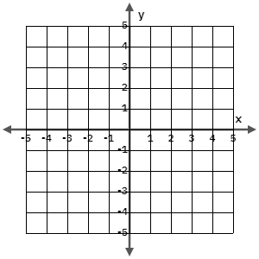

SOL 8.15b - Just in Time Quick Check Teacher Notes
Common Errors/Misconceptions and their Possible Indications
- Sabrina’s teacher asked her to list the range for the function represented in the table below.

x | y
-3 | -7
-1 | -3
0 | -1
2 | 3
4 | 7

What should Sabrina write as the range of this function? Explain.

A common misconception some students make may be to confuse the definitions of domain and range. If students are listing x-values for the range, this might indicate a need to revisit the vocabulary. Refer to the Grade 8 Word Wall Cards for a visual representation of domain and range.
- What is the domain of the relation shown?

{(-1, 2), (-5, 3), (-1, -4), (0, -6), (4, -2)}

A common error a student may make is to list the y-values for the domain instead of the x-values. If a student understands the definition of domain and range, this error may indicate the student does not understand that ordered pairs are written as (x, y). This student may need more experience with writing and interpreting ordered pairs.

- The following graph shows a relation.
What is the range of the relation?

A common error is a student may incorrectly list {-3, -2, 0, 1, 4} as the range. A student may understand the definition of range, but have difficulty identifying and writing ordered pairs for the graphed points. A student may also make this error assuming that the y-axis is vertical and then look to each vertical line to determine the range values. A student may benefit from more experience identifying ordered pairs represented by points. Refer to the Grade 6 Curriculum Framework (see SOL 6.8).

- Corey graphed a relation that has a domain of {-4, -1, 0, 2, 3}. Use the coordinate plane below to show one possible relation Corey could have graphed.
A student may incorrectly graph a relation with a range of {-4, -1, 0, 2, 3}. A student may understand the definition of domain, but have difficulty graphing ordered pairs. The student may benefit from more experience graphing ordered pairs. Refer to the Grade 6 Curriculum Framework (see SOL 6.8).

