Just In Time Quick Check
Standard of Learning (SOL) 8.13c
Strand: Patterns, Functions, and Algebra

Standard of Learning (SOL) 8.13c
The student will use a drawing to estimate the line of best fit for data represented in a scatterplot.

Grade Level Skills:
- Estimate the line of best fit with a drawing for data represented in a scatterplot.
Just in Time Quick Check
Just in Time Quick Check Teacher Notes

Supporting Resources:
- VDOE Mathematics Instructional Plans (MIPS)
  - 8.13c - Scatterplots: Estimating the Line of Best Fit (Word)/(PDF)
- VDOE Word Wall Cards: Grade 8 (Word) | (PDF)
  - Scatterplot
  - Positive Linear Relationship
  - Negative Linear Relationship
  - No Relationship
- Desmos Activity
  - Scatter Plot Capture
Supporting and Prerequisite SOL: 8.13a, 8.13b, 8.16a, 8.16b, 8.16c, 8.16d, 7.9c, 7.10b, 7.10d, 6.8b, 6.10c

SOL 8.13c - Just in Time Quick Check

- Students from an 8th grade math class were asked to draw a line of best fit for the same scatterplot. Three students’ work is displayed below.
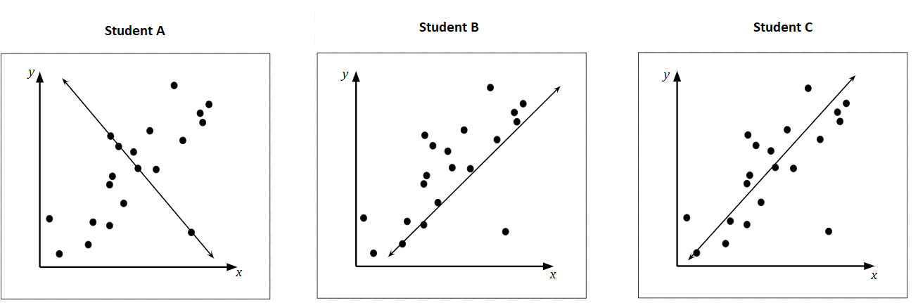
Which student drew the most accurate line of best fit? Explain the error the other two students made.

- The scatterplot shows the relationship between the daily high temperature and the number of cups of lemonade sold over 11 days. Draw a line of best fit to represent the trend in the data.
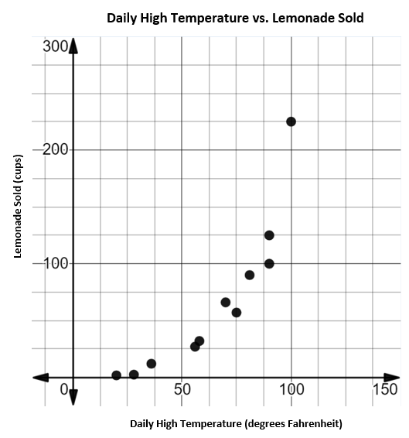

- Jessica created a scatterplot to show the relationship between the time spent exercising and the amount of calories burned. If the trend in this data continues, what is the best estimate for the number of calories burned when a person spends 90 minutes exercising?
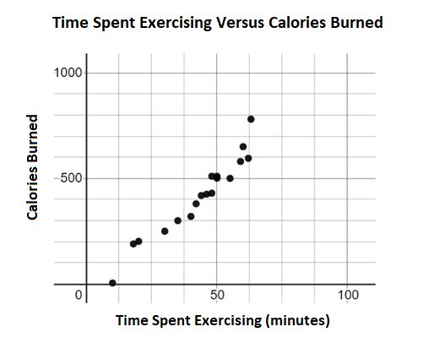

- The scatterplot shows the relationship between the number of student absences and the grade in a student’s math class. Based on the data, what is most likely the number of student absences when that student’s grade is 25%?
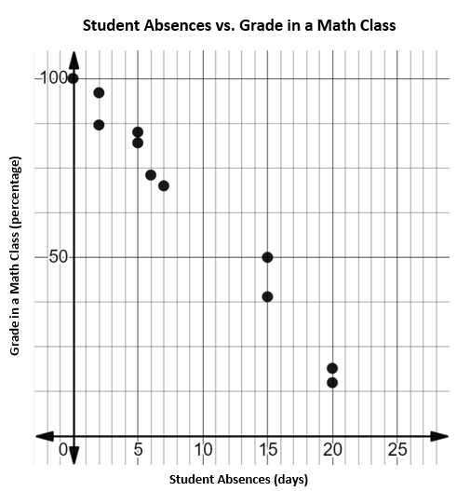

SOL 8.13c - Just in Time Quick Check Teacher Notes
Common Errors/Misconceptions and their Possible Indications
- Students from an 8th grade math class were asked to draw a line of best fit for the same scatterplot. Three students’ work is displayed below.
Which student drew the most accurate line of best fit? Explain the error the other two students made.
A student may incorrectly select Student A. This may indicate that a student does not clearly understand that if the data points show a positive relationship then the line of best fit must show a positive slope. The student may benefit from a discussion about how the slope of a line and the relationship of linear data are similar. Examples of lines with positive and negative slopes can be found in bullet 6 of Understanding the Standard in the Grade 8 Curriculum Framework.
A student may incorrectly select Student B. This may indicate a student does not understand that a line of best fit should be drawn as best as possible to split the data into equal number of points below and above the line of best fit. Students who make this error may benefit from the strategy of drawing an oval shape around the entire set of data points. Then, drawing a line through the middle of the oval. This may help the student to draw a line of best fit that accurately displays the trend in data and shows half of the data above and below the line drawn.

2. The scatterplot shows the relationship between the daily high temperature and the number of cups of lemonade sold over 11 days. Draw a line of best fit to represent the trend in the data.

A common student error is to draw a line of best fit that passes through the origin despite the position of the data points. This may indicate that a student believes the line of best fit must represent a proportional relationship. Another common error a student may make is to draw a line of best fit that passes through the first point and last point shown on the scatterplot. This may indicate that a student believes that a line of best fit must always pass through at least two points shown on the scatterplot. Students may benefit from additional practice drawing lines of best fit for a set of data using the scatterplots examples in the VDOE Mathematics Instructional Plans - 8.13c - Scatterplots: Estimating the Line of Best Fit. An additional resource is the NCTM Illuminations – Line of Best Fit. This application allows students to create scatterplots, analyze data and add a line of best fit.

3. Jessica created a scatterplot to show the relationship between the time spent exercising and the amount of calories burned. If the trend in this data continues, what is the best estimate for the number of calories burned when a person spends 90 minutes exercising?
A common error a student may make is use the given value of 90 as a y-value and stating the answer in the range of 10-14 instead of around 800. This may indicate that a student is reading the graph as calories burned as the independent variable and time spent exercising as the dependent variable. Students may benefit from drawing a line of best fit for the scatterplot and finding the x-coordinate. From this point, the student may draw a line to the corresponding y-coordinate. A student may also benefit from practice identifying what the points in the scatterplot represent. For example, ask a student to write a sentence about what the point (50, 500) represents.

4. The scatterplot shows the relationship between the number of student absences and the grade in a student’s math class. Based on the data, what is most likely the number of student absences when that student’s grade is 25%?

A common error a student may make is use the given value of 25% as an x-value and stating the answer in the range of 5-10 instead of a range of 16-18. This may indicate that a student believes the given value of 25% represents the independent variable. A student may benefit from identifying the independent and dependent variables in a real world context and writing a statement about the relationship. Using the statement, a student can determine if their answer is reasonable. Another strategy is to draw a line of best fit and find the specified value on the line and drawing a point. The student may identify the coordinates of the point and predict an outcome.

