Just In Time Quick Check
Standard of Learning (SOL) 8.13b
Strand: Patterns, Functions, and Algebra

Standard of Learning (SOL) 8.13b
The student will make observations about data represented in scatterplots.

Grade Level Skills:
- Make observations about a set of data points in a scatterplot as having a positive linear relationship, a negative linear relationship, or no relationship.
Just in Time Quick Check
Just in Time Quick Check Teacher Notes

Supporting Resources:
- VDOE Mathematics Instructional Plans (MIPS)
  - 8.13ab - Constructing and Analyzing Scatterplots (Word)/(PDF)
- VDOE Algebra Readiness Remediation Plans
  - Analyzing Graphs (Word)/(PDF)
  - Data Organizers (Word)/(PDF)
  - Interpreting Graphs (Word)/(PDF)
  - Scatterplots (Word)/(PDF)
- VDOE Word Wall Cards: Grade 8 (Word) | (PDF)
  - Scatterplot
  - Positive Linear Relationship
  - Negative Linear Relationship
  - No Relationship
- VDOE Desmos Activity
  - Polygraph: Scatter Plots
Supporting and Prerequisite SOL: 8.13a, 8.16a, 7.9b, 6.8b, 6.10b

SOL 8.13b - Just in Time Quick Check

- What type of correlation is shown in each scatterplot? Explain your answer by describing the pattern of points in each graph.

Scatterplot 1:

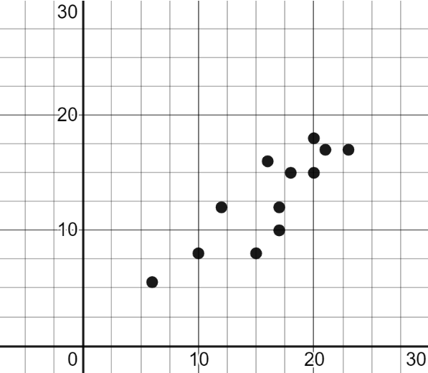

Scatterplot 2:

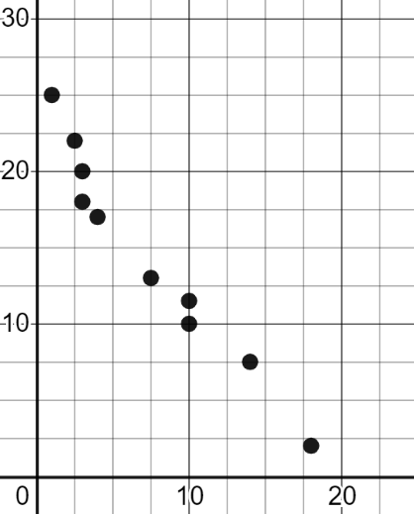

2. Cameron drove his car on a road trip. The scatterplot shows the relationship between the distance traveled and gas used during Cameron’s road trip.
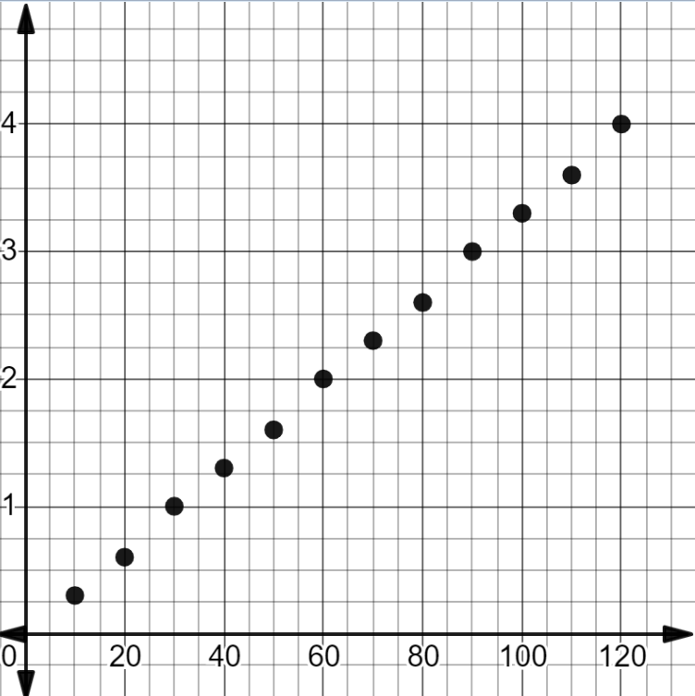
Distance Traveled vs. Gas Used
Distance Traveled (miles)
Gas Used (gallons)

Which statement is true regarding the type of correlation shown in this scatterplot?

The correlation is positive because the pattern of points rises from lower left to upper right.

The correlation is negative because the pattern of points falls from upper left to lower right.

3. The scatterplot shows the relationship between the test scores of nine students and their height.
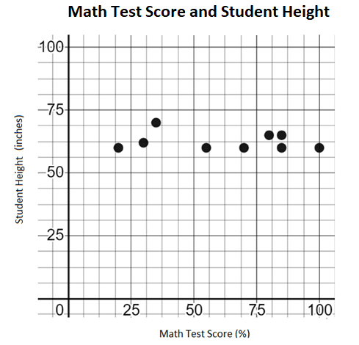

- Write a statement describing the relationship between a student’s math test score and student height.

- Jeremy stated that he will score 75% on his math test because he is 50 inches tall. Can Jeremy’s statement be justified using the data presented in the graph? Explain your answer.

4. A scatterplot shows the relationship between the distance traveled and the amount of gas remaining in the tank of a car.
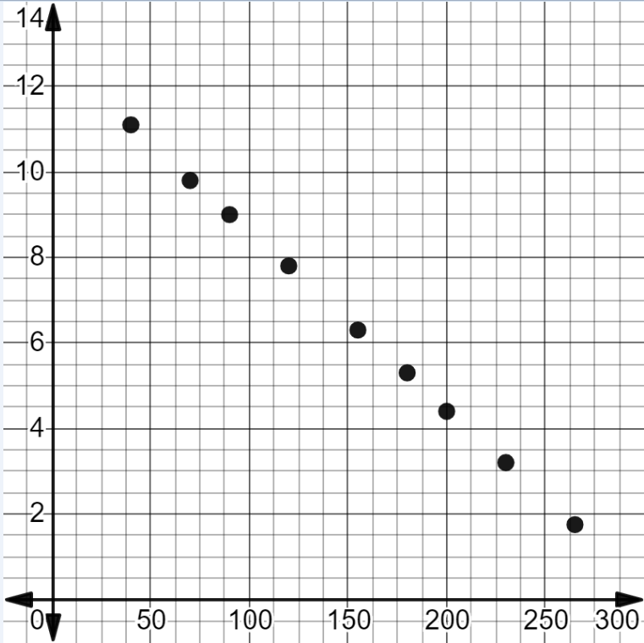
Distance Traveled vs. Gas Remaining
Distance Traveled (miles)
Gas Remaining (gallons)

Complete the statement that describes the relationship between the distance traveled and gas remaining in the tank of a car. As the gas remaining in the tank of the car decreases –
Explain your answer.

SOL 8.13b - Just in Time Quick Check Teacher Notes
Common Errors/Misconceptions and their Possible Indications
- What type of correlation is shown in each scatterplot? Explain your answer by describing the pattern of points in each graph.

Scatterplot 1:

Scatterplot 2:

A common student error is stating that the linear relationship is positive when it is negative and vice versa. This may indicate a student does not understand that a scatterplot is read from left to right. In addition, a student may not understand if the pattern of points slopes from lower left to upper right, it indicates a positive linear relationship and if the pattern of points slopes from upper left to lower right, it indicates a negative linear relationship. The student may benefit from visual examples of patterns of points in scatterplots found in the Grade 8 Math Word Wall Cards as well as bullet 5 of Understanding the Standard (8.13) in the Grade 8 Curriculum Framework.

2. Cameron drove his car on a road trip. The scatterplot shows the relationship between the distance traveled and gas used during Cameron’s road trip.
Distance Traveled vs. Gas Used
Distance Traveled (miles)
Gas Used (gallons)

Which statement is true regarding the type of correlation?

The correlation is positive because the pattern of points rises from lower left to upper right.

The correlation is negative because the pattern of points falls from upper left to lower right.
A common error is that a student may select the second choice because they are reading the graph from right to left. This error may indicate a student does not understand that the pattern of points in a scatterplot are read from left to right. A student may benefit from additional practice describing the linear relationships in scatterplots and comparing the patterns to the slope of a linear function.

3. The scatterplot shows the relationship between the test scores of nine students and their height.

- Write a statement describing the relationship between a student’s math test score and student height.

A common error is a student may write the statement, “Math test scores and student height change together.” This may indicate a student has difficulty making observations about a scatterplot with no linear relationship. A student may benefit from creating additional scatterplots that have no linear relationship such as, a student’s shoe size and the number of text messages sent in a day. Students may benefit from looking for relationships in scatterplots from real world scenarios displaying all types of linear relationships using Desmos software.
- Jeremy stated that he will score 75% on his math test because he is 50 inches tall. Can Jeremy’s statement be justified using the data presented in the graph? Explain your answer.
A common student error is stating that Jeremy will not score a 75% because it does not follow the pattern of the data values. This indicates that a student may not understand that there is no relationship between the score on a test and a person’s height. A student may benefit from additional practice interpreting data displayed in a scatterplot. Refer to VDOE Algebra Readiness Plans -Scatterplots for scenarios.

4. A scatterplot shows the relationship between the distance traveled and the amount of gas remaining in the tank of a car.
Distance Traveled vs. Gas Remaining
Distance Traveled (miles)
Gas Remaining (gallons)

Complete the statement that describes the relationship between the distance traveled and gas remaining in the tank of a car. As the gas remaining in the tank of the car decreases –
Explain your answer.

A student may state as the amount of gas remaining in the tank of a car decreases, the distance traveled decreases. This may indicate a student thinks that in a negative linear relationship both data values are decreasing instead of one value decreasing as the other value increases. A student may benefit from additional practice analyzing statements about the trend in the data displayed in a scatterplot. In addition, a student might benefit from analyzing the trends in scatterplots using Desmos-Polygraph: Scatter Plots.

