Just In Time Quick Check
Standard of Learning (SOL) 8.13a
Strand: Patterns, Functions, and Algebra

Standard of Learning (SOL) 8.13a
The student will represent data in scatterplots.

Grade Level Skills:
- Collect, organize, and represent a data set of no more than 20 items using scatterplots.
Just in Time Quick Check
Just in Time Quick Check Teacher Notes

Supporting Resources:
- VDOE Mathematics Instructional Plans (MIPS)
  - 8.13ab - Constructing and Analyzing Scatterplots (Word)/(PDF)
- VDOE Algebra Readiness Remediation Plans
  - Data Organizers (Word)/(PDF)
  - Graph Match (Word)/(PDF)
  - Interpreting Graphs (Word)/(PDF)
  - Mystery Data (Word)/(PDF)
  - Scatterplots (Word)/(PDF)
- VDOE Word Wall Cards: Grade 8 (Word) | (PDF)
  - Scatterplot
Supporting and Prerequisite SOL: 8.16a, 7.9a, 6.8b, 6.10a

SOL 8.13a - Just in Time Quick Check

- Jacob collected data on the age versus value of a car. These data are displayed in the table below.
Age (years) | 1 | 2 | 3 | 4 | 5 | 6 | 7 | 8 | 9 | 10 | 11
Value  (thousands) | 18 | 16.5 | 14 | 12 | 10 | 8 | 6 | 5 | 4 | 2 | 1.5

Jacob created a scatterplot to represent these data and made a mistake. Describe the mistake that Jacob made.
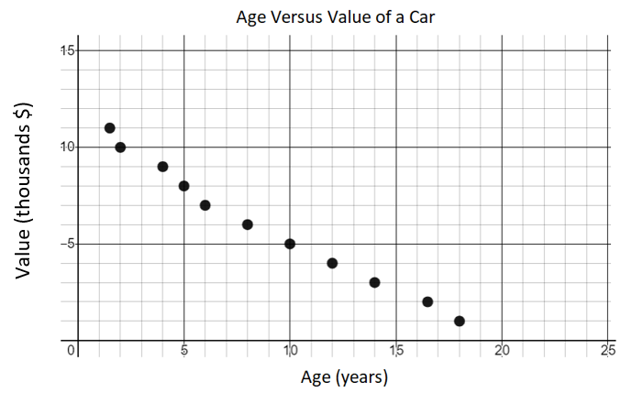

- Students at a middle school were surveyed. The survey asked students how many hours they watch television per week, x, and the number of hours they sleep each night, y. These data are displayed in the table.
Watch Television  (hours per week) | 1 | 3 | 10 | 15 | 7 | 12 | 2 | 3 | 6 | 2 | 3 | 20 | 9 | 4 | 3 | 11 | 4.5
Sleep  (hours per night) | 10 | 12 | 3 | 2 | 5 | 5 | 9 | 8 | 5.5 | 10 | 9 | 2 | 3 | 8 | 7.5 | 5.5 | 8

Create a scatterplot to represent the data. Include a title, labels for each axis, and all data points recorded in the table.

- The scatterplot shows the number of hours classmates spent studying and the final grade on their test. The data is displayed in the scatterplot.

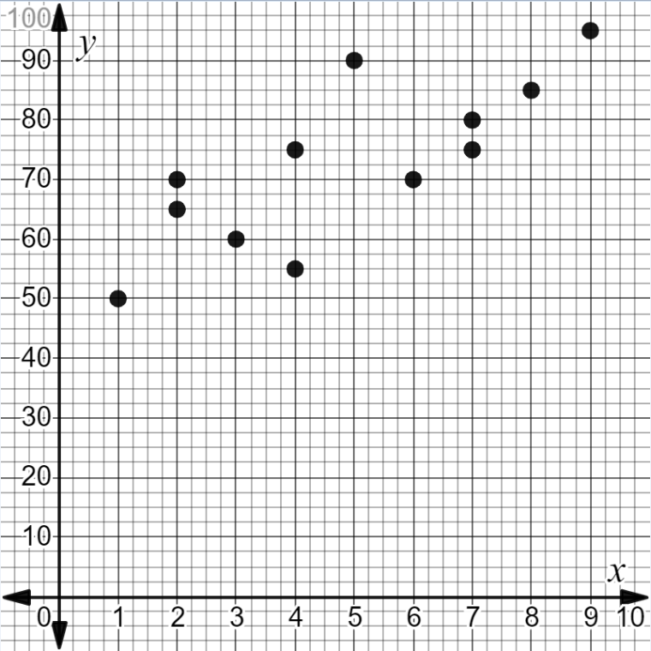

- Place a title on the scatterplot.
- Place labels on the x and y-axis to include the units.
- Create a table to represent the data displayed in the scatterplot. Place row headings for the independent and dependent variables in the table.

SOL 8.13a - Just in Time Quick Check Teacher Notes

Common Errors/Misconceptions and their Possible Indications
1. Jacob collected data on the age versus value of a car. These data are displayed in the table below.
Age (years) | 1 | 2 | 3 | 4 | 5 | 6 | 7 | 8 | 9 | 10 | 11
Value  (thousands) | 18 | 16.5 | 14 | 12 | 10 | 8 | 6 | 5 | 4 | 2 | 1.5

Jacob created a scatterplot to represent these data and made a mistake. Describe the mistake that Jacob made.
A common misconception is a student might state that the titles on the x and y axis are reversed and may not identify that the values are plotted incorrectly. This error may indicate that a student does not understand that x-values are graphed on the horizontal axis and y-values are graphed on the vertical axis. A student might benefit from graphing values on a coordinate plane from ordered pairs and from a table of values. (Refer to 6.8b Math 6 Curriculum Framework and Desmos: The (Awesome) Coordinate Plane Activity for examples) Another resource is Algebra Readiness Remediation Plan – Data Representation and Interpretation (use the cards on pages three through seven).

2. Students at a middle school were surveyed. The survey asked students how many hours they watch television per week, x, and the number of hours they sleep each night, y. These data are displayed in the table.
Television watched  (hours per week) | 1 | 3 | 10 | 15 | 7 | 12 | 2 | 3 | 6 | 2 | 3 | 20 | 9 | 4 | 3 | 11 | 4.5
Sleep  (hours per night) | 10 | 12 | 3 | 2 | 5 | 5 | 9 | 8 | 5.5 | 10 | 9 | 2 | 3 | 8 | 7.5 | 5.5 | 8
Create a scatterplot to represent these data. Include a title, labels for each axis, and all data points recorded in the table.

A common misconception is that a student may use inconsistent increments when numbering the axes. This may indicate that a student has difficulty creating appropriate increments on an axis to match the data represented in a table. A student may benefit from a guided lesson on creating scatterplots which can be found in the Grade 8 Math Instructional Plan-8.13ab - Constructing and Analyzing Scatterplots.

3. The scatterplot shows the number of hours classmates spent studying and their final grade on a test. The data is displayed in the scatterplot.

- Place a title on the scatterplot.
- Place labels on the x and y-axis to include the units.
- Create a table to represent the data displayed in the scatterplot. Place row headings for the independent and dependent variables in the table.

- A possible common error is that a student may create a title that does not summarize the data displayed in the scatterplot. This error indicates a student may not understand the importance of titles and labels on graphs. A student may benefit from practice graphing and labeling scatterplots from raw data or a table of values.
- A possible common error is that a student may label the horizontal axis as final grade and the vertical axis as time spent studying. This error may indicate that a student does not understand what the points on the scatterplot represent. A student may benefit from practice graphing and labeling scatterplots from raw data or a table of values.
- A possible common error is that a student may incorrectly record some of the data points from the scatterplot in the table. This may indicate that a student has difficulty interpreting, in this case, a scale of 2.5 on the y-axis. In addition, a student may record time spent studying (x) in the y row and final grade on a test (y) in the x row of the table. This error may indicate that a student does not fully understand that the coordinates of a data point are written in the form $(x,y)$. Students may benefit from additional practice recording the coordinates of a point from a graph into a table of values by completing the Grade 6 Desmos Activity: Battle Boats

