Just In Time Quick Check
Standard of Learning (SOL) 8.12c
Strand: Patterns, Functions, and Algebra

Standard of Learning (SOL) 8.12c
The student will compare and analyze two data sets using boxplots.

Grade Level Skills:
- Compare and analyze two data sets represented in boxplots.
Just in Time Quick Check
Just in Time Quick Check Teacher Notes

Supporting Resources:
- VDOE Mathematics Instructional Plans (MIPS)
  - 8.12 - Representing Data Using Boxplots (Word) / PDF Version
- VDOE Word Wall Cards: Grade 8 (Word) | (PDF)
  - Boxplots
  - Comparing Boxplots
Supporting and Prerequisite SOL: 8.12a, 8.12b, 7.9c, 6.6a, 6.10c

SOL 8.12c - Just in Time Quick Check

- These boxplots summarize the test scores for two students in a math class.

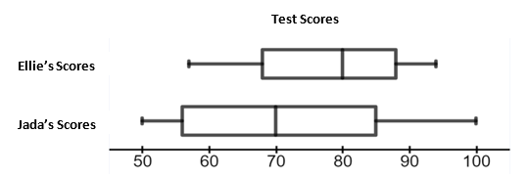

Which student had a greater number of test scores of 80% or higher? Explain your reasoning.

- These boxplots summarize the number of text messages received per day for Marla and Darren. These data were collected for fifteen days.
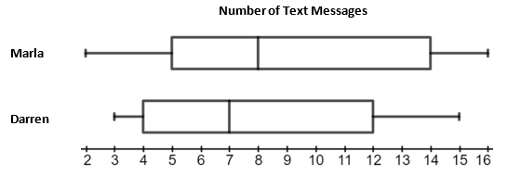
What is closest to the difference in the interquartile range for Marla and the interquartile range for Darren?

- These boxplots summarize the average yearly salary, in thousands, of a mechanic working in Mississippi and Nebraska in 2020.
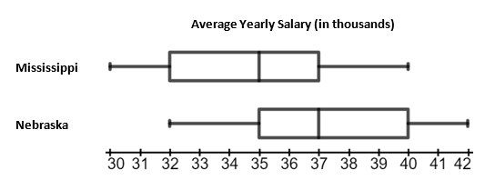

Determine which of the following statements are true.
The interquartile range of salaries for a mechanic in Mississippi is the same as the interquartile range of salaries for a mechanic in Nebraska. | The range of salaries for a mechanic in Nebraska is greater than range of salaries for a mechanic in Mississippi.
The approximate percentage of salaries for mechanics in Mississippi that fall between $35,000 and $40,000 is less than the approximate percentage of salaries for mechanics in Nebraska that fall between $35,000 and $40,000. | The median salary for a mechanic in Nebraska is the same as the salary representing the upper quartile for a mechanic in Mississippi.

- These boxplots summarize the heights, in inches, of boys and girls at a high school.
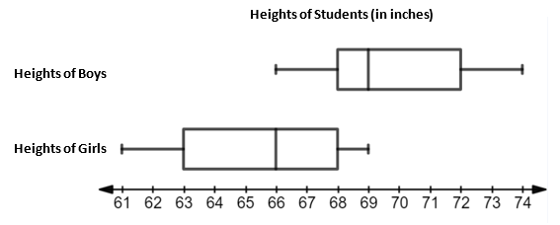

Circle each true statement.
Statement 1: The height of the tallest boy is 5 inches more than the height of the tallest girl.
Statement 2: Approximately fifty percent of the girls are between 61 and 68 inches tall.
Statement 3: The median height of a boy is 3 inches more than the median height of a girl.
Statement 4: The interquartile range of the boys’ height is more than the interquartile range of the girls’ height.

SOL 8.12c - Just in Time Quick Check Teacher Notes
Common Errors/Misconceptions and their Possible Indications
- These boxplots summarize the test scores for two students in a math class.

Which student had a greater number of test scores of 80% or higher on their tests? Explain your reasoning.
A student may not understand that a larger percentage of the data lies above 80% in the boxplot representing Ellie’s scores. This indicates that the student does not understand that each quartile of the boxplot represents approximately 25% of the data. Students may benefit from additional practice in identifying the percentage of data represented by each section of the boxplot. (See 8.12a Quick Check.)
2. These boxplots summarize the number of text messages received per day by Marla and Darren. These data were collected for fifteen days.

What is the difference in the interquartile ranges for Marla and Darren?

A common student error is using the values for the upper and lower extreme to calculate the interquartile range for each boxplot and find the difference resulting in an answer of 2. This indicates a misunderstanding in the location of the lower and upper quartile and the lower and upper extremes of a boxplot. A student may benefit from a visual representation of interquartile range by referring to the Grade 8 Word Wall Cards. A student may also benefit from a description of how to calculate the range by viewing the Grade 5 Word Wall Cards.

3. These boxplots summarize the average yearly salary, in thousands, of a mechanic working in Mississippi and Nebraska in 2020.
Determine which of the following statements are true.
The interquartile range of salaries for a mechanic in Mississippi is the same as the interquartile range of salaries for a mechanic in Nebraska. | The range of salaries for a mechanic in Nebraska is greater than range of salaries for a mechanic in Mississippi.
The approximate percentage of salaries for mechanics in Mississippi that fall between $35,000 and $40,000 is less than the approximate percentage of salaries for mechanics in Nebraska that fall between $35,000 and $40,000. | The median salary for a mechanic in Nebraska is the same as the salary representing the upper quartile for a mechanic in Mississippi.
A common error a student may make is to think the interquartile range of salaries for a mechanic is greater in Nebraska. This might indicate that a student believes the higher values contained in the interquartile range in Nebraska must indicate the range is higher. A student may benefit from a visual representation of interquartile range by referring to the Grade 8 Word Wall Cards.
A common error a student may make is to think the range of salaries is greater in Nebraska. This might indicate that a student believes the boxplot with the greater upper extreme must have a greater range of salaries. A student may benefit from a visual representation of interquartile range by referring to the Grade 8 Word Wall Cards.
A common error a student may make is to think the approximate percentage of salaries that fall between $35,000 and $40,000 is less than the approximate percentage of salaries in Nebraska that fall between $35,000 and $40,000. This might indicate that a student has difficulty understanding that each section of a boxplot represents approximately 25% of the data. Students may benefit from additional practice in identifying the approximate percentage of data represented by each section of the boxplot. (Refer to 8.12b Quick Check.)
A common error a student may make is to assume that the value representing the upper quartile salary for mechanics in Mississippi is larger than the value representing the median salary for mechanics in Nebraska. This may indicate that students assume that since the approximate percentage of data included in a boxplot from the minimum to the upper quartile is larger than approximate percentage of data included in the boxplot from the minimum to the median, that the values representing those critical endpoints (median and upper quartile) cannot be equal. A student may benefit from a visual representation of each critical point of a boxplot by referring to the Grade 8 Word Wall Cards.

4. These boxplots summarize the heights, in inches, of boys and girls at a high school.
Circle each true statement.
Statement 1: The height of the tallest boy is 5 inches more than the tallest girl.
Statement 2: Approximately fifty percent of the girls are between 61 and 68 inches tall.
Statement 3: The median height of a boy is 3 inches more than the median height of a girl.
Statement 4: The interquartile range of the boys’ height is more than the interquartile range of the girls’ height.
A common error is a student may state that approximately fifty percent of the girls are between 61 and 68 inches tall. This may indicate that a student does not understand that each quartile represents approximately 25% of the data. Students may benefit from additional practice in identifying the approximate percentage of data represented by each section of the boxplot.
Another common error a student may make is to calculate the range of each boxplot rather than the interquartile range. This may indicate that the student does not understand that the interquartile range is represented by the difference between the upper quartile and the lower quartile. A student may benefit from a graphical representation of each critical point of a boxplot by referring to the Grade 8 Word Wall Cards. A student may also benefit from bullet 6 of Understanding the Standard (SOL 8.12) in the Grade 8 Mathematics Curriculum Framework, where an example is provided for calculating the interquartile range.

