Just In Time Quick Check
Standard of Learning (SOL) 8.12b
Strand: Patterns, Functions, and Algebra

Standard of Learning (SOL) 8.12b
The student will make observations and inferences about data represented in boxplots.

Grade Level Skills:
- Make observations and inferences about data represented in a boxplot.
- Given a data set represented in a boxplot, identify and describe the lower extreme (minimum), upper extreme (maximum), median, upper quartile, lower quartile, range, and interquartile range.
Just in Time Quick Check
Just in Time Quick Check Teacher Notes

Supporting Resources:
- VDOE Mathematics Instructional Plans (MIPS)
  - 8.12 - Representing Data Using Boxplots (Word) / PDF Version
- VDOE Word Wall Cards: Grade 8 (Word) | (PDF)
  - Boxplots
- Desmos Activity
  - Polygraph: Box Plots
Supporting and Prerequisite SOL: 8.12a, 7.9b, 6.6a, 6.10b, 6.11b

SOL 8.12b - Just in Time Quick Check

- The number of pages Suzy read each day for a month was recorded and summarized in a boxplot.
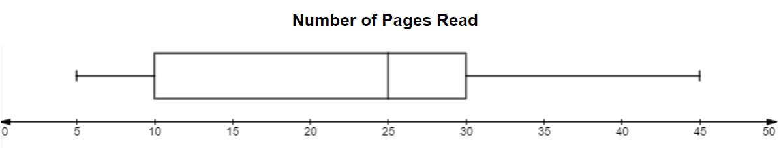
Based on this boxplot, what are the values for the maximum, minimum, interquartile range, and median?
- The number of people standing in line for an amusement park ride were recorded at various times during one day. The data is summarized in the boxplot shown. Mrs. Taylor asked the students to make an observation about the data displayed in the boxplot.

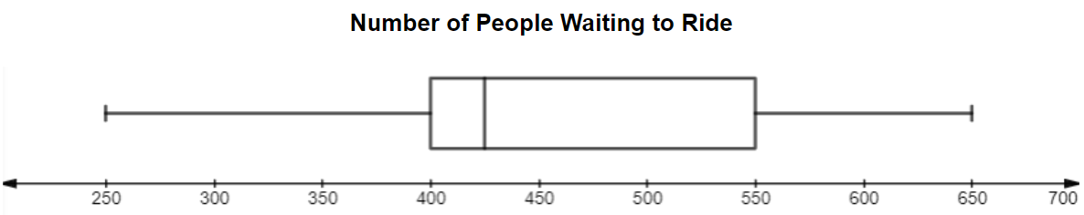

  - Jelena wrote: The right whisker represents 50% of the data collected.
  - Danielle wrote: The box represents 100% of the data collected.
  - Maria wrote: The left whisker represents 25% of the data collected.
Which student wrote a true statement? Explain your reasoning.

- The boxplot shows the number of videos rented by twenty people in one year.
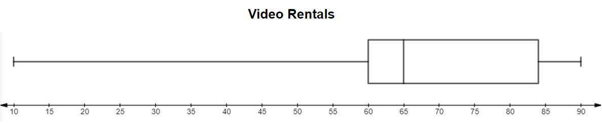

Approximately what percent of people rented fewer than 60 videos? Explain your answer.

- The grades a student earned were displayed in a boxplot.

Grades | 55 | 64 | 83 | 92 | 100 | 75 | 86 | 95 | 80 | 98
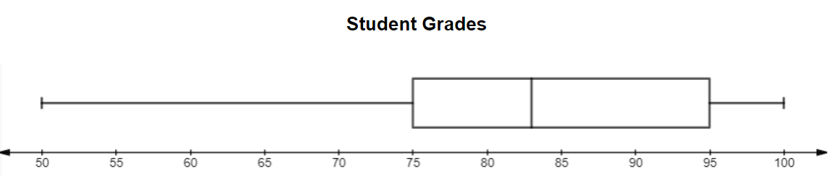
The middle 50% of the data falls between which two grades?
- The Augusta City Chamber of Commerce computed the average dinner price for two at several area restaurants.
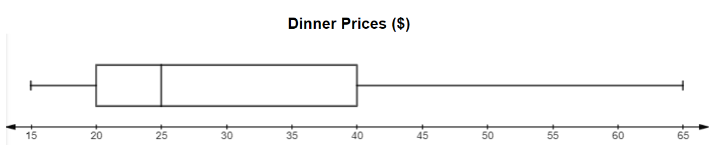
Approximately what percent of the average dinner prices are between $15 and $40? Explain your answer.

- The number of runs scored in several baseball games was displayed in the boxplot.
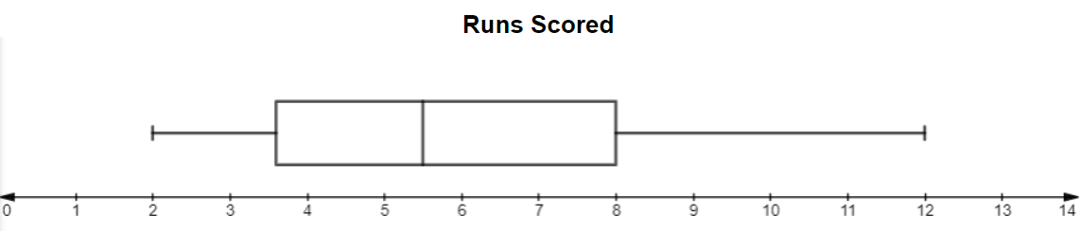

Both the left and right whisker of the boxplot shown each represent approximately 25% of the data. Explain why the left whisker is shorter in length than the right whisker.

SOL 8.12b - Just in Time Quick Check Teacher Notes
Common Errors/Misconceptions and their Possible Indications

- The number of pages Suzy read each day for a month was recorded and summarized in a boxplot.
Based on this boxplot, what are the values for the maximum, minimum, interquartile range, and median?
A common student error is stating that the value of the interquartile range is forty. This indicates a misunderstanding in the difference between range and interquartile range. A student may benefit from a visual representation of interquartile range by referring to the Grade 8 Word Wall Cards. A student may also benefit from a description of how to calculate the range by viewing the Grade 5 Word Wall Cards.
- The number of people standing in line for an amusement park ride were recorded at various times during one day. The data is summarized in the boxplot shown. Mrs. Taylor asked the students to make an observation about the data displayed in the boxplot.

  - Jelena wrote: The right whisker represents 50% of the data collected.
  - Danielle wrote: The box represents 100% of the data collected.
  - Maria wrote: The left whisker represents 25% of the data collected.
Which student wrote a true statement? Explain your reasoning.
A common misconception is that a student may interpret that longer sections of the boxplot contain more data and select Jelena’s statement. Another error is a student may think the box has most of the data values. Both of these errors indicate a student does not understand that each quartile of the boxplot represents 25% of the data. Students may benefit from additional practice identifying the percentage of data represented by each section of the boxplot using the number of data values in each quartile. Refer to the Grade 8 Mathematics Curriculum Framework, 8.12 Understanding the Standard, for more visual examples of boxplots.

- The boxplot shows the number of videos rented by twenty people in one year.

Approximately what percent of people rented fewer than 60 videos? Explain your answer.
A common misconception is that students may see the length of the left whisker and assume that it represents more movie rentals. This indicates the student does not understand that each quartile represents only 25% of the data. The student does not understand the length indicates how spread out the data values are and not how many there are. Students may benefit from additional practice in creating boxplots. For more visual examples of boxplots, refer to the Grade 8 Mathematics Curriculum Framework, 8.12 Understanding the Standard.

- The grades a student earned were displayed in a boxplot.

Grades | 55 | 64 | 83 | 92 | 100 | 75 | 86 | 95 | 80 | 98
The middle 50% of the data falls between which two grades?
Student may incorrectly say 50-83 because this range is about half of the range of the data. A student may also select between 100-75 because these are the middle values in the table. These errors indicate the student may not understand that the middle 50% of the data represents the “box” or interquartile range of the boxplot. Students may benefit from additional practice identifying the key statistical measures and their location on the boxplot. Refer to the VDOE Mathematics Instructional Plan-8.12 - Representing Data Using Boxplots or Quick Check 8.12a for additional practice creating boxplots.

- The Augusta City Chamber of Commerce computed the average dinner price for two at several area restaurants.
Approximately what percent of the average dinner prices are between $15 and $40? Explain your answer.
A student may incorrectly state that the percentage is 25% because they subtracted fifteen from forty. Another error is a student may say 50% because the difference of twenty-five is half of the range for the boxplot. Both errors indicate that students don’t understand this range represents 3 quartiles or 75% of the data. See teacher notes from questions three and four for strategies to help students with these misconceptions.
- The number of runs scored in several baseball games was displayed in the boxplot.

Both the left and right whisker of the boxplot shown each represent approximately 25% of the data. Explain why the left whisker is shorter in length than the right whisker.
A student might say that the difference between 2 and $3\frac{1}{2}$ is $1\frac{1}{2}$ (as opposed to $12-8=4$) and that is why the left whisker is smaller than the right whisker. This misconception indicates the student does not understand that there are approximately 25% of the data values in each quartile. The student may benefit from additional practice creating boxplots to help them understand that the number of data values in each quartile is approximately the same.

