Just In Time Quick Check
Standard of Learning (SOL) 8.12a

Strand: Probability and Statistics

Standard of Learning (SOL) 8.12a
The student will represent numerical data in boxplots.

Grade Level Skills:
- Collect and display a numeric data set of no more than 20 items, using boxplots.
Just in Time Quick Check
Just in Time Quick Check Teacher Notes

Supporting Resources:
- VDOE Mathematics Instructional Plans (MIPS)
  - 8.12 - Representing Data Using Boxplots (Word) / PDF Version
- VDOE Word Wall Cards: Grade 8 (Word) | (PDF)
  - Boxplots
- Other VDOE Resources:
  - Boxplots Against All Odds: Unit 5 (eMedia)
  - Constructing a Box and Whisker Plot (eMedia)
Supporting and Prerequisite SOL: 7.9a, 6.3b, 6.10a

SOL 8.12a - Just in Time Quick Check

- Gabe recorded the number of pages that he read in a book each night. The data for eleven nights is shown below.
14, 4, 9, 18, 7, 2, 16, 13, 6, 11, 5
Compute the five-number summary that represents this set of data.
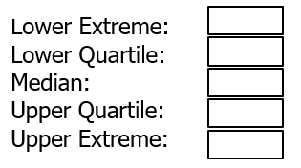
- The following set of data was displayed in the classroom.
5, 9, 8, 6, 11, 10, 13, 6, 2
- Amelia stated the median was 11.
- Darrell stated the median was 8.
Who is correct? Explain the mistake made by the other student.
- Jada rode her bike for eight days. She listed the number of miles she rode her bike each day.
10, 9, 2, 3, 13, 5, 7, 8
Create and label a boxplot to represent this set of data.

- The data set represents the number of minutes Ben walked each day for twelve days.
25, 68, 10, 27, 80, 42, 36, 20, 26, 38, 42, 26
Ben created a boxplot to display this data.
Number of Minutes Walked
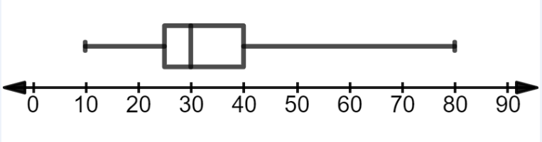
Did Ben correctly display the data set in the boxplot? Justify your answer.

SOL 8.12a - Just in Time Quick Check Teacher Notes
Common Errors/Misconceptions and their Possible Indications
- Gabe recorded the number of pages that he read in a book each night. The data is for eleven days as shown below.
14, 4, 9, 12, 7, 2, 16, 13, 6, 11, 5
Compute the five-number summary that represents this set of data.
A common mistake is that students forget to place the data values in order prior to calculating the 5 number summary. A student may determine that the median is two if the values are not placed in order from least to greatest. This error would indicate that a student does not understand the median is the middle value of a data set in ranked order. Refer to the Grade 6 Curriculum Framework (SOL 6.11 bullet seven) for an example. An additional example can be found in the Grade 6 Word Wall Cards.

Another common misconception is not determining the correct values for either the lower or upper quartile when there is an odd number of values in the data set. This type of error would indicate that the student is most likely including the median of the data set when determining the upper and lower quartile. A student may benefit from additional examples of calculating the lower and upper quartiles with an odd number of values in the data set. Refer to bullet seven, Understanding the Standard for SOL 8.12 in the Grade 8 Curriculum Framework.
- The following set of data was displayed in the classroom.
5, 9, 8, 6, 11, 10, 13, 6, 2
- Amelia stated the median was 11.
- Darrell stated the median was 8.
Who is correct? Explain the mistake made by the other student.
A common mistake is that students forget to place the data values in order prior to calculating the median. This error indicates a student does not understand data must be in ranked order prior to finding the median for a set of data. A student may benefit from practice calculating the median separate from boxplots. Refer to the Mathematics Instructional Plan - 6.11b - Effects on Measures of Center for additional practice.
- Jada rode her bike for eight days. She listed the number of miles she rode her bike each day.
10, 9, 25, 18, 13, 27, 16, 12
Create and label a boxplot to represent the data shown above.
A common mistake is that a student may not correctly label the five summary points in the boxplot which may indicate they do not understand the different parts of the graph. Another mistake is that the student may not correctly draw the parts of the boxplot, specifically the whiskers and the interquartile range. Refer to the Grade 8 Word Wall Cards for an example.

A student may not correctly calculate the median. This may indicate a misunderstanding that the median is the middle value of a data set in ranked order. If given an odd number of pieces of data, the median is the middle value in ranked order. If there is an even number of pieces of data, the median is the arithmetic average of the two middle values. Refer to SOL 5.17, bullet seven of Understanding the Standard in the Grade 5 Curriculum Framework and the Grade 6 Word Wall Cards for additional examples.

In addition, students may struggle with trying to determine an appropriate scale on the number line or simply write the numbers from the data set in consecutive order below the number line. Refer to the Grade 6 Mathematics Instructional Plan - 6.3b - Compare and Order Integers for additional practice on ordering integers on a number line.

- The data set represents the number of minutes Ben walked each day for twelve days.
25, 68, 10, 27, 80, 42, 36, 20, 26, 38, 42, 26
Ben created a boxplot to display this data.

Number of Minutes Walked
Did Ben correctly display the data set in the boxplot? Justify your answer.

A student may only consider the lower and upper extreme of the data set and determine that the boxplot correctly represents the data set. This indicates that the student does not understand that all 5 of the critical points must be accurately represented. The student may benefit from listing each of the five critical points prior to evaluating the accuracy of the boxplot.

Another mistake is a student may not take the average of the two numbers when calculating the median. In this problem, this mistake could be repeated three times when calculating the median, lower quartile, and upper quartile. This type of error indicates that the student does not understand that if there is an even number of pieces of data, the median is the numerical average of the two middle values. This error may also indicate a misunderstanding that the median is not used in the calculation of the lower quartile and upper quartile. Students may benefit from additional practice in determining the median of a data set. Refer to the SOL 6.11b Mathematics Instructional Plan, 6.11b - Effects on Measures of Center for more examples.

