Just In Time Quick Check
Standard of Learning (SOL) 8.9b
Strand: Measurement and Geometry

Standard of Learning (SOL) 8.9b
The student will apply the Pythagorean Theorem.

Grade Level Skills:
- Determine whether a triangle is a right triangle given the measures of its three sides.
- Determine the measure of a side of a right triangle, given the measures of the other two sides.
- Solve practical problems involving right triangles by using the Pythagorean Theorem.
Just in Time Quick Check
Just in Time Quick Check Teacher Notes

Supporting Resources:
- VDOE Mathematics Instructional Plans (MIPS)
  - 8.9 - Pythagorean Theorem (Word) / PDF Version
- VDOE Co-Teaching Mathematics Instruction Plans (MIPS)
  - 8.9 - Pythagorean Theorem (Word) / PDF Version
- VDOE Word Wall Cards: Grade 8 (Word) | (PDF)
  - Right Triangle
  - Pythagorean Theorem
Supporting and Prerequisite SOL: 8.3b, 8.9a, 7.1d, 6.4

SOL 8.9b - Just in Time Quick Check

- Place a check in the boxes next to the three side lengths that form a right triangle. Show work to justify your answer.
13 in, 5 in, 12 in
9 m, 40 m, 41 m
8 cm, 15 cm, 9 cm
- Using the lengths given, label the sides of each triangle to form a right triangle. Explain your reasoning for your selection of side lengths. (Note: Triangles are not drawn to scale).
8 | 9 | 6 | 12 | 10 | 15

- Naudia rode her bike two miles south. Then, she went east for three miles to reach her destination. How far is she from her starting point? Round your answer to the nearest tenth.
Starting
Point
2 miles
3 miles
Destination
- Solve for the missing length, x, shown in the triangle. Round your answer to the nearest whole number.
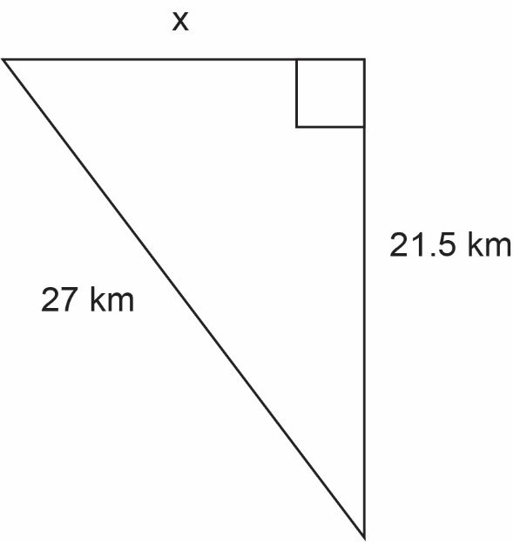

- Solve for the missing length, x, shown in the triangle.

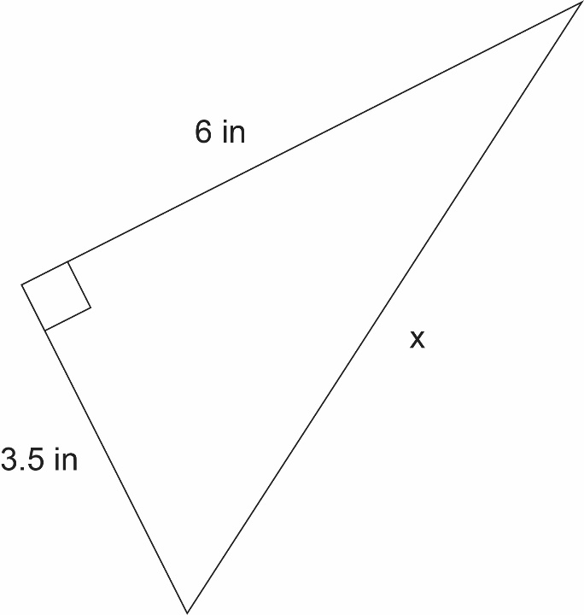

SOL 8.9b - Just in Time Quick Check Teacher Notes
Common Errors/Misconceptions and their Possible Indications
- Place a check in the boxes next to the three side lengths that form a right triangle. Show work to justify your answer.
13 in, 5 in, 12 in
9 m, 40 m, 41 m
8 cm, 15 cm, 9 cm
A common error a student may make is applying the Pythagorean Theorem in the order the numbers are listed. This may indicate that a student cannot correctly identify the hypotenuse. It might be helpful for students to put side lengths in ascending order prior to substituting into the Pythagorean Theorem. Teachers are encouraged to review vocabulary associated with right triangles.
- Using the lengths given, label the sides of each triangle to form a right triangle. Explain your reasoning for your selection of side lengths. (Note: Triangles are not drawn to scale).
8 | 9 | 6 | 12 | 10 | 15

A common error a student may make is identifying 15 and 12 as the hypotenuses. This may indicate that a student understands that the hypotenuse is the longest side of a right triangle, but did not consider that the leg of one right triangle might be longer than the hypotenuse of another. It might be helpful for students to square each number before attempting to identify the placement for side lengths. Teachers are encouraged to provide additional practice identifying the parts of a right triangle and Pythagorean triples (see the Grade 8 Curriculum Framework).
A common error a student may make is selecting 6, 9, and 15 as the side lengths of a right triangle. This may indicate that a student is omitting the squares from the Pythagorean Theorem and instead is using $a+b=c$. It might be helpful for students to write down the formula before beginning each problem. Teachers are encouraged to provide virtual or hands-on manipulatives, such as square tiles, graph paper, or square shaped food items, to reinforce the elements of the Pythagorean Theorem.
- Naudia rode her bike two miles south. Then, she went east for three miles. How far is she from her starting point? Round your answer to the nearest tenth.
Starting
Point
2 miles
3 miles
Destination

A common error a student may make is finding the sum of two and three and determining the distance to be five miles. This may indicate that a student is calculating the total distance traveled rather than the shortest distance between the starting point and destination. For indications of student weaknesses, suggestions, and teacher notes, see question 2.
A student may also make an error when rounding their answer. This may indicate a need to emphasize place value vocabulary and/or the rules of rounding.
- Solve for the missing length. Round your answer to the nearest tenth.
A common error a student may make is taking the square root of the sum of 27² and 21.5², resulting in 34.5 kilometers. This may indicate that a student is not identifying the parts of a right triangle before applying the Pythagorean Theorem. It might be helpful for students to label each leg and the hypotenuse before beginning the problem. Teachers are encouraged to review the differences between solving for a leg and a hypotenuse.
A student may also make an error when rounding their answer. This may indicate a need to emphasize place value vocabulary and/or the rules of rounding.

- Solve for the missing length, x, shown in the triangle. Round your answer to the nearest whole number.
A common error a student may make is finding the sum of 6² and 3.5² and determining that 48 is the length of the hypotenuse. This may indicate that a student completed all but the last step of solving for the hypotenuse. It might be helpful for students to ask themselves whether their answer is appropriate. A student must understand that, given the diagram, a side length of 48 is not a reasonable answer. Teachers are encouraged to model a think-aloud strategy for determining a missing measure and assessing its validity.

A student may also make an error when rounding their answer. This may indicate a need to emphasize place value vocabulary and/or the rules of rounding.

