Just In Time Quick Check
Standard of Learning (SOL) 8.9a
Strand: Measurement and Geometry

Standard of Learning (SOL) 8.9a
The student will verify the Pythagorean Theorem.

Grade Level Skills:
- Verify the Pythagorean Theorem, using diagrams, concrete materials, and measurement.
Just in Time Quick Check
Just in Time Quick Check Teacher Notes

Supporting Resources:
- VDOE Mathematics Instructional Plans (MIPS)
  - 8.9 - Pythagorean Theorem (Word) / PDF Version
- VDOE Co-Teaching Mathematics Instruction Plans (MIPS)
  - 8.9 - Pythagorean Theorem (Word) / PDF Version
- VDOE Word Wall Cards: Grade 8 (Word) | (PDF)
  - Right Triangle
  - Pythagorean Theorem
- Desmos Activity
  - Exploring Length With Geoboards
Supporting and Prerequisite SOL: 6.4

SOL 8.9a - Just in Time Quick Check

- The diagram below shows the relationship between the sides of a right triangle. Use the figure to complete sections a and b.
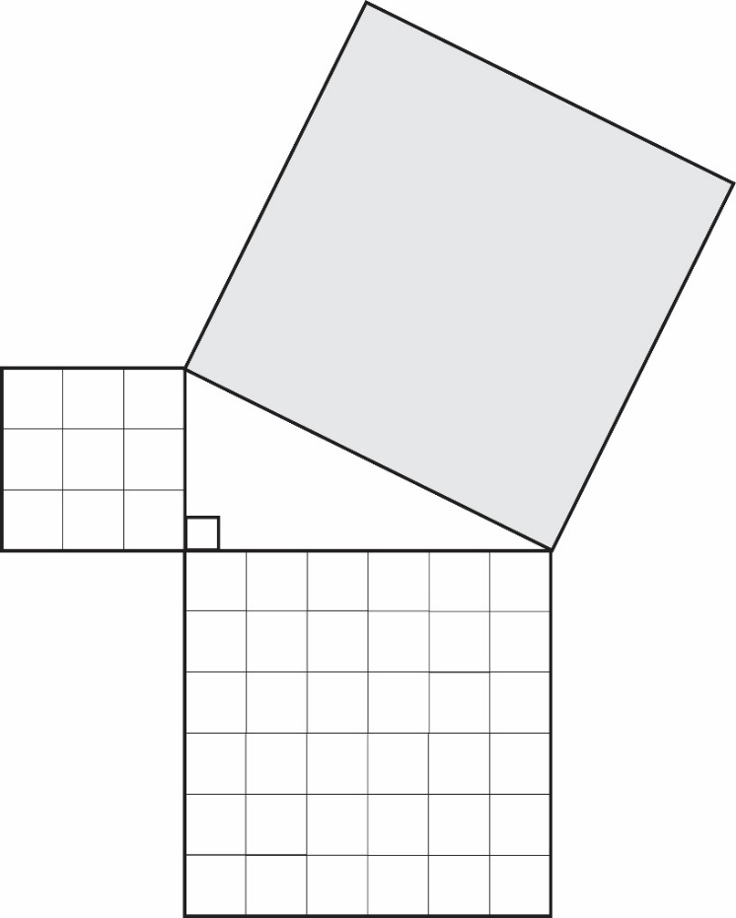
  - Determine the area of the shaded square.
  - Explain how you found your answer.
- Given the figure shown, determine the length of x. Show work to support your answer.
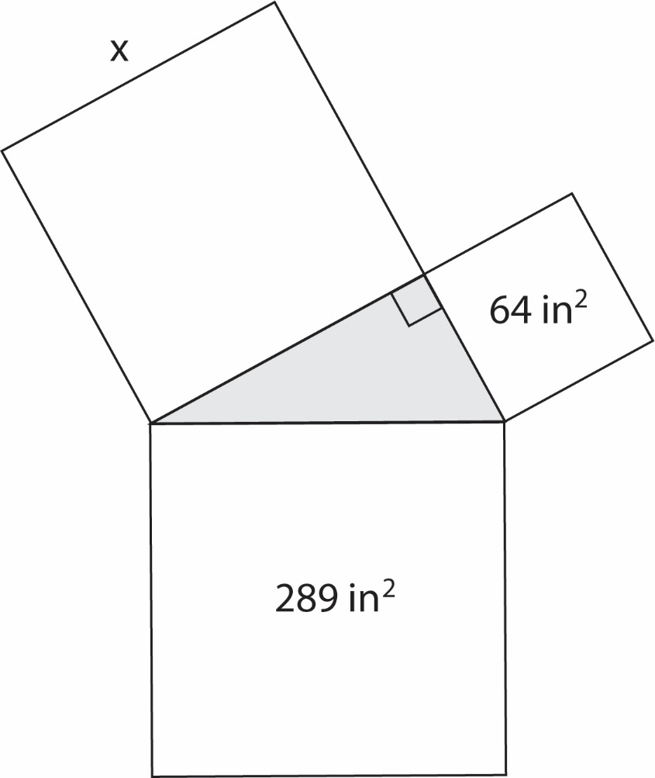

- Ricardo is using an area model using a right triangle and squares to represent the equation $3^{2}+4^{2}=5^{2}$. He starts by drawing the right triangle shown below. Finish the model by drawing and labeling the squares that Ricardo could use to represent the equation.

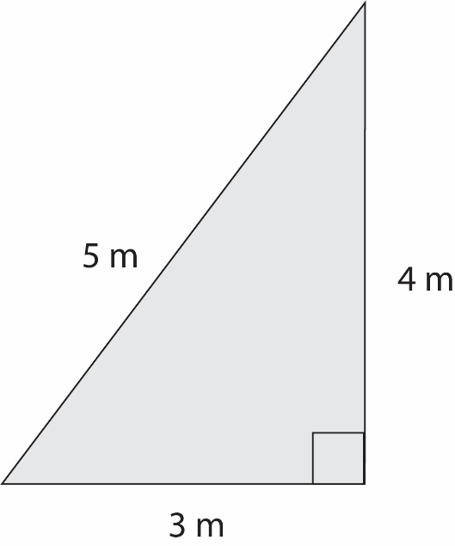

SOL 8.9a - Just in Time Quick Check Teacher Notes
Common Errors/Misconceptions and their Possible Indications

- The diagram below shows the relationship between the sides of a right triangle. Use the figure to complete sections a and b.
  - Determine the area of the shaded square.
A common error a student may make is subtracting 9 from 36. This may indicate that a student is incorrectly identified the legs and the hypotenuse of the right triangle. It might be helpful for students to label the hypotenuse before beginning the problem. Teachers should demonstrate how to identify the hypotenuse, regardless of a right triangle’s orientation. For example, students can draw an arrow through the right angle to show that the hypotenuse is the side of a right triangle across from the right angle. This also creates the notation for a right angle:
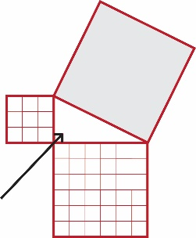
Teachers are also encouraged to display a standard-specific word wall and to review vocabulary regularly.
A common error a student may make is calculating the length of the hypotenuse. This may indicate that a student can identify the process for finding a side length but does not understand the proof of the Pythagorean Theorem. Teachers are encouraged to design lessons using manipulatives, such as square tiles, to demonstrate area models and to explore the relationship between the hypotenuse and legs of a right triangle.
  - Explain how you found your answer.
A student may determine the area of the square in a variety of ways. Look for student answers that are mathematically correct, involve sound reasoning, and employ one or more of the following techniques: using their calculator, pencil and paper, and/or manipulatives. Students who are unable to explain their method may lack a thorough understanding of the Pythagorean Theorem. Teachers are encouraged to provide a variety of tools, such as square tiles, graph paper, square food items, or virtual manipulatives, for exploring the properties of right triangles.

- Determine the length of x.
A common error a student may make is taking the square root of the sum of 64 and 289. This may indicate that a student incorrectly identified the hypotenuse. For suggestions and teacher notes, see question 1a.
A common error a student may make is subtracting 64 from 289, resulting in the area of the empty square. This may indicate that a student understands the relationship between the hypotenuse and legs but did not complete the next step to find x. It might be helpful for students to ask themselves whether or not their answer is reasonable. A student must understand that, given the diagram, a side length of 235 inches is not a reasonable answer. Teachers are encouraged to model a think-aloud strategy for determining a missing measure and assessing its validity.

- Ricardo is using an area model using a right triangle and squares to represent the equation $3^{2}+4^{2}=5^{2}$. He starts by drawing the right triangle shown below. Finish the model by drawing and labeling the squares that Ricardo could use to represent the equation.
A common error a student may make is sketching a single row of squares along each side, as shown below.
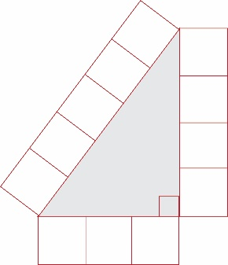
This may indicate that a student needs to review the use of area models for proving the Pythagorean Theorem. Teachers are encouraged to utilize virtual and hands-on manipulatives to verify the Pythagorean Theorem using area models.

