Just In Time Quick Check
Standard of Learning (SOL) 8.8

Strand: Measurement and Geometry

Standard of Learning (SOL) 8.8
The student will construct a three-dimensional model, given the top or bottom, side, and front views.

Grade Level Skills:
- Construct three-dimensional models, given the top or bottom, side, and front views.
- Identify three-dimensional models given a two-dimensional perspective.
- Identify the two-dimensional perspective from the top or bottom, side, and front view, given a three-dimensional model.
Just in Time Quick Check
Just in Time Quick Check Teacher Notes

Supporting Resources:
- VDOE Mathematics Instructional Plans (MIPS)
  - 8.8 - 3-D Figures (Word) / PDF Version
- VDOE Co-Teaching Mathematics Instruction Plans (MIPS)
  - 8.8 - 3-Dimensional Figures (Word) / PDF Version
- VDOE Algebra Readiness Remediation Plans
  - Constructing a 3-D Model (Word) / PDF
- VDOE Word Wall Cards: Grade 8 (Word) | (PDF)
  - Three Dimensional Models
Supporting and Prerequisite SOL: N/A

SOL 8.8 - Just in Time Quick Check

- A three-dimensional figure is constructed using identical cubes.
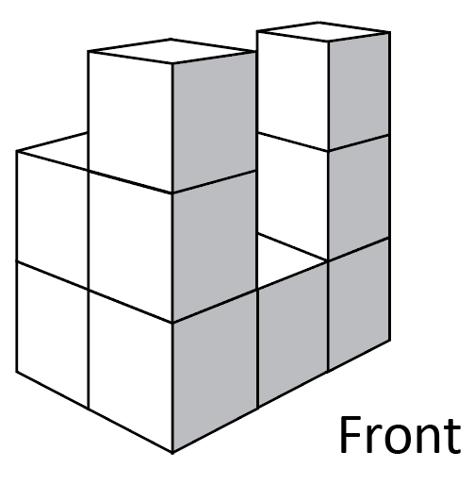
Identify which could be the top view, front view, and side view of this figure. Write your response under each perspective.

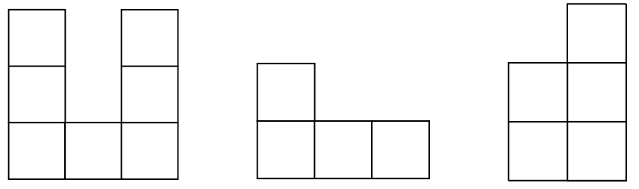
___________________ __________________ _________________

- Sketch a three-dimensional figure that could be represented by these three views.
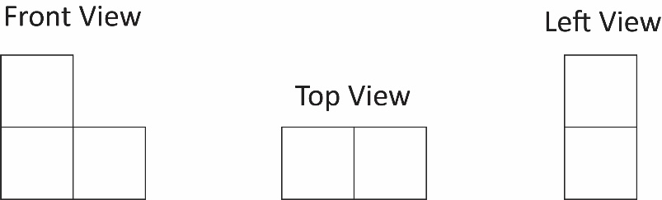

- A three-dimensional figure is constructed using identical cubes.
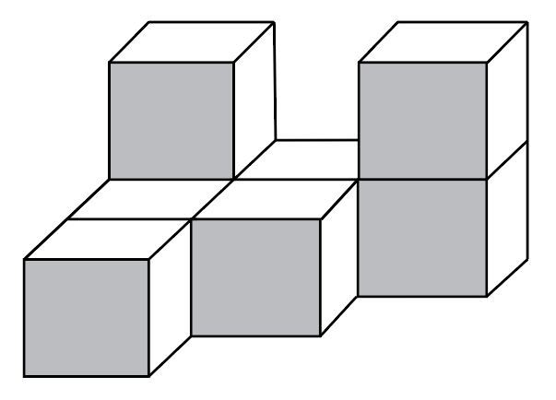
Use the grid paper below to illustrate the top view of this figure.

SOL 8.8 - Just in Time Quick Check Teacher Notes
Common Errors/Misconceptions and their Possible Indications

- A three-dimensional figure is constructed using identical cubes.
Identify which could be the top view, front view, and side view of this figure. Write your response under each perspective.

___________________ __________________ _________________

A common error a student may make is misidentifying the top, front, and side views. This may indicate a need to emphasize positional vocabulary. Teachers are encouraged to display a standard-specific word wall and to review vocabulary regularly while utilizing three-dimensional models such as linking or unit cubes. Students who have difficulty with spatial relationships might use the cubes to build and manipulate the three-dimensional model. It might also be helpful for students to color-code each perspective.

- Sketch a three-dimensional figure that could be represented by these three views.

A common error a student may make is sketching the following figure.

This may indicate that a student does not recognize the relationship between the views and instead sketches them as independent parts. Teachers are encouraged to provide students with three-dimensional physical models to increase their understanding of perspective and to provide tactile experiences. Teachers are encouraged to use computer software programs and online resources to further demonstrate the different views and rotations of three-dimensional figures.

- A three-dimensional figure is constructed using identical cubes.
Use the grid paper below to illustrate the top view of this figure.

A common error a student may make is illustrating the front view of the figure, rather than the top, due to the shading. This may indicate the need to emphasize careful interpretation of the orientation of the figure in the question. It might be helpful for students to label the top, front, and side of the figure and to mark the squares they need to sketch.
A common error a student may make is sketching an incorrect number of squares to depict the top view. This may indicate that a student does not understand that the top view represents the entire figure, rather than representing the tops of each layer separately. It might be helpful for students to build the three-dimensional shape using linking or unit cubes and to view the shape from different positions around and over the figure.

