Just In Time Quick Check
Standard of Learning (SOL) 8.7b

Strand: Measurement and Geometry

Standard of Learning (SOL) 8.7b
The student will identify practical applications of transformations.

Grade Level Skills:
- Identify the type of translation in a given example.
- Identify practical applications of transformations including, but not limited to, tiling, fabric, wallpaper designs, art, and scale drawings.
Just in Time Quick Check
Just in Time Quick Check Teacher Notes

Supporting Resources:
- VDOE Mathematics Instructional Plans (MIPS)
  - 8.7ab - Transformations (Word) / PDF Version
- VDOE Word Wall Cards: Grade 8 (Word) | (PDF)
  - Reflection
  - Translation
  - Dilation
  - Reflection and Translation
- Other VDOE Resources
  - Translations and Reflections [eMediaVA]
  - Reflection [eMediaVA]
- Desmos Activity
  - Des-Patterns
Supporting and Prerequisite SOL: 8.7a, 7.7, 6.9

SOL 8.7b - Just in Time Quick Check

- Identify the type of transformation performed in each coordinate plane below.
  - ________________________________
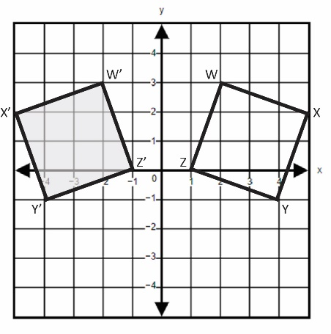
  - ________________________________
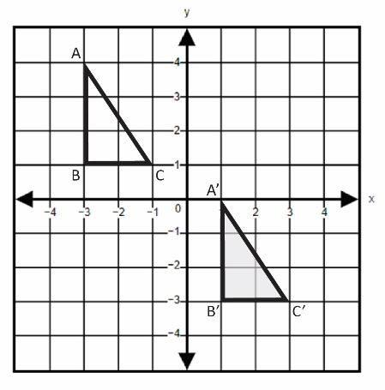

  - ________________________________
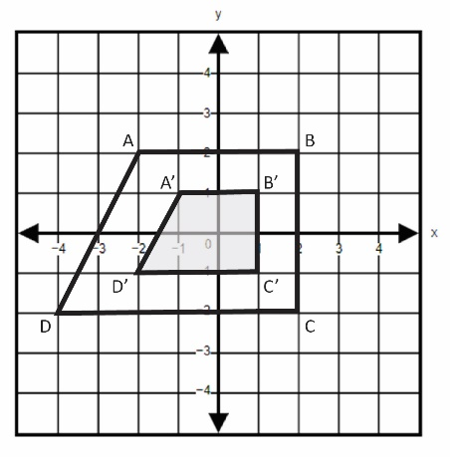
- The picture below shows the tiles in the school cafeteria. Zamien thinks that the tiles are being reflected while Chloe thinks that they are being translated. Explain who you think is correct and justify your answer.

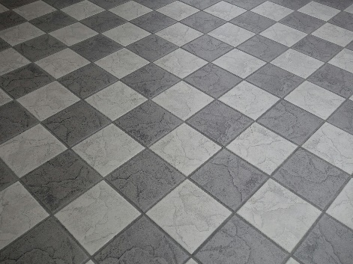

- Identify the type of transformation used to create the bullseye pattern.

- Sasha drew figure A on a coordinate plane. She then performed separate transformations that resulted in figures B, C, and D. Identify which figure is the image of figure A after a reflection over the y-axis. Justify your answer.

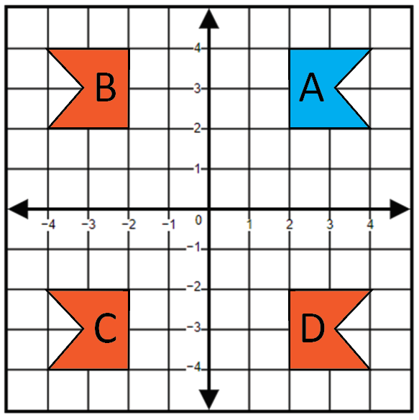

SOL 8.7b - Just in Time Quick Check Teacher Notes
Common Errors/Misconceptions and their Possible Indications

- Identify the type of transformation performed in each coordinate plane below.
  - ________________________________
A common error a student may make is misidentifying the transformation as a rotation. Students are familiar with the term “rotation” as it is introduced in previous grade levels. This may indicate a need to emphasize the characteristics and vocabulary associated with specific transformations, particularly reflections across the x- or y-axis. Teachers are encouraged to model transformations using manipulatives and grid paper.

  - ________________________________
A common error a student may make is misidentifying the transformation as a rotation. This may indicate that the student does not recognize the combination of vertical and horizontal translations that are being used to create the image. It might be helpful for students to use manipulatives that they can move on a coordinate plane.

  - ________________________________
A common error a student may make is misidentifying the transformation as a translation. This may indicate that a student considers the movement of the vertices to be a translation, without considering the change in size. Teachers are encouraged to demonstrate dilations using technology, emphasizing the difference between rigid and non-rigid transformations as well as scale factors.

- The picture below shows the tiles in the school cafeteria. Zamien thinks that the tiles are being reflected while Chloe thinks that they are being translated. Explain who you think is correct and justify your answer.

A student may believe that Zamien or Chloe is correct. A common error a student may make is the improper justification of either option.

If a student states that the tiles are being reflected, look for justifications that include a line(s) of symmetry over which tiles are being reflected. If a student states that the tiles are being translated, look for justifications that include vertical and horizontal movement.

- Identify the type of transformation used to create the bullseye pattern.

A common error a student may make is misidentifying the transformation as a translation. This may indicate that a student does not recognize the difference between rigid and non-rigid transformations. Teachers are encouraged to emphasize the specific types of transformations and their descriptions by displaying a standard-specific word wall and regularly reviewing vocabulary along with practical applications of transformations.

- Sasha drew figure A on a coordinate plane. She then performed separate transformations that resulted in figures B, C, and D. Identify which figure is the image of figure A after a reflection over the y-axis. Justify your answer.

A common error a student may make is misidentifying figure D as a reflection over the y-axis. This may indicate a need to emphasize vocabulary associated with the coordinate plane, focusing on the x- and y-axis. When reflecting a figure in the coordinate plane, it might be helpful for students to highlight the axis over which they are reflecting.

