Just In Time Quick Check
Standard of Learning (SOL) 8.7a

Strand: Measurement and Geometry

Standard of Learning (SOL) 8.7a
The student will, given a polygon, apply transformations, to include translations, reflections, and dilations, in the coordinate plane.

Grade Level Skills:
- Given a preimage in the coordinate plane, identify the coordinate of the image of a polygon that has been translated vertically, horizontally, or a combination of both.
- Given a preimage in the coordinate plane, identify the coordinates of the image of a polygon that has been reflected over the x- or y-axis.
- Given a preimage in the coordinate plane, identify the coordinates of the image of a right triangle or a rectangle that has been dilated. Scale factors are limited to $\frac{1}{4}$, $\frac{1}{2}$, 2, 3, or 4. The center of the dilation will be the origin.
- Given a preimage in the coordinate plane, identify the coordinates of the image of a polygon that has been translated and reflected over the x-or y-axis, or reflected over the x- or y-axis and then translated.
- Sketch the image of a polygon that has been translated vertically, horizontally, or a combination of both.
- Sketch the image of a polygon that has been reflected over the x- or y-axis.
- Sketch the image of a dilation of a right triangle or a rectangle limited to a scale factor of $\frac{1}{4}$, $\frac{1}{2}$, 2, 3, or 4. The center of the dilation will be the origin.
- Sketch the image of a polygon that has been translated and reflected over the x- or y-axis, or reflected over the x- or y-axis and then translated.
- Identify the type of translation in a given example.
Just in Time Quick Check
Just in Time Quick Check Teacher Notes

Supporting Resources:
- VDOE Mathematics Instructional Plans (MIPS)
  - 8.7ab - Transformations (Word) / PDF Version
- VDOE Algebra Readiness Remediation Plans
  - Dilations (Word) / PDF
  - Reflections (Word) / PDF
  - Transformations (Word) / PDF
  - Translations (Word) / PDF
- VDOE Word Wall Cards: Grade 8 (Word) | (PDF)
  - Reflection
  - Translation
  - Dilation
  - Reflection and Translation
- Other VDOE Resources
  - Translations and Reflections [eMediaVA]
  - Reflection [eMediaVA]
- Desmos Activity
  - Polygraph: Transformations (8.7a)
  - 20+ Questions Transformations
  - Transformation Golf: Rigid Motion
Supporting and Prerequisite SOL: 7.7, 6.8a, 6.8b, 6.9

SOL 8.7a - Just in Time Quick Check

- Complete sections a and b using the coordinate plane below. The vertices of the triangle shown have integral coordinates.
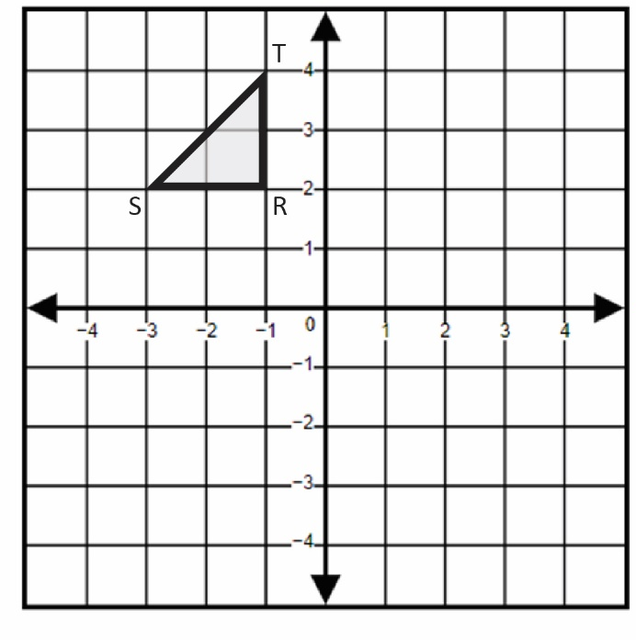
  - Identify the coordinates of the image of triangle RST after a translation down 4 units and then 3 units to the right.
  - Identify the coordinates of the image of triangle RST after a reflection over the y-axis.

- Triangle ABC is shown on the grid. Identify the coordinates of the image of triangle ABC after a dilation about the origin by a scale factor of 2.
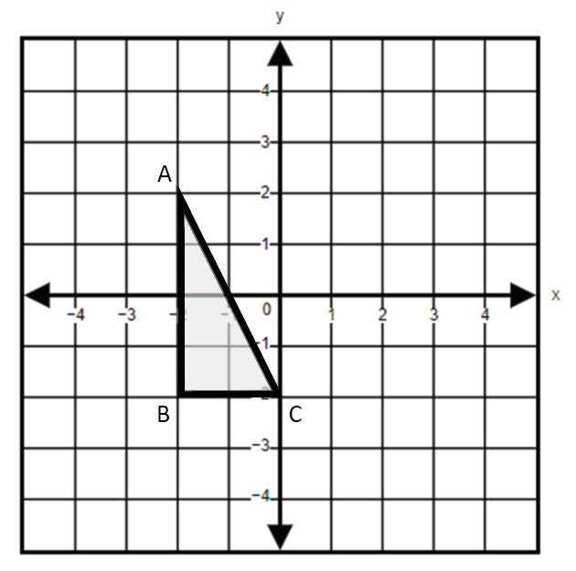

- Triangle XYZ is shown on the grid. Reflect triangle XYZ across the x-axis and then translate right 6 units. What are the coordinates of Y’?
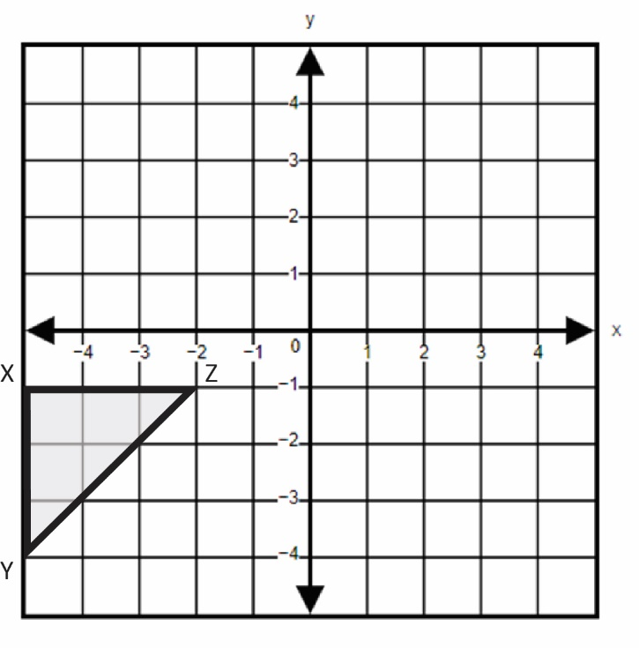

- The vertices of quadrilateral PQRS are located at (-2, 4), (2, 4), (-2, -4), and (2, -4). Graph the image of quadrilateral PQRS after a dilation about the origin by a scale factor of $\frac{1}{4}$.
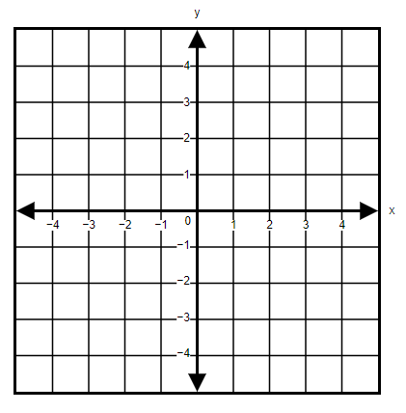
- Describe the transformations that could be applied to figure WXYZ that will result in the figure W’X’Y’Z’.
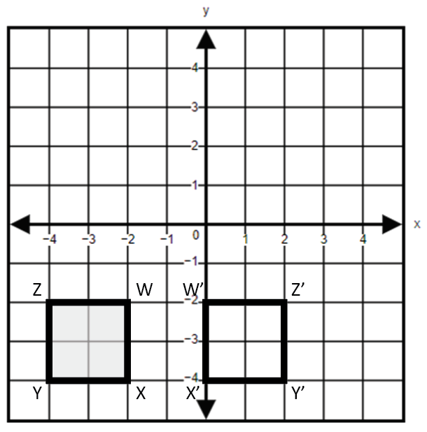

SOL 8.7a - Just in Time Quick Check Teacher Notes
Common Errors/Misconceptions and their Possible Indications

- Complete sections a and b using the coordinate plane below. The vertices of the polygon shown have integral coordinates.
  - Identify the coordinates of the image of triangle RST after a translation down 4 units and then 3 units to the right.
A common error students may make is translating the polygon down 4 units and then 3 units to the left. This may indicate a need to review directional vocabulary associated with translations. When translating a figure in the coordinate plane, it might be helpful for students to draw an arrow in the direction of the translation.
A common error a student may make is performing one translation, but not both. This may indicate that the student does not have an understanding that there are two transformations that need to be performed on this figure. It would be helpful if teachers asked students to describe what each transformation means before graphing the resulting the image. Use of color coding to track the combination of transformations would help students connect the preimage to the image.
  - Identify the coordinates of the image of triangle RST after a reflection over the y-axis.
A common error a student may make is reflecting the polygon over the x-axis. This may indicate a need to emphasize vocabulary associated with the coordinate plane. When reflecting a figure in the coordinate plane, it might be helpful for students to highlight the axis over which they are reflecting.
- Triangle ABC is shown on the grid. Identify the coordinates of the image of triangle ABC after a dilation about the origin by a scale factor of 2.
A common error a student may make is adding two to each coordinate. This may indicate a need to emphasize vocabulary associated with dilations and that a scale factor represents multiplying by a constant. When dilating a figure in the coordinate plane, it may be helpful for teachers to encourage a deeper understanding of the value of the scale factor and its effect on the figure. A scale factor greater than 1 will increase the size of the original figure whereas a scale factor less than 1 will produce a resulting figure that is smaller than the original. Teachers are encouraged to demonstrate dilations using technology. See the Desmos activities associated with this standard as examples.

- Triangle XYZ is shown on the grid. Reflect triangle XYZ across the x-axis and then translate right 6 units. What are the coordinates of Y’?
Common errors that students may make include reflecting over the wrong axis and/or translating in the wrong direction. This may indicate a need to emphasize vocabulary associated with the coordinate geometry. Teachers are encouraged to point out methods to distinguish between vertical and horizontal. For example, the “v” in vertical points down and the horizon is horizontal.
A common error a student may make is either completing the reflection or the translation, but not both. See the second common error for question 1a for indication of instructional need and teacher notes.
- The vertices of quadrilateral PQRS are located at (-2, 4), (2, 4), (-2, -4), and (2, -4). Graph the image of quadrilateral PQRS after a dilation about the origin by a scale factor of $\frac{1}{4}$.
A common error a student may make is multiplying each coordinate by 4. This may indicate that the student does not understand the vocabulary of scale factor. Teachers are encouraged to develop a conceptual understanding of scale factor by using real-world examples, such as model cars, scale drawings, etc.

- Describe the transformations that could be applied to figure WXYZ that will result in the figure W’X’Y’Z’.
A common error a student may make is incorrectly identifying the image as a translation of the figure 4 units to the right. This may indicate that the student does not recognize that the figure would have needed to be reflected to change the position of the vertices. The student may benefit from seeing multiple representations of the figure and the table values.
A common error a student may make is incorrectly identifying the image as a reflection over the y-axis. This may indicate that the student does not understand that the pre-image and image of a figure must be equidistant from the axis over which it is reflected. Teachers are encouraged to demonstrate reflections with manipulatives and a coordinate grid.

