Just In Time Quick Check
Standard of Learning (SOL) 8.6b

Strand: Measurement and Geometry

Standard of Learning (SOL) 8.6b
The student will describe how changing one measured attribute of a rectangular prism affects the volume and surface area.

Grade Level Skills:
- Describe how the volume of a rectangular prism is affected when one measured attribute is multiplied by a factor of $\frac{1}{4}$, $\frac{1}{3}$ , $\frac{1}{2}$ , 2, 3, or 4.
- Describe how the surface area of a rectangular prism is affected when one measured attribute is multiplied by a factor of $\frac{1}{2}$ or 2.
Just in Time Quick Check
Just in Time Quick Check Teacher Notes

Supporting Resources:
- VDOE Mathematics Instructional Plans (MIPS)
  - 8.6b - Changing Attributes (Word) / PDF Version
- VDOE Word Wall Cards: Grade 8 (Word) | (PDF)
  - Volume – Changing One Attribute
  - Surface Area – Changing One Attribute
- VDOE Instructional Videos for Teachers
  - Volume and Surface Area (grades 6-8)
  - Units of Measure (grades 4-8)
- Other VDOE Resources
  - Area, Volume, and Surface Area: Find the Volume of Rectangles inside Rectangles [eMediaVA]
Supporting and Prerequisite SOL: 8.6a, 7.4a, 7.4b, 6.7c

SOL 8.6b - Just in Time Quick Check

- The dimensions for rectangular prism A are shown in the table. The height of rectangular prism B is $\frac{1}{2}$ the height of Prism A. The other dimensions of Prism B are the same as Prism A.

Measurement | Rectangular Prism A | Rectangular Prism B
Length | 3 in | 3 in
Width | 7 in | 7 in
Height | 10 in | 5 in
Volume
Surface Area

- Calculate the volume and surface area for Prism A and Prism B.
- Describe the effect of changing the height of Prism B on the surface area and volume compared to that of Prism A.

- Nancy’s swimming pool is shaped like a rectangular prism. Nancy is remodeling her swimming pool and she has decided to triple the length.

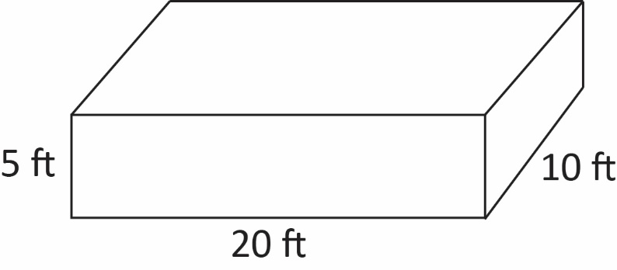
- What is the volume of the remodeled swimming pool?
- What is the relationship between the change in the length of the remodeled pool and the change in the volume?

- A movie theater sells two sizes of popcorn, large and small, in bags shaped like rectangular prisms. The large bag has a height of 9 inches, a length of 6 inches, and a width of 4 inches. The small bag has the same width and length as the large bag, but one-third of the volume. What is the height of the small bag of popcorn?
- A house is being constructed with large and small bricks in the shape of rectangular prisms. All of the small bricks have a height of 2 inches, a length of 8 inches, and a width of 3.5 inches. All of the large bricks have a height of 2 inches, a length of 16 inches, and a width of 3.5 inches.

- What is the difference in the surface area of one large brick and one small brick?

- How did the change of the dimension (length) affect the surface area?

SOL 8.6b - Just in Time Quick Check Teacher Notes
Common Errors/Misconceptions and their Possible Indications

- The dimensions for rectangular prism A are shown in the table. The height of rectangular prism B is $\frac{1}{2}$ the height of Prism A. The other dimensions of Prism B are the same as Prism A.

Measurement | Rectangular Prism A | Rectangular Prism B
Length | 3 in | 3 in
Width | 7 in | 7 in
Height | 10 in | 5 in
Volume
Surface Area

- Calculate the volume and surface area for Prism A and Prism B.
A common error students may make is incorrectly substituting values into the volume and surface area formulas. Students should be encouraged to reference the Grade 8 Mathematics Formula Sheet. Teachers should allow students to practice evaluating the formula by exploring the Desmos scientific calculator capabilities. Teachers may also consider using concrete manipulatives such as linking or unit cubes to encourage students to engage in discussions explaining how changing an attribute affects the volume and surface area through visual or concrete representation.
A common misconception students may have is providing a correct solution either without units or using the incorrect units. This may indicate a need to emphasize the difference in the units used for volume and surface area.

- Describe the effect of changing the height of Prism B on the surface area and volume compared to that of Prism A.

A common error students may make is not recognizing the relationship between the change in an attribute and the change in the volume. Students may describe the volume of Rectangular Prism B as smaller than the volume of Rectangular Prism A without recognizing the scale factor.
A common misconception students may have when an attribute is changed is the thought that the effect on the surface area follows the same relationship as the effect on the volume. Students may divide the surface area of Rectangular Prism A by two, as they would for volume.
Students will benefit from examining the rules and patterns associated with changing an attribute of a rectangular prism. Examples and explanations can be found in the Grade 8 Mathematics Curriculum Framework.

- Nancy’s swimming pool is shaped like a rectangular prism. Nancy is remodeling her swimming pool and she has decided to triple the length.

- What is the volume of the remodeled swimming pool?
A common misconception students may have is not understanding the definition of “triple.” This may indicate a need to review ordinal number vocabulary.
A common error students may make is multiplying all three attributes by three, resulting in an incorrect answer of 27,000 cubic feet (ft³).
Students should be encouraged to reference the Grade 8 Mathematics Formula Sheet. Teachers should allow students to practice evaluating the formula by exploring the Desmos scientific calculator capabilities.

- What is the relationship between the change in the length of the remodeled pool and the change in the volume?

For common misconceptions and errors, see question 1b.

- A movie theater sells two sizes of popcorn, large and small, in bags shaped like rectangular prisms. The large bag has a height of 9 inches, a length of 6 inches, and a width of 4 inches. The small bag has the same width and length as the large bag, but one-third of the volume. What is the height of the small bag?
A common error students may make is multiplying the height of the larger bag by three, resulting in an incorrect answer of 27 inches. This may indicate a need to review vocabulary such as double, triple, quadruple or multiplication by a factor of $\frac{1}{4}$, $\frac{1}{3}$, and $\frac{1}{2}$. Teachers should be encouraged to provide additional practice with practical applications involving this vocabulary and these factors.
A common error students may make is calculating the volume of the small bag, rather than finding the height. This error may indicate a need to emphasize vocabulary associated with rectangular prisms and the components of the formula. Students should be encouraged to reference the Grade 8 Mathematics Formula Sheet.
- A house is being constructed with large and small bricks in the shape of rectangular prisms. All of the small bricks have a height of 2 inches, a length of 8 inches, and a width of 3.5 inches. All of the large bricks have a height of 2 inches, a length of 16 inches, and a width of 3.5 inches.

- What is the difference in the surface area of one large brick and one small brick?

A common error students may make is incorrectly identifying the length, width, and height of the figure. Students may use one of the numbers more than once, resulting in an incorrect answer. This may indicate a need to emphasize vocabulary associated with rectangular prisms and the formula for surface area. Students should be encouraged to reference the Grade 8 Mathematics Formula Sheet. Teachers should encourage students to label the values used for the dimensions of the prisms and allow practice time to evaluate the formula for surface area by exploring the Desmos scientific calculator capabilities.
Teachers are encouraged to provide students with concrete nets of three-dimensional figures before transitioning to the pictorial representation to support students with misconceptions and errors about the dimensions of such figures.

A common misconception students may have is not understanding the definition of “difference” and instead performing division. This may indicate a need to review vocabulary associated with verbal expressions. Teachers should reference the Grade 8 Mathematics Curriculum Framework to further develop this concept.

- How did the change of the dimension (length) affect the surface area?

For common misconceptions and errors, see question 1b.

