Just In Time Quick Check
Standard of Learning (SOL) 8.6a

Strand: Measurement and Geometry

Standard of Learning (SOL) 8.6a
The student will solve problems, including practical problems, involving volume and surface area of cones and square-based pyramids.

Grade Level Skills:
- Distinguish between situations that are applications of surface area and those that are applications of volume.
- Determine the surface area of cones and square-based pyramids by using concrete objects, nets, diagrams and formulas.
- Determine the volume of cones and square-based pyramids, using concrete objects, diagrams, and formulas.
- Solve practical problems involving volume and surface area of cones and square-based pyramids.
Just in Time Quick Check
Just in Time Quick Check Teacher Notes

Supporting Resources:
- VDOE Mathematics Instructional Plans (MIPS)
  - 8.6a - Volume and Surface Area of Cones and Pyramids (Word) / PDF Version
- VDOE Algebra Readiness Remediation Plans
  - Cones and Square Pyramids (Word) / PDF
  - Relational Solids (Word) / PDF
- VDOE Word Wall Cards: Grade 8 (Word) | (PDF)
  - Pyramid
  - Cone
- Other VDOE Resources
  - Area, Volume, and Surface Area: Find the Volume of Rectangles inside Rectangles [eMediaVA]
Prerequisite Supporting SOL: 8.14a, 7.4a, 7.4b, 6.7b, 6.7c

SOL 8.6a - Just in Time Quick Check

- Consider each situation below. Determine if the situations presented are applications of surface area or volume.

- Jonah is filling his swimming pool. ______________________________

- Audrey is wrapping a present. ______________________________

- Alando must determine the capacity of an ice cream cone. ______________________________

- Use the diagram to answer the questions below.
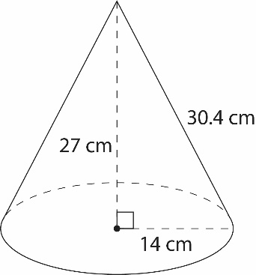
- Find the volume of the cone. Round your answer to the nearest tenth.
- Find the surface area of the cone. Round your answer to the nearest tenth.
- Find the surface area of the square-based pyramid pictured below.

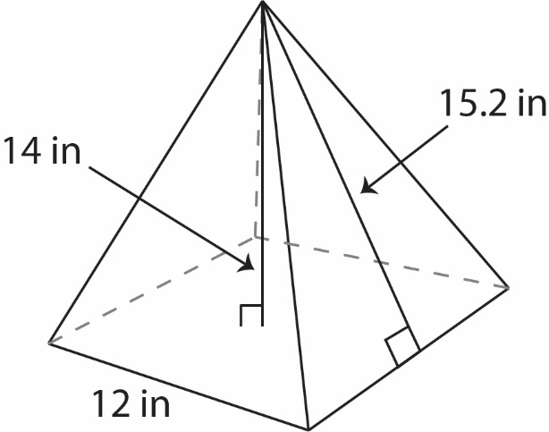

- Dravin is painting a cone-shaped centerpiece for the school dance. The centerpiece has a diameter of 12 inches and slant height of 19 inches. What is the total surface area that needs painting? Round your answer to the nearest whole number.

- There is a building shaped like a square-based pyramid. The length of each side of the building’s base is 180 meters and the height of the building is 98 meters. What is the capacity of the pyramid?

SOL 8.6a - Just in Time Quick Check Teacher Notes
Common Errors/Misconceptions and their Possible Indications

- Consider each situation below. Determine if the situations presented are applications of surface area or volume.

- Jonah is filling his swimming pool. ______________________________

- Audrey is wrapping a present. ______________________________

- Alando must determine the capacity of an ice cream cone. ______________________________

A common error a student may make is incorrectly identifying applications of surface area and volume. This may indicate a need to emphasize vocabulary associated with surface area and volume. Teachers are encouraged to revisit practical uses for surface area and volume.

- Use the diagram to answer the questions below.
- Find the volume of the cone. Round your answer to the nearest tenth.

A common misconception a student may have is using the slant height of the cone instead of the height to calculate the volume – incorrectly calculating the volume as 6,239.6 cubic centimeters (cm³). This may indicate a need to emphasize vocabulary associated with cones and the formula for volume. When solving for volume of a cone, it might be helpful for the student to label which values they will use as the radius and height.
A student may also make an error when calculating the square of the radius. When substituting values into the formula $V=\frac{1}{3}πr^{2}h$, students should carefully follow the order of operations. This error may indicate a need to revisit evaluating an algebraic expression for given replacement values of the variables by referring to the Grade 8 Mathematics Curriculum Framework. Teachers may consider reviewing the meaning of an exponent (power) by having the student write the expression in expanded form. Students should be encouraged to reference the Grade 8 Mathematics Formula Sheet, but to use reasoning and problem solving to justify the formula by using relational solids.
In addition, teachers should allow students to practice evaluating the formula by exploring the Desmos scientific calculator capabilities.
A common misconception a student may have is providing a correct solution either without units or using square units. This may indicate a need to emphasize the units for volume.
A student may also make an error when rounding their answer. This may indicate a need to emphasize place value vocabulary and/or the rules of rounding.

- Find the surface area of the cone. Round your answer to the nearest tenth.
A common misconception a student may have is using the height of the cone instead of the slant height to calculate the surface area – incorrectly calculating the surface area as 1,803.3 square centimeters (cm²). This may indicate a need to emphasize vocabulary associated with cones and the formula for surface area. When solving for surface area of a cone, it might be helpful for the student to label the values of the radius and the slant height. Teachers should consider providing students with relational solids and demonstrate how to identify the dimensions of the figure and, in this case, distinguish between the height and the slant height.
A student may also make an error when following the order of operations. For example, if a student does not apply exponents before multiplication, they may square the entire first term and get 3,271.5 square centimeters (cm²). This may indicate a need to review the order of operations and evaluating expressions by referring to the Grade 8 Mathematics Curriculum Framework. Students should be encouraged to reference the Grade 8 Mathematics Formula Sheet, but to use reasoning and problem solving to justify the formula using nets.
Teachers should allow students to practice evaluating the formula by exploring the Desmos scientific calculator capabilities.
A common misconception a student may have is providing a correct solution either without units or using cubic units. This may indicate a need to emphasize the appropriate application of units for surface area.
A student may also make an error when rounding their answer. This may indicate a need to emphasize place value vocabulary and/or the rules of rounding.

- Find the surface area of the square-based pyramid pictured below.

A common error a student may make is incorrectly using the height as the slant height, substituting 14 for $l$ in the formula.
A common error a student may make is incorrectly using the side length of the base as the perimeter, substituting 12 for p in the formula. A student may also multiply the side length by itself to find the perimeter, incorrectly substituting 144 for p.
A common error a student may make is incorrectly using the side length of the base as the area of the base, substituting 12 for B in the formula. A student may also add the side lengths to find the area of the base, incorrectly substituting 48 for B.
These errors may indicate a need to emphasize vocabulary associated with square-based pyramids and the formula for surface area. Teachers should consider providing students with relational solids and demonstrate how to identify the dimensions of the figure and, in this case, distinguish between the height and the slant height. Students should be encouraged to reference the Grade 8 Mathematics Formula Sheet, but to use reasoning and problem solving to justify the formula using nets. Teachers are encouraged to provide students with concrete nets of square-based pyramids before transitioning to the pictorial representation to support students with misconceptions and errors about the dimensions of such figures. Teachers should allow students to practice evaluating the formula by exploring the Desmos scientific calculator capabilities.
A common misconception a student may have is providing a correct solution either without units or using cubic units. This may indicate a need to emphasize the appropriate application of units for surface area. Further, it may be helpful for teachers to emphasize a structure that will allow students to clearly organize their work. For example, when calculating the perimeter (p) and the area of the base (B), it might be helpful for the student to first separate their paper into two columns. Secondly, write the surface area formula in the first column. Then, in the second column, calculate the perimeter and area of the base.
- Dravin is painting a cone-shaped centerpiece for the school dance. The centerpiece has a diameter of 12 inches and slant height of 19 inches. What is the total surface area that needs painting? Round your answer to the nearest whole number.

A common error a student may make is incorrectly deriving the radius, given the diameter. This may indicate a need to emphasize vocabulary related to circles and cones. Students must understand how to accurately identify and/or calculate the radius of a circle, given the diameter. For example, a student that uses 12 inches as “r” in the formula $SA=πr^{2}+πrl$, will calculate the surface area as 1,169 square inches (in²). A teacher should allow students to practice evaluating the formula by exploring the Desmos scientific calculator capabilities.
A common misconception a student may have is providing a correct solution either without units or using cubic units. Another common error a student may make is incorrectly identifying applications of surface area. This may indicate a need to emphasize vocabulary distinguishing surface area from volume. Teachers are encouraged to revisit practical uses for surface area.
A student may also make an error when rounding their answer. This may indicate a need to emphasize place value vocabulary and/or the rules of rounding.

- There is a building shaped like a square-based pyramid. The length of each side of the building’s base is 180 meters and the height of the building is 98 meters. What is the capacity of the pyramid in cubic meters?

A common error a student may make is incorrectly using the side length of the base as the area of the base, substituting 180 for B in the formula. A student may also add the side lengths to find the area of the base, incorrectly substituting 720 for B. These errors may indicate a need to emphasize vocabulary associated with square-based pyramids and the formula for volume. In addition, a teacher should allow students to practice evaluating the formula by exploring the Desmos scientific calculator capabilities.

Teachers are encouraged to provide students with relational solids and concrete nets of square-based pyramids before transitioning to the pictorial representation to support students with misconceptions and errors about the dimensions of such figures.
A common misconception a student may have is providing a correct solution either without units or using cubic units. Another common error a student may make is incorrectly identifying applications of volume. This may indicate a need to emphasize vocabulary distinguishing volume from surface area. Teachers are encouraged to revisit practical uses for volume.

