Just In Time Quick Check
Strand: Measurement and Geometry

Standard of Learning (SOL) 8.5
The student will use the relationships among pairs of angles that are vertical angles, adjacent angles, supplementary angles, and complementary angles to determine the measure of unknown angles.

Grade Level Skills:
- Identify and describe the relationship between pairs of angles that are vertical, adjacent, supplementary, and complementary.
- Use the relationships among supplementary, complementary, vertical, and adjacent angles to solve problems, including practical problems, involving the measure of unknown angles.
Just in Time Quick Check
Just in Time Quick Check Teacher Notes

Supporting Resources:
- VDOE Mathematics Instructional Plans (MIPS)
  - 8.5 - What Are Your Angles? (Word) / PDF Version
- VDOE Word Wall Cards: Grade 8 (Word) | (PDF)
  - Complementary Angles
  - Supplementary Angles
  - Vertical Angles
  - Adjacent Angles
- Other VDOE Resources
  - Geometry Basics: Angle Relationships Lesson 6 [eMediaVA]
- Desmos Activity
  - Polygraph: Figure it Out
Supporting and Prerequisite SOL: 7.5, 6.9
Standard of Learning (SOL) 8.5

SOL 8.5 - Just in Time Quick Check

- Look at the diagram below. Given $m∠1=39°$, use your knowledge of vertical and supplementary angles to find the measures of the other missing angles.
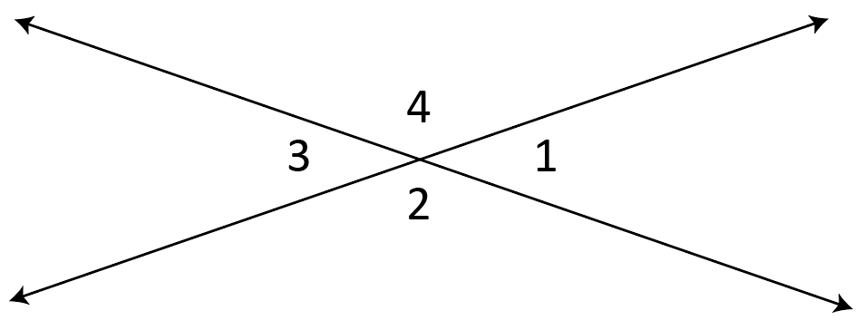
$m∠2=$ ______$°$
$m∠3=$ ______$°$
$m∠4=$ ______$°$
- Use the diagram below to complete sections a through c.
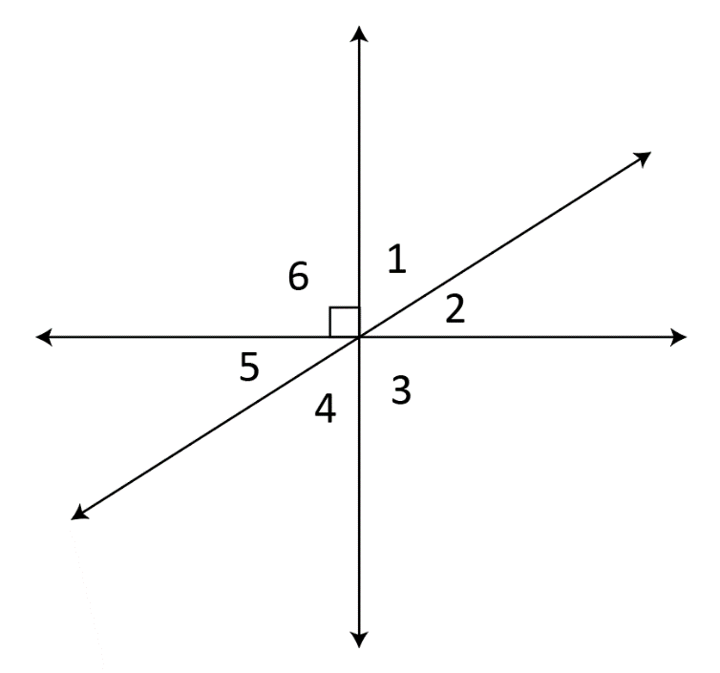
  - Identify a pair of vertical angles.
  - Identify a pair of complementary angles.
  - Identify an angle adjacent to $∠4$.

- Use the diagram below to complete sections a and b.
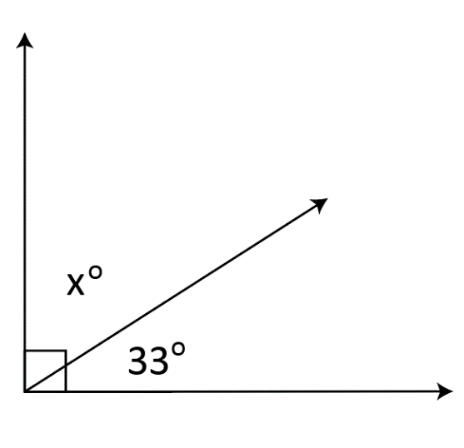
a) What type of angle relationship is pictured above?
b) Solve for the value of x.
4) Use the relationships among the angles shown in the figure to solve for x.
(6x + 38)⁰
(7x + 26)⁰

- Given that points A, B, and D fall on the same line, use the angle relationships shown in the figure to find the measure of angle ABC.

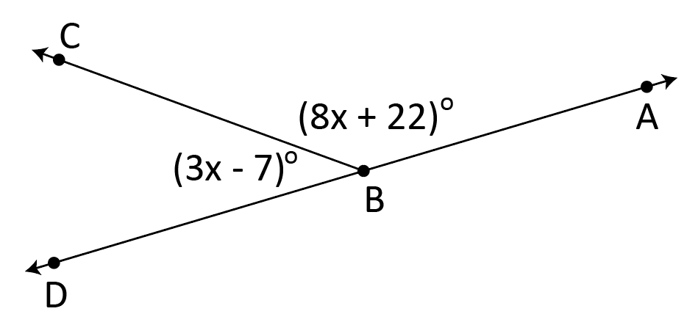

- Shayla wants to fix the fence pictured below but she needs to determine the measure of $∠ABC$. She knows that $∠DBC$ measures 108$°$. If $∠ABC$ and $∠DBC$ form a linear pair, what is the measure of $∠ABC$?
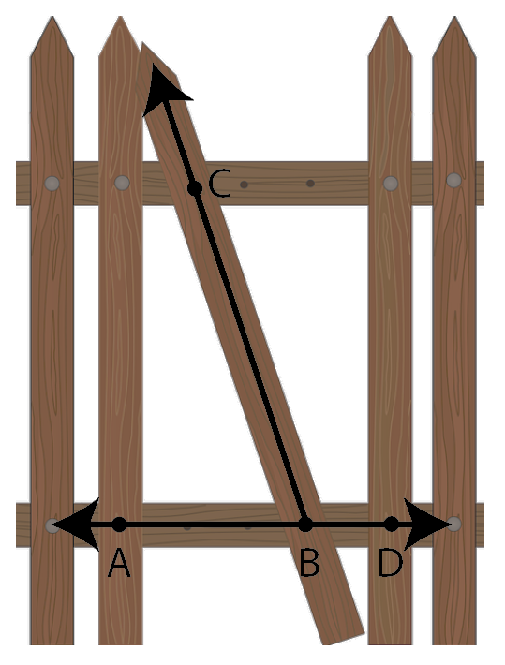
SOL 8.5 - Just in Time Quick Check Teacher Notes
Common Errors/Misconceptions and their Possible Indications

- Look at the diagram below. Given $m∠1=39°$, use your knowledge of vertical and supplementary angles to find the other missing angles.
$m∠2=$ ______$°$
$m∠3=$ ______$°$
$m∠4=$ ______$°$
A common error a student may make is setting up the equation $x+39=90$ to solve for the measure of angles 2 and 4. This may indicate that a student recognizes the relationship between vertical angles but does not understand that supplementary angles equal 180$°$, rather than 90$°$. Teachers are encouraged to provide additional opportunities for identifying angle relationships, determining their sum, and calculating missing angle measures.

- Use the diagram below to complete sections a through c.
  - Identify a pair of vertical angles.
A common error a student may make is identifying angles 1 and 5 or angles 2 and 4 as vertical angles. This may indicate a need to review characteristics of vertical angles. Teachers are encouraged to provide hands-on experiences for identifying vertical angles. Items such as patty paper and angle manipulatives can be used to identify vertical angles and form conjectures about their measurements. Students may also use a protractor to verify the angle measurements. Color-coding angle relationships may help students to differentiate between the types of angles being identified.
  - Identify a pair of complementary angles.
A common error a student may make is identifying angles 3 or 6 as complementary. Students must understand that “complementary” refers to a pair of angles measuring 90 degrees and not one right angle. This may indicate that a student has partial understanding of the terminology, but needs further reinforcement. Color-coding angle relationships may help students to differentiate between the types of angles being identified. Teachers are encouraged to provide examples of complementary angles using angle measurements and visual representations.
  - Identify an angle adjacent to $∠4$.
A common error a student may make is identifying angle 1 as adjacent to angle 4. This may indicate that a student is recalling the relationship between vertical angles. It might be helpful for students to highlight or outline angle 4 before identifying adjacent angles. Color-coding angle relationships may help students to differentiate between the types of angles being identified. Teachers are encouraged to explore the meaning of adjacent and relate this relationship to real-world examples, such as neighboring apartments or classrooms that share a common wall.
- Use the diagram below to complete sections a and b.
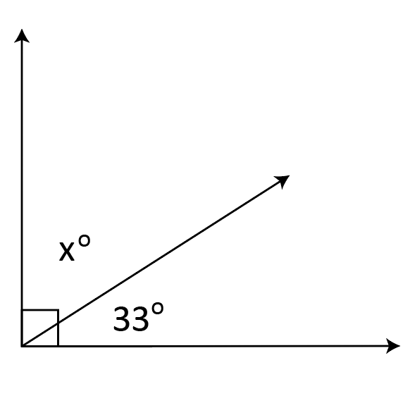
  - What type of angle relationship is pictured above?
A common error a student may make is identifying the angle pair as supplementary. This may indicate a need to review the vocabulary associated with angle relationships as well as vocabulary from the Grade 5 Word Wall Cards, such as Acute Angle, Obtuse Angle, Right Angle, and Straight Angle. Teachers are encouraged to display a standard-specific word wall and to review vocabulary regularly.
  - Solve for the value of x.
A common error a student may make is setting up the equation $x+33=180$ to solve for the value of x. This may indicate that a student does not understand the right angle symbol or the definition of complementary angles. As indicated in section a, teachers are encouraged to display and review vocabulary associated with angle relationships as well as prior knowledge of angle types.
A common error a student may make is misidentifying the angles as congruent. This may indicate a need to review vocabulary associated with complementary angle relationships and congruency. Teachers are encouraged to use virtual or physical manipulatives to demonstrate the number of possibilities for complementary angles.

- Use the relationships among the angles shown in the figure to solve for x.
(6x + 38)⁰
(7x + 26)⁰
A common error a student may make is identifying the angles as supplementary and setting up the equation $\left(6x+38\right)+\left(7x+26\right)=180$ to solve for the value of x. This may indicate that a student sees the lines pictured as a linear pair and therefore believes the angles have a sum of 180 degrees. It might be helpful for students to highlight or outline the angles with given information and determine their relationship before setting up an equation. For teacher suggestions, see question 2a.

- Given that points A, B, and D fall on the same line, use the angle relationships shown in the figure to find the measure of angle ABC.

A common error a student may make is correctly solving for the value of x, but not calculating the measure of angle ABC. This may indicate a need to emphasize careful interpretation of multi-step problems. It might be helpful for students to annotate the question and highlight the angle that is being referenced. Teachers are encouraged to review the symbols and notations associated with angles.

- Shayla wants to fix the fence pictured below but she needs to determine the measure of $∠ABC$. She knows that $∠DBC$ measures 108$°$. If $∠ABC$ and $∠DBC$ form a linear pair, what is the measure of $∠ABC$?
The student may have misconceptions about the relationships between the angles due to the figure being overlaid on the image of the fence. This may indicate difficulty translating a practical problem into a traditional representation of an angle pair. It might be helpful for students to re-draw the angles, separate from the fence, in order to more clearly view the referenced angle relationship.

