Just In Time Quick Check
Standard of Learning (SOL) 8.10
Strand: Measurement and Geometry

Standard of Learning (SOL) 8.10
The student will solve area and perimeter problems, including practical problems, involving composite plane figures.

Grade Level Skills:
- Subdivide a plane figure into triangles, rectangles, squares, trapezoids, parallelograms, and semicircles. Determine the area of subdivisions and combine to determine the area of the composite plane figure.
- Subdivide a plane figure into triangles, rectangles, squares, trapezoids, parallelograms, and semicircles. Use the attributes of the subdivisions to determine the perimeter of the composite plane figure.
- Apply perimeter, circumference, and area formulas to solve practical problems involving composite plane figures.
Just in Time Quick Check
Just in Time Quick Check Teacher Notes

Supporting Resources:
- VDOE Mathematics Instructional Plans (MIPS)
  - 8.10 - Composite Figures: Area and Perimeter (Word) / PDF Version
- VDOE Word Wall Cards: Grade 8 (Word) | (PDF)
  - Composite figures
- Other VDOE Resources
  - Geometry Basics: Angle Relationships Lesson 6 [eMediaVA]
Supporting and Prerequisite SOL: 6.7a, 6.7b, 6.7c

SOL 8.10 - Just in Time Quick Check

- Use the figure below to complete sections a and b.
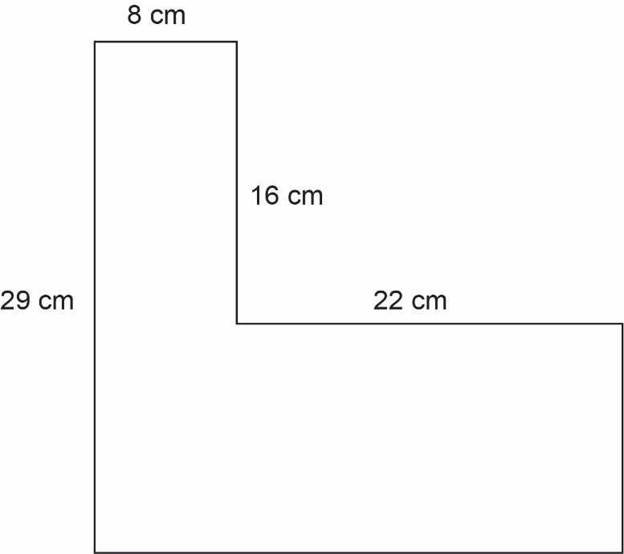
  - Find the area of the composite figure. Show work to support your answer.
  - Find the perimeter of the composite figure. Show work to support your answer.

- The figure shown is composed of a square and an equilateral triangle. The side length of the square is 15 inches. What is the distance around the composite figure?
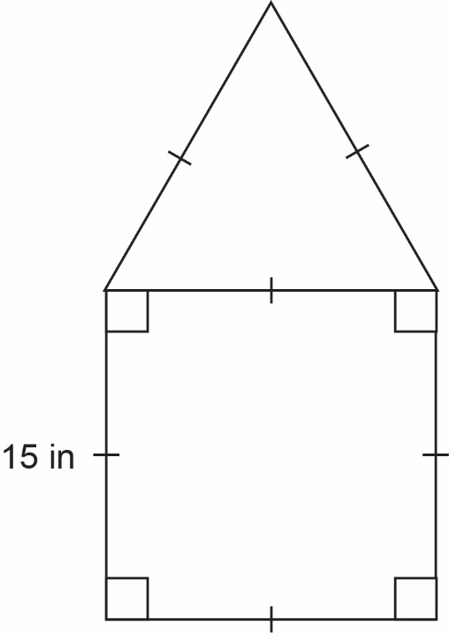
- Find the area of the composite figure below. Round your answer to the nearest hundredth.
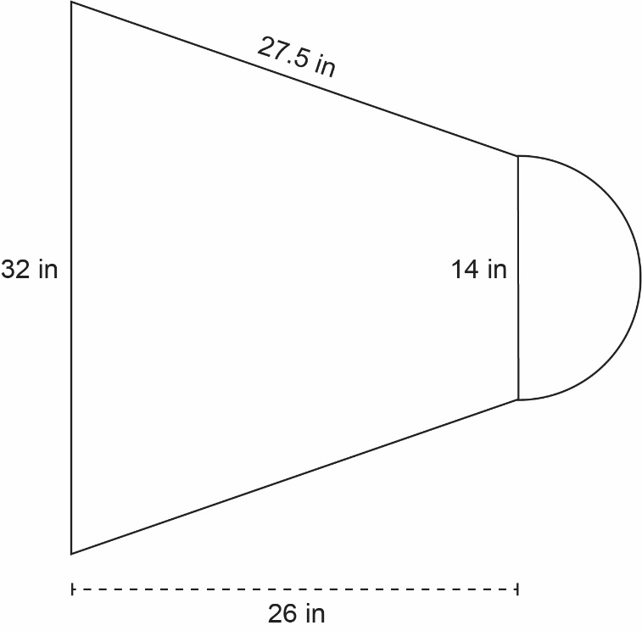
- A landscaper fertilized the yard surrounding the house and shed, represented by the shaded region shown below. How much fertilizer will he need?
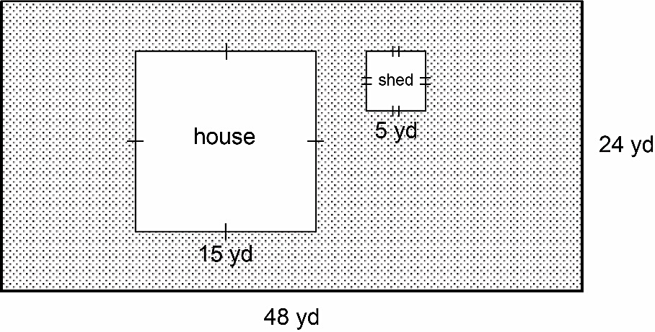

SOL 8.10 - Just in Time Quick Check Teacher Notes
Common Errors/Misconceptions and their Possible Indications

- Use the figure below to complete sections a and b.
  - Find the area of the composite figure.
A common error a student may make is attempting to find the area using only given measures and not calculating for missing side lengths. This may indicate a need to review identifying shapes used to create composite figures. It might be helpful for students to draw the two rectangles separately and label their side lengths. Teachers are encouraged to provide hands-on manipulatives, such as a geoboards or pattern blocks, and allow students to create composite figures.
Another common error a student may make is determining that the vertical missing side is 16 centimeters. This may indicate that a student did not take the difference of 29 and 16 but assumed that the two shorter, vertical sides are congruent. It might be helpful for a student to draw the figure to scale on grid paper, allowing them to count the side lengths. Teachers are encouraged to show students at least two methods for calculating the missing side lengths: drawing the figure on grid paper and performing the needed calculation based on the position of the missing side.
  - Find the perimeter of the composite figure.
A common error a student may make is adding the four given measures and calculating the perimeter to be 75 centimeters. This may indicate a need to review vocabulary associated with two-dimensional figures and perimeter. It might be helpful for students to highlight the entire perimeter of the composite figure before beginning the calculation. Teachers are encouraged to review vocabulary, as shown in the VDOE Word Wall Cards: Grade 6 (Perimeter). Teachers are also encouraged to review the appropriate formulas with students, as listed on the Grade 8 Mathematics Formula Sheet.

- The figure below is composed of a square and an equilateral triangle. The side length of the square is 15 inches. What is the perimeter of the composite figure?
A common error a student may make is adding all six lengths, resulting in a perimeter of 90 inches. This may indicate that a student believes perimeter must include all sides of all pictured shapes, rather than considering the composite figure as a single shape. For suggestions and teacher notes, see question 1b.

- Find the area of the composite figure below. Round your answer to the nearest hundredth.
A common error a student may make is using the length of the diameter as the radius when calculating the area of the semicircle. This may indicate a need to review vocabulary associated with circles. It might be helpful for students to reference the circle diagram on the formula sheet while identifying the radius. Teachers are encouraged to provide notes that identify each variable used in the formula. Teachers may also reference the VDOE Word Wall Cards: Grade 6 (Circumference, Area of a Circle, Area).
A common error a student may make is determining the height of the trapezoid to be 27.5 inches. This may indicate a need to review vocabulary associated with trapezoids. It might be for helpful for students to reference the trapezoid diagram on the formula sheet while identifying the height, base₁, and base₂. Teachers are encouraged to provide notes that identify each variable used in the formula.
A common error a student may make is calculating the area of a whole circle (153.94 in²) rather than the area of the semicircle. This may indicate that a student does not understand how to manipulate the formula for area of a circle to calculate area of a semicircle. It might be helpful for students to identify the shapes in the composite figure and the necessary formulas before beginning the problem. Teachers are encouraged to develop and demonstrate a way for students to organize their work while answering questions about composite figures.
A student may also make an error when rounding their answer. This may indicate a need to emphasize place value vocabulary and/or the rules of rounding.

- A landscaper was hired to fertilize the yard represented by the shaded region shown below. How much fertilizer will he need?
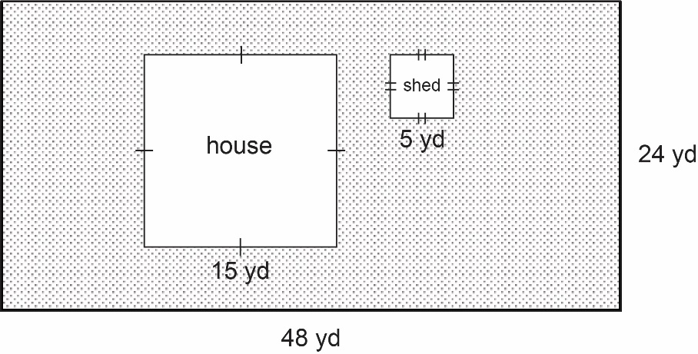
A common error a student may make is calculating the perimeter, rather than the area. This may indicate a need to review vocabulary associated with area and perimeter. It might be helpful for students to underline important information that may indicate what is being asked. Teachers are encouraged to facilitate a discussion where students can list words that indicate area and perimeter. Teachers are also encouraged to provide opportunities for students to read and sort practical problems that utilize area and perimeter, without solving them.
A common error a student may make is adding the areas of the house and shed, rather than subtracting the areas of the house and shed from the area of the yard. This may indicate that a student does not understand negative space. It might be helpful for students to identify the shapes, the necessary formulas, and whether the areas of the shapes will be added or subtracted before beginning the problem. Teachers are encouraged to provide students with hands-on practice that allows a student to see the change in area once a shape has been cut out of another shape.

