Just In Time Quick Check

Standard of Learning (SOL) 7.9c
Strand: Probability and Statistics

Standard of Learning (SOL) 7.9c
The student, given data in a practical situation, will compare histograms with the same data represented in stem-and-leaf plots, line plots, and circle graphs.

Grade Level Skills:
- Compare data represented in histograms with the same data represented in line plots, circle graphs, and stem-and-leaf plots.
Just in Time Quick Check
Just in Time Quick Check Teacher Notes

Supporting Resources:
- VDOE Mathematics Instructional Plans (MIPS)
  - 7.9abc - Numbers in a Name (Word) / PDF Version
  - 7.9c - All Graphs are Not the Same (Word) / PDF Version
- VDOE Word Wall Cards: Grade 7 (Word) | (PDF)
  - Histogram
  - Comparing Graphs: Histogram and Stem and Leaf Graph
  - Comparing Graphs: Histogram and Circle Graph
  - Comparing Graphs: Histogram and Line Plot
Supporting and Prerequisite SOL: 7.9a, 7.9b, 6.10c, 5.16c

SOL 7.9c - Just in Time Quick Check

1. The owner of a restaurant recorded the total amount of fluid ounces of soda that customers consumed on Tuesday. The information was recorded in a stem-and-leaf plot and a histogram.
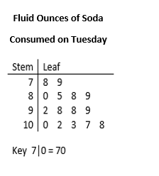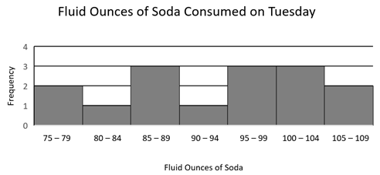
One of the restaurant employees concluded that the median amount of soda that customers consumed that day was between 90 and 94 fluid ounces. Is this employee correct? Explain your thinking, and include evidence from one of the graphs.

2. The manager at a neighborhood pool asked the age of each guest entering the pool between 11:00 and 12:00. The manager created two graphs to show the data on ages of pool guests he collected.
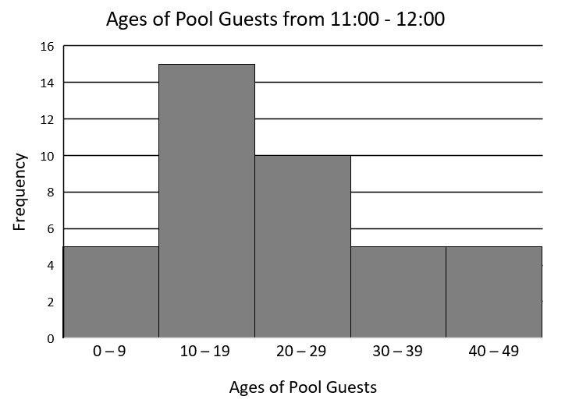
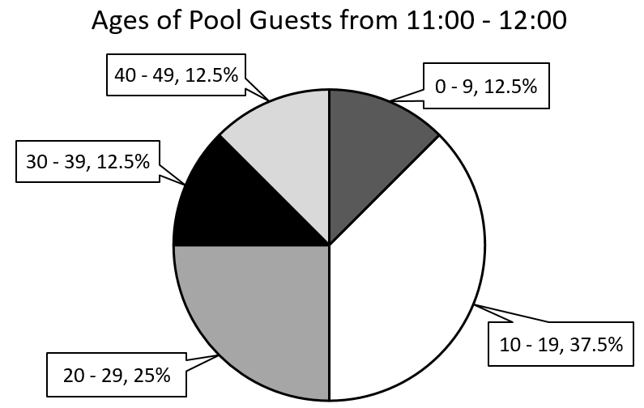

A pool member saw one of the two graphs and made the following statements:
- 15 of the pool guests were ages 10 – 19.
- The pool guests ages 10 – 19 make up 37.5% of the total number of guests.
Which graph did this pool member see? Explain your reasoning.

3. Mrs. Smith asked each of her students how many pets live in their household. The next day, Mrs. Smith represented the household pet data for her students in a line plot and a histogram.
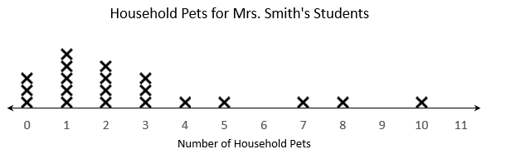

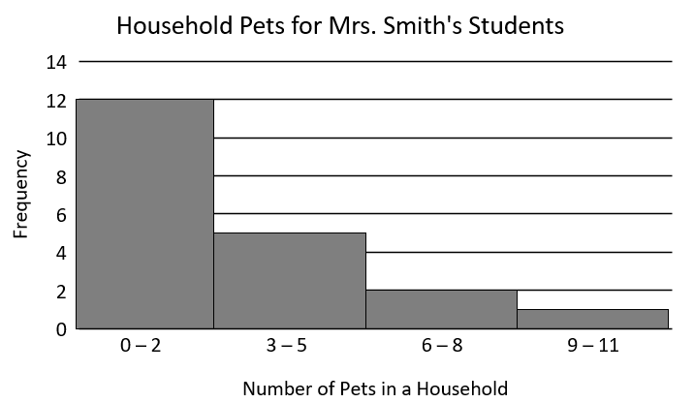

Mrs. Smith asked students to name the graph they could use to determine the range of the household pet data.
- The line plot
- The histogram
- Both the line plot and histogram
Which is correct? Explain how you know.

SOL 7.9c - Just in Time Quick Check Teacher Notes
Common Errors/Misconceptions and their Possible Indications

1. The owner of a restaurant recorded the total amount of fluid ounces of soda that customers consumed on Tuesday. The information was recorded in a stem-and-leaf plot and a histogram.
One of the restaurant employees concluded that the median amount of soda that customers consumed that day was between 90 and 94 fluid ounces. Is this employee correct? Explain your thinking, and include evidence from one of the graphs.
A common error a student may make is to agree that the median amount of soda that customers consume that day way between 90 and 94 fluid ounces. This may indicate that the student mistakenly looked at the middle bar of the histogram and assumed that the middle value would fall within that range. A student could benefit from recording the actual data values from the stem-and-leaf graph onto the bars of the histogram and crossing off individual extreme values until they find the median value. This process will also help to connect the two forms of graphs with one another.

2. The manager at a neighborhood pool asked the age of each guest entering the pool between 11:00 and 12:00. The manager created two graphs to show the data on ages of pool guests he collected.

A pool member saw one of the two graphs and made the following statements:
- 15 of the pool guests were ages 10 – 19.
- The pool guests ages 10 – 19 make up 37.5% of the total number of guests.
Which graph did this pool member see? Explain your reasoning.
A common error a student may make is to name the circle graph as the graph the pool member referenced. This may indicate the student does not understand that the number of data points represented in a section of a circle graph cannot be determined unless the total number of guests is provided. This may also indicate that students do not realize that part to whole comparisons can be made in a histogram by viewing the number of guests in one category and then combining the number of guests in all categories to determine a total number of guests. This part and whole information from the histogram can then be used to calculate a percentage. These students could benefit from activities similar to the VDOE MIP 7.9c – All Graphs are Not the Same that allow them to match circle graphs and histograms. Activities of this type require that students calculate percentages from a histogram in order to determine the matching circle graph.

3. Mrs. Smith asked each of her students how many pets live in their household. The next day, Mrs. Smith represented the household pet data for her students in a line plot and a histogram.

Mrs. Smith asked students to name the graph they could use to determine the range of the household pet data.
- The line plot
- The histogram
- Both the line plot and histogram
Which is correct? Explain how you know.
A common error a student may make is stating that both the line plot and histogram could be used to calculate the range. This may indicate the student does not recognize that individual data points are not represented in a histogram and you are not guaranteed to have data values for each number in a given interval. This student could benefit from making more histograms (SOL 7.9a) and putting brackets beneath each interval on the line plot. This enables the student to see the twelve values in the 0 – 2 interval, the five values in the 3 – 5 interval, the two values in the 6 – 8 interval, and the one value in the 9 – 11 interval. It also allows them to see the last two intervals do not have every value in the interval represented in the data.

