Just In Time Quick Check

Standard of Learning (SOL) 7.9b
Strand: Probability and Statistics

Standard of Learning (SOL) 7.9b
The student, given data in a practical situation, will make observations and inferences about data represented in a histogram.

Grade Level Skills:
- Collect, organize, and represent data in a histogram.
Just in Time Quick Check
Just in Time Quick Check Teacher Notes

Supporting Resources:
- VDOE Mathematics Instructional Plans (MIPS)
  - 7.9abc - Numbers in a Name (Word) / PDF Version
- VDOE Word Wall Cards: Grade 7 (Word) | (PDF)
  - Histogram
- Desmos Activity
  - Histograms
Supporting and Prerequisite SOL: 7.9a, 6.10b, 5.16b

SOL 7.9b - Just in Time Quick Check

Mr. Hamilton surveyed his class to find the total number of hours each of his students slept the previous night. The histogram shows the results of the survey. Use the histogram to answer questions 1 – 3.

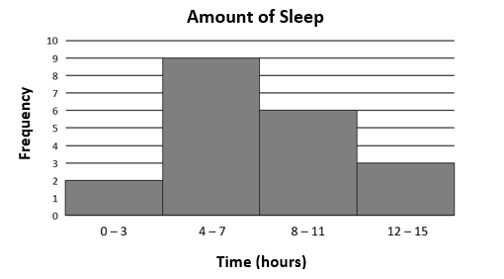

1. What percentage of Mr. Hamilton’s students slept 12 hours or more?

2. How many students slept at least 8 hours?

3. How many more students slept 4 – 7 hours than 12 – 15 hours?

The annual amount of rainfall for 25 cities is shown in the histogram. Use this information to answer questions 4 and 5.

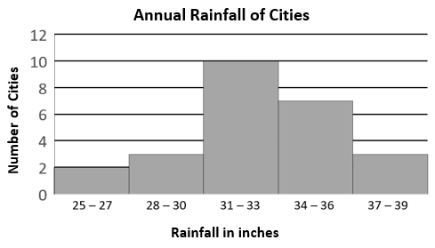

4. What percentage of cities recorded no fewer than 31 inches of annual rainfall?

5. Mrs. Smith asked her students to make observations about the histogram, Annual Rainfall of Cities.
- Sam wrote: There are 3 cities that had an annual rainfall of exactly 30 inches.
- Julie wrote: There were 15 cities with no more than 33 inches of annual rainfall.
- Maria wrote: More than $\frac{1}{2}$ of the cities received 34 or more inches of annual rainfall.
- Antonio wrote: Only 8% of the cities received 25 – 27 inches of annual rainfall.
Which student(s) wrote a true statement about the annual rainfall of cities? Explain your thinking.

6. On a typical summer day, the owners of a local lemonade stand recorded the times they sold lemonades during the day. The results are displayed in the histogram shown.
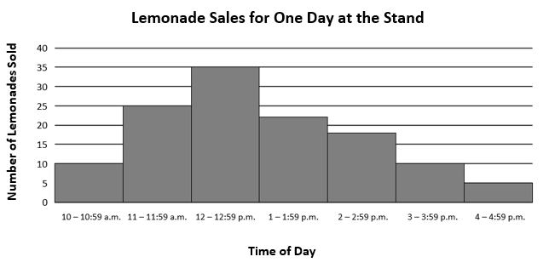
The owners of the local lemonade stand decided to hire one extra worker to help during the day when sales are the highest. Would it be more beneficial to hire an extra worker before or after 1:00 p.m.? Explain your thinking.

SOL 7.9b - Just in Time Quick Check Teacher Notes
Common Errors/Misconceptions and their Possible Indications

Mr. Hamilton surveyed his class to find the total number of hours each of his students slept the previous night. The histogram shows the results of the survey. Use the histogram to answer questions 1 – 3.

1. What percentage of Mr. Hamilton’s students slept 12 hours or more?

A common error a student may make is to inaccurately calculate the percentage, saying that the percentage was 3%, which is the frequency or height of the bin instead of 3 out of 20 or 15%. This may indicate a student has a lack of understanding of how to calculate the percentage of a total. Students may benefit from a review of 6.10b, May I Have Fries with That? where they calculate percentages to create a circle graph which will emphasize the part to whole relationship of a percent.

2. How many students slept at least 8 hours?

A common error is that students will inaccurately interpret the phrasing of “at least” to represent the values of 8 and less instead of hours greater than or equal to 8. Students may also make the error of not including the bin 12-15 as part of the solution. This may indicate the student has a lack of understanding of translating verbal expressions representing inequalities. A student may benefit from a review of representing practical situations with inequalities. For examples of practical situations that can be represented with inequalities and practice translating verbal expressions to inequalities, refer to 6.14a MIP Representing Practical Situations with Inequalities.

3. How many more students slept 4 – 7 hours than 12 – 15 hours?

A common error a student may make is to calculate the sum of the number of students represented in bin 4-7 and bin 12-15 obtaining a value of 12 instead of the difference of 9 and 3 obtaining a value of 6. This may indicate that a student may need additional practice with translating expressions. A student may benefit from brainstorming common mathematical phrases and their translations, as well as practice translating verbal expressions to algebraic expressions. Refer to the MIP Translating Expressions and Equations for examples.

The annual amount of rainfall for 25 cities is shown in the histogram. Use this information to answer questions 4 and 5.

4. What percentage of cities recorded no fewer than 31 inches of annual rainfall?

A common error is that students may inaccurately calculate the percentage neglecting to combine bins. For example, students may find the percentage of bin 31-33 as 10 out of 25 instead of the combined bins 31-33, 34-36 and 37-39 as 20 cities out of 25 cities or 80%. This may indicate students saw 31 inches and only included that bin. Students may benefit from highlighting important information in the question stem, such as “no fewer than 31 inches” and then highlighting the corresponding bins before calculating the percentage.

5. Mrs. Smith asked her students to make observations about the histogram, Annual Rainfall of Cities.
- Sam wrote: There are 3 cities that had an annual rainfall of exactly 30 inches.
- Julie wrote: There were 15 cities with no more than 33 inches of annual rainfall.
- Maria wrote: More than $\frac{1}{2}$ of the cities received 34 or more inches of annual rainfall.
- Antonio wrote: Only 8% of the cities received 25 – 27 inches of annual rainfall.
Which student(s) wrote a true statement about the annual rainfall of cities? Explain your thinking.

A common error is students may believe that Sam’s statement of “There are 3 cities that had an annual rainfall of exactly 30 inches” is true. This may indicate that students believe individual data points can be seen in a histogram. These students may benefit from more experiences constructing histograms and then comparing the histogram to the original data set to see that the histogram shows the range in which a data point falls, but no longer gives information about the specific value of each data point.

6. On a typical summer day, the owners of a local lemonade stand recorded the times that they sold lemonades during the day. The results are displayed in the histogram shown.
The owners of the local lemonade stand decided to hire one extra worker to help during the day when sales are the highest. Would it be more beneficial to hire an extra worker before or after 1:00 p.m.? Explain your thinking.
A common misconception is a student may believe that it would be more beneficial to hire the extra worker after 1:00 since there are four intervals from 1:00 p.m. to 5:00 p.m., but only three beforehand. This type of error might indicate that students believe the greater the number of intervals leads to a greater quantity of sales and do not take into account the number of items sold. They may also make this error by making an inference based on a personal preference that they enjoy lemonade in the afternoon instead of making inferences based on the data presented in the histogram. This may indicate the student does not have a strong foundation with the concept of making inferences from a histogram. Students making these errors could benefit from more practice looking at histograms and making inferences. Enabling class discussions around possible inferences in relation to a given histogram would help to promote this type of thinking for students. Refer to the MIP Numbers in a Name for examples of inference questions.

