Just In Time Quick Check

Standard of Learning (SOL) 7.9a
Strand: Probability and Statistics

Standard of Learning (SOL) 7.9a
The student, given data in a practical situation, will represent data in a histogram.

Grade Level Skills:
- Collect, organize, and represent data in a histogram.
Just in Time Quick Check
Just in Time Quick Check Teacher Notes

Supporting Resources:
- VDOE Mathematics Instructional Plans (MIPS)
  - 7.9abc - Numbers in a Name (Word) / PDF Version
- VDOE Algebra Readiness Remediation Plans
  - Histograms (Word) / PDF
- VDOE Word Wall Cards: Grade 7 (Word) | (PDF)
  - Histogram
- Desmos Activity
  - Histograms
Supporting and Prerequisite SOL: 6.10a, 5.16a

SOL 7.9a - Just in Time Quick Check

1.) The table shows homeruns the Cardinals’ players had in the 2019 baseball season. Create a histogram that correctly represents the data.

Cardinal Homeruns in the 2019 Season
Player | Homeruns
Player 1 | 11
Player 2 | 29
Player 3 | 11
Player 4 | 2
Player 5 | 34
Player 6 | 5
Player 7 | 0
Player 8 | 10
Player 9 | 15
Player 10 | 2
Player 11 | 30
Player 12 | 2
Player 13 | 11
Player 14 | 12
Player 15 | 19

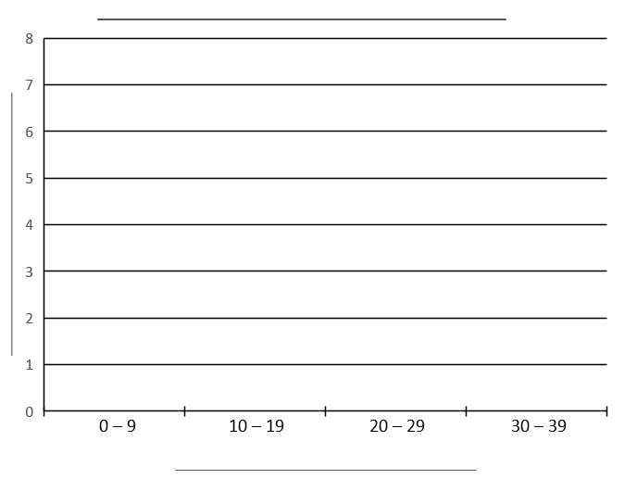

2.) The following set of data represents the scores on a mathematics quiz:
58, 79, 81, 99, 68, 92, 76, 84, 53, 57, 81, 91, 77, 50, 65, 57, 51, 72, 84, 89
Create a histogram to correctly represent this data.

Scores on a Mathematics Quiz
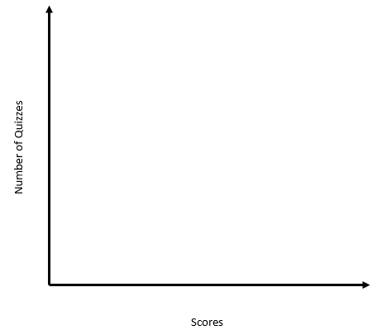

SOL 7.9a - Just in Time Quick Check Teacher Notes
Common Errors/Misconceptions and their Possible Indications

1.) The table shows homeruns the Cardinals’ players had in the 2019 baseball season. Create a histogram that correctly represents the data.

Cardinal Homeruns in the 2019 Season
Player | Homeruns
Player 1 | 11
Player 2 | 29
Player 3 | 11
Player 4 | 2
Player 5 | 34
Player 6 | 5
Player 7 | 0
Player 8 | 10
Player 9 | 15
Player 10 | 2
Player 11 | 30
Player 12 | 2
Player 13 | 11
Player 14 | 12
Player 15 | 19

A common error is for a student to incorrectly label the horizontal axis as players and the vertical axis as the number of homeruns. This may indicate that the student is still confusing a histogram with a bar graph. In a bar graph, the data in the first column of the table is usually displayed on the x-axis, and the data from the second column is usually displayed on the y-axis. These students need to review that a histogram presents an analysis of a set of numerical data by showing the frequency with which pieces of data fall within given intervals, or bins. Refer to the histogram card provided in the VDOE Word Wall Cards: Grade 7. These students may also benefit from more experiences collecting data and representing the data in a histogram. Refer to the Mathematics Instructional Plan 7.9abc - Numbers in a Name.
2.) The following set of data represents the scores on a mathematics quiz:
58, 79, 81, 99, 68, 92, 76, 84, 53, 57, 81, 91, 77, 50, 65, 57, 51, 72, 84, 89
Create a histogram to correctly represent this data.

Scores on a Mathematics Quiz
A common error for students is to create bins that do not represent equal intervals of data or to struggle with determining how to set up the intervals so that they are suitable for the data set provided. This may indicate that the student has limited experience analyzing the entire set of data and considering the range of each interval. Many of these students feel that the interval 0 – 5 and the interval 6 – 10 are equal intervals. They need practice finding the range for a given interval. For example, the interval 0 – 5 has a range of 5 while the interval 6 – 10 has a range of 4. A possible strategy to use with students who struggle to determine suitable intervals is to organize the data in ascending order and find the difference between the highest and lowest value and then add one to that difference (i.e., 99 – 50 = 49 and 49 + 1 = 50). A student could use the value of 50 to divide by one of its factors to obtain equal intervals of data. For example, 50/10 = 5. A student could set up 5 equal intervals of data that each have a range of 10. Alternatively, a student could use 50/5 to obtain 10 intervals all of which have a range of 5.

