Just In Time Quick Check
Standard of Learning (SOL) 7.12
Strand: Patterns, Functions, and Algebra

Standard of Learning (SOL) 7.12
The student will solve two-step linear equations in one variable, including practical problems that require the solution of a two-step linear equation in one variable.

Grade Level Skills:
- Represent and solve two-step linear equations in one variable using a variety of concrete materials and pictorial representations.
- Apply properties of real numbers and properties of equality to solve two-step linear equations in one variable. Coefficients and numeric terms will be rational.
- Confirm algebraic solutions to linear equations in one variable.
- Write verbal expressions and sentences as algebraic expressions and equations.
- Write algebraic expressions and equations as verbal expressions and sentences.
- Solve practical problems that require the solution of a two-step linear equation.
Just in Time Quick Check
Just in Time Quick Check Teacher Notes

Supporting Resources:
- VDOE Mathematics Instructional Plans (MIPS)
  - 7.12 - Solving Two-Step Equations (Word) / PDF Version
  - 7.12 - Translating Expressions and Equations (Word) / PDF Version
- VDOE Co-Teaching Mathematics Instruction Plans (MIPS)
  - 7.12 - Solving Equations (Word) / PDF Version
- VDOE Algebra Readiness Formative Assessments
  - SOL 7.12 (Word) / PDF
- VDOE Algebra Readiness Remediation Plans
  - Applying Properties of Real Numbers When Solving Equations (Word) / PDF
  - Solving Equations - Applying Properties (Word) / PDF
  - Solving Equations Using Algebra Tiles (Word) / PDF
  - Solving Two-Step and Multi-Step Equations (Word) / PDF
  - Solving Practical Problems Using Two-Step Equations (Word) / PDF
- VDOE Word Wall Cards: Grade 7 (Word) | (PDF)
  - Verbal and Algebraic Expressions and Equations
  - Equations
- Desmos Activity
  - Translating Expressions and Equations Card Sorts
Supporting and Prerequisite SOL: 7.11, 6.5a, 6.6a, 6.6c, 6.13, 5.5a, 5.6a, 5.6b, 5.19a, 5.19b, 5.19c, 5.19d

SOL 7.12 - Just in Time Quick Check
- Solve for $x$.
  - $2x-4=-20$
  - $\frac{1}{3}x+5=14$
  - $\frac{x+7}{3}=4$
- George and Sarah each solved the same equation. Their work is shown below.
George’s Work
$$4x-\frac{3}{4}=9$$
$$4x-\frac{3}{4}+\frac{3}{4}=9+\frac{3}{4}$$
$$4x=9\frac{3}{4}$$
$$4x÷4=9\frac{3}{4}÷4$$
$x=\frac{39}{16}$

Sarah’s Work
$$4x-\frac{3}{4}=9$$
$$4x-\frac{3}{4}·\frac{4}{3}=9·\frac{4}{3}$$
$$4x=12$$
$$4x÷4=12÷4$$
$x=3$

Who was correct? Explain how you know.
- Write the verbal sentence as an algebraic equation.
  - The product of a three and a number plus five is 20.
  - Nine less than a number is four.

- The monthly fees to swim at the community pool are below.
- $8 cleaning fee once a month
- $2 fee per visit to the pool
- If Hector paid a total of $34 in pool fees for the month, write an equation that could be used to determine how many times Hector visited the pool.
- How many times did Hector visit the pool this month?
- The balance scale represents an equation.
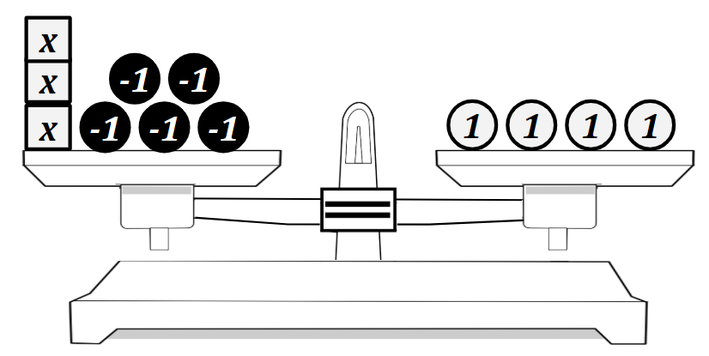
Write an equation for this model and solve for $x$.
SOL 7.12 - Just in Time Quick Check Teacher Notes
Common Errors/Misconceptions and their Possible Indications
- Solve for $x$.
  - $2x-4=-20$
A student may incorrectly apply inverse operations resulting in a solution of$-12 or$
$-24 if the student does not divide by 2$. This error indicates a misunderstanding in applying inverse operations to solve a two-step equation. A student may benefit from additional practice with one-step equations. Reference SOL 6.13 in the Math 6 curriculum framework for examples of these problems. A student may also benefit from practice modeling equations with concrete manipulatives such as algebra tiles.
  - $\frac{1}{3}x+5=14$
After subtracting 5 from both sides, a student may incorrectly divide both sides by 3 instead of multiplying by 3. A student may benefit from additional practice with solving one-step equations involving fractional coefficients. Additional practice dividing fractions may help students recognize that a fraction multiplied by its reciprocal will result in a product of one.
  - $\frac{x+7}{3}=4$
A student may incorrectly subtract seven from both sides of the equation first, resulting in a solution of $x=-9$. This error indicates a misconception that $\frac{x+7}{3}=4$ is the same as
$\frac{x}{3}+7=4$. The student may need additional instruction and practice with solving equations that include an expression involving addition or subtraction divided by a constant (implied parentheses).
- George and Sarah each solved the same equation. Their work is shown below.
George’s Work
$$4x-\frac{3}{4}=9$$
$$4x-\frac{3}{4}+\frac{3}{4}=9+\frac{3}{4}$$
$$4x=9\frac{3}{4}$$
$$4x÷4=9\frac{3}{4}÷4$$
$x=\frac{39}{16}$

Sarah’s Work
$$4x-\frac{3}{4}=9$$
$$4x-\frac{3}{4}·\frac{4}{3}=9·\frac{4}{3}$$
$$4x=12$$
$$4x÷4=12÷4$$
$x=3$

Who was correct? Explain how you know.
A common error a student may make is to multiply the fractional constant by the reciprocal, resulting in incorrectly identifying Sarah as correct. This indicates confusion in applying inverse operations with fractional coefficients and fractional constants. The student may benefit from additional practice in solving one- and two-step equations involving fractional coefficients and constants. The student may also benefit from practice confirming algebraic solutions to linear equations in one variable.
- Write the verbal sentence as an algebraic equation.
  - The product of a three and a number plus five is 20.
A common error a student may make is to translate the meaning of product as a sum resulting in an answer of $3+x+5=20$. This error would indicate a learning gap in operational vocabulary. A student may benefit from additional practice with one-step equations or expressions with variables. Reference VDOE MIP: 7.12 - Translating Expressions and Equations. It may also be helpful to practice numerical expressions or equations where the student can reason an answer mentally and then verify with their algebraic equation.
  - Nine less than a number is four.
The student may incorrectly write the answer as 9 – x = 4. This indicates the student understands that “less than” represents subtraction but does not make the connection of reversing the order of the expression on the left side of the equation. The student may benefit from a review the concept of subtraction, particularly that it is not commutative. Additional practice with non-variable equations that students can solve mentally may be effective as well.
- The monthly fees to swim at the community pool are below.
- $8 cleaning fee once a month
- $2 fee per visit to the pool
- If Hector paid a total of $34 in pool fees for the month, write an equation that could be used to determine how many times Hector visited the pool.
A student may make the mistake of writing $8x+2=34$. This error indicates that the student is struggling conceptualizing the scenario and transferring that into an algebraic equation. A student may need additional practice with writing equations from practical scenarios.
- How many times did Hector visit the pool this month?
A student may incorrectly answer that Hector visited the pool 4 times. This error may indicate that the student struggles to conceptualize practical problems and transfer to a mathematical context. A student may need additional practice with writing equations from practical scenarios.
- The balance scale represents an equation
Write an equation for this model and solve for $x$.
A common error a student may make is to incorrectly write an expression rather than an equation resulting in 3x – 5 + 4. This error indicates that the student is not making the connection between pictorial and symbolic representations of equations. Another common error a student may make is to translate the model as $3x+5=4.$ This indicates a misunderstanding of negative numbers and how they are represented.
A student may benefit from exposure to different visual representations of equations including pictorial representations, balance scales, and algebra tiles. Colored tiles, balance scales, and algebra tiles are all great choices. There are also many online interactive tools that can be helpful in building conceptual understanding. Reference VDOE Math Instructional Plan 6.13 - Modeling One-Step Linear Equations (Word) / PDF Version for modeling one-step equations.

