Just In Time Quick Check
Standard of Learning (SOL) 7.10e
Strand: Patterns, Functions, and Algebra

Standard of Learning (SOL) 7.10e
The student will make connections between and among representations of a proportional or additive relationship between two quantities using verbal descriptions, tables, equations, and graphs.

Grade Level Skills:
- Make connections between and among representations of a proportional or additive relationship between two quantities using verbal descriptions, tables, equations, and graphs.
Just in Time Quick Check
Just in Time Quick Check Teacher Notes

Supporting Resources:
- VDOE Mathematics Instructional Plans (MIPS)
  - 7.10e - Making Connections (Word) / PDF Version
  - 7.10ab- Discover Slope (m) (Word) / PDF Version
  - 7.10cd - Discover y-intercept (b) (Word) / PDF Version
- VDOE Algebra Readiness Formative Assessments
  - SOL 7.10e (Word) / PDF
- VDOE Algebra Readiness Remediation Plans
  - Making Connections between Representations (Word) / PDF
- VDOE Word Wall Cards: Grade 7 (Word) | (PDF)
  - Connecting Representations: Proportional Relationship
  - Connecting Representations: Additive Relationship
- VDOE Rich Mathematical Tasks: Name of on-grade-level Task
  - 7.10 Summer Passes Task Template (Word) / PDF Version
- Desmos Activity
  - Making Connections SOL 7.10e
Supporting and Prerequisite SOL: 7.10a, 7.10b, 7.10c, 7.10d, 6.12a, 6.12b, 6.12c, 6.12d

SOL 7.10e - Just in Time Quick Check
- Louis and Jenny each wrote an equation to represent the linear function graphed below.
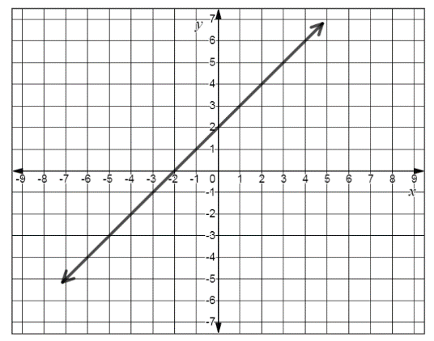
- Louis’s answer is $y=2x$.
- Jenny’s answer is $y=x+2$.
Which student is correct? Explain your answer.
- Match each representation with an equation.
The bakery uses three cups of flour for each of their sheet cakes. Let x represent the number of cakes and y represent the cups of flour. | x y  -2 -1  0 0  2 1  4 2 | 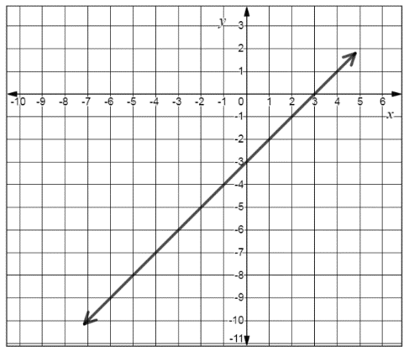
$y=\frac{1}{2}x$ $y=x+2$ $y=3x$ $y=x-3$

- Select each representation that could represent the same relationship.
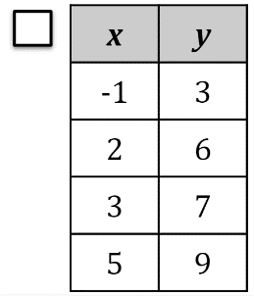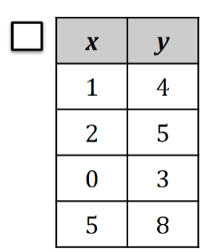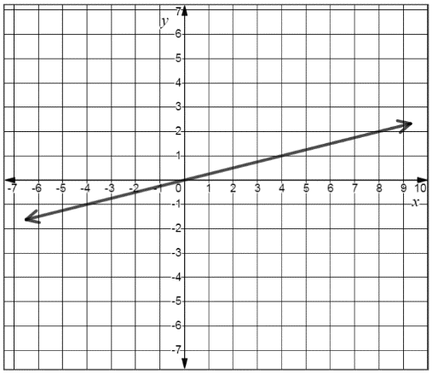
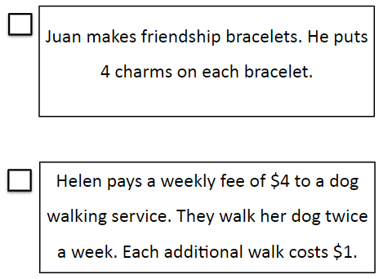
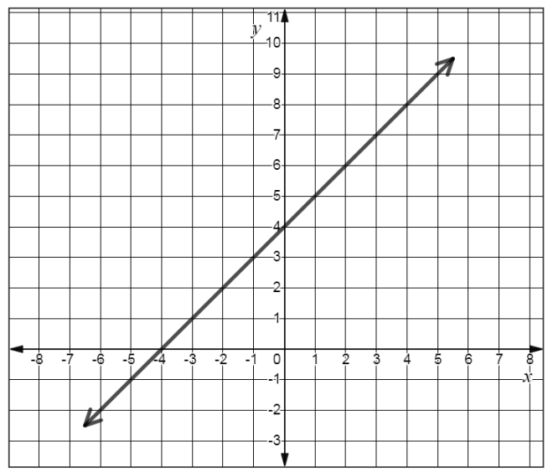

- Erica is designing a new town park. Every 5 yards of bike path, will require 3 hours of clearing and paving. Erica graphed this relationship between the number of yards of bike path, $x$, and the number of hours of clearing and paving, $y$.
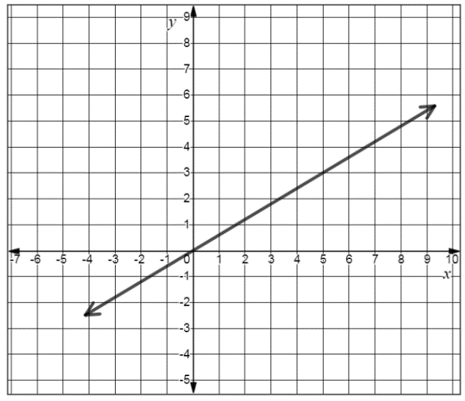

Did Erica graph the relationship correctly? Explain your answer.

SOL 7.10e - Just in Time Quick Check Teacher Notes

Common Errors/Misconceptions and their Possible Indications
- Louis and Jenny each wrote an equation to represent the linear function graphed below.
- Louis’s answer is $y=2x$.
- Jenny’s answer is $y=x+2$.
Which student is correct? Explain your answer.
A common error a student may make is to interpret the y-intercept as the value that represents the slope of the line and answer that Louis is correct. This type of error may indicate a student cannot differentiate between an additive and a proportional relationship. A student may benefit from choosing an ordered pair on the graph of the line shown and substitute that ordered pair into the equation to determine if it satifies the condition. For example, a student could choose to substitute the ordered pair (3, 5) and the ordered pair (-4, -2) into each equation to determine if they both produce a true statement. In addition, a student may benefit from additional practice writing equations for additive and proportional relationships. (Mathematics Instructional Plans - 7.10ab - Discover Slope (m) and 7.10cd - Discover y-intercept (b))

2. Match each representation with an equation.
A baker uses three cups of flour for each sheet cake she makes. Let x represent the number of cakes made and y represent the cups of flour used. | x y  -2 -1  0 0  2 1  4 2 | 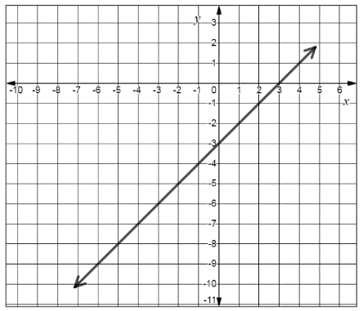
$y=\frac{1}{2}x$ $y=x+2$ $y=3x$ $y=x-3$

A student may incorrectly match the graph with the equation $y=3x,$ thinking the x-intercept of three represents the slope of the line. A student may incorrectly match the table with the equation $y=x+2$ using the ordered pairs (0, 0) and (4, 2) and substituting for the wrong variable. These errors may indicate confusion distinguishing between additive relationships and proportional relationships when presented with multiple representations of linear functions. The student may benefit from additional practice using the Mathematics Instructional Plans - 7.10e - Making Connections.

3. Select each representation that could be represent the same relationship.
A common error a student may have is interpreting the meaning of a contextual scenario in relation to additive or proportional relationship. This type of error may indicate that a student may be having difficulty with translating a verbal description into a tabular, symbolic, or graphical representation that is equivalent. For example, a student may not select the scenario about the dog walking service because they incorrectly write the equation for that scenario as $y=4x$. Another error may be for a student to write an equation of $y=x+4$ for the scenario about the friendship bracelets. The student may benefit from additional practice writing linear equations from verbal representations. Refer to Algebra Readiness Remediation Plans - Making Connections between Representations for additional examples.

4. Erica is designing a new town park. Every 5 yards of bike path, will require 3 hours of clearing and paving. Erica graphed this relationship between the number of yards of bike path, $x$, and the number of hours of clearing and paving, $y$.

Did Erica graph the relationship correctly? Explain your answer.
A student may state that Erica’s graph is incorrect because the line shown should have a slope of $\frac{5}{3}$ . This error indicates that a student may be struggling with interpreting the slope of the real-world scenario and using the ratio of y to x. A student may benefit from additional practice with connecting proportional relationships to practical applications where the slope must interpreted.

