Just In Time Quick Check
Standard of Learning (SOL) 7.10d
Strand: Patterns, Functions, and Algebra

Standard of Learning (SOL) 7.10d
The student will graph a line representing an additive relationship between two quantities given the y-intercept and an ordered pair, or given the equation in the form y = x + b, where b represents the y-intercept.

Grade Level Skills:
- Graph a line representing an additive relationship (y = x + b, b ≠ 0) between two quantities, given an ordered pair on the line and the y-intercept (b). The y-intercept (b) is limited to integer values and slope is limited to 1.
- Graph a line representing an additive relationship between two quantities, given the equation in the form y = x + b, b ≠ 0. The y-intercept (b) is limited to integer values and slope is limited to 1.
Just in Time Quick Check
Just in Time Quick Check Teacher Notes

Supporting Resources:
- VDOE Mathematics Instructional Plans (MIPS)
  - 7.10cd - Discover y-intercept (b) (Word) / PDF Version
- VDOE Algebra Readiness Formative Assessments
  - SOL 7.10d (Word) / PDF
- VDOE Algebra Readiness Remediation Plans
  - Y-Intercept and Additive Relationships (Word) / PDF
- VDOE Word Wall Cards: Grade 7 (Word) | (PDF)
  - Additive Relationship: y = x + b
  - Additive Relationship
  - Graphing Linear Relationships
- Desmos Activity
  - SOL 7.10cd Y-Intercept Investigation
Supporting and Prerequisite SOL: 7.10c, 6.8b, 5.18

SOL 7.10d - Just in Time Quick Check
- Graph the line that passes through (-2, 3) and has a y-intercept of 5. Graph at least two additional points that lie on this line.
y
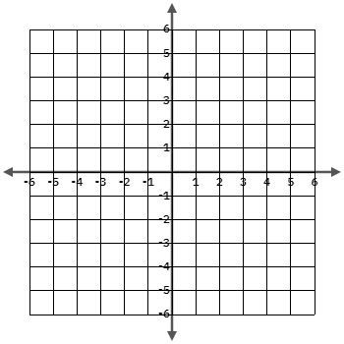
x
- Plot two points that lie on the line represented by this equation, $y=x-2$.
y
x

- Graph the line that passes through (-3, -6) and has a y-intercept of -3. Plot two points that lie on this line.
y
x
- Write the equation of the line representing the relationship shown in the graph.
y
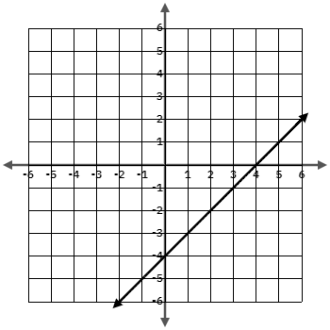
x

SOL 7.10d - Just in Time Quick Check Teacher Notes
Common Errors/Misconceptions and their Possible Indications

- Graph the line that passes through (-2, 3) and has a y-intercept of 5. . Graph at least two additional that lie on this line.
A common mistake is to use the y-intercept value to plot both the x-intercept and y-intercept. This error indicates the student does not understand what the y-intercept or b in the equation represents. A student may need additional practice with additive relationships as well as identifying the y-intercept from a graph and from an equation separately to build understanding. One resource is the VDOE MIP: 7.10cd - Discover y-intercept (b).
- Plot two points that lie on the line represented by this equation, $y=x-2$.

A common error that a student may make is to graph the line y = x + 2. This may indicate that a student is plotting an x-intercept of -2 instead of a y-intercept of -2. A student may benefit from additional practice graphing lines with negative y-intercepts. Another common error is to graph $y=2x$. This may indicate the student is having trouble differentiating between additive and multiplicative relationships. Reference the VDOE Algebra Readiness lesson, Y-Intercept and Additive Relationships, and formative assessement items, SOL 7.10d for additional examples and practice.

- Graph the line that passes through (-3, -6) and has a y-intercept of -3. Plot two points that lie on this line.
A common error a student may make is to graph (-6, -3) and/or plot an x-intercept of -3. Each of these errors may indicate confusion graphing ordered pairs and differentiating between the x- and y-axis. A student may benefit from additional practice plotting points (reference VDOE MIP 6.8ab - What's the Point?).

- Write the equation of the line representing the relationship shown in the graph.
A common error a student may make is to use the y-intercept as the slope and write the equation $y=-4x$. This indicates that the student may not understand the difference between $y=mx$ and $y=x+b$. A student may benefit from additional practice writing equations from additive graphs and verifying with ordered pairs or intercepts (reference the Desmos activity SOL 7.10cd Y-Intercept Investigation). Additional practice could also include creating a table with points from the graph and use the table to write the equation of the graph.

