Just In Time Quick Check
Standard of Learning (SOL) 7.10c
Strand: Patterns, Functions, and Algebra

Standard of Learning (SOL) 7.10c
The student will determine the y-intercept, b, in an additive relationship between two quantities and write an equation in the form y = x + b to represent the relationship.

Grade Level Skills:
- Determine the y-intercept, b, in an additive relationship between two quantities given a table of values or a verbal description, including those represented in a practical situation, and write an equation in the form y = x + b, b ≠ 0, to represent the relationship.
Just in Time Quick Check
Just in Time Quick Check Teacher Notes

Supporting Resources:
- VDOE Mathematics Instructional Plans (MIPS)
  - 7.10cd - Discover y-intercept (b) (Word) / PDF Version
- VDOE Algebra Readiness Formative Assessments
  - SOL 7.10c (Word) / PDF
- VDOE Algebra Readiness Remediation Plans
  - Y-Intercept and Additive Relationships (Word) / PDF
- VDOE Word Wall Cards: Grade 7 (Word) | (PDF)
  - Additive Relationship: y = x + b
  - Additive Relationship
- Desmos Activity
  - SOL 7.10cd Y-Intercept Investigation
Supporting and Prerequisite SOL: 6.8b

SOL 7.10c - Just in Time Quick Check

- The table of values represents a relationship between $x$and $y$.
$$x$$ | $$y$$
0 | 3
2 | $$5$$
3 | 6
  - Determine the y-intercept of the line that passes through the points represented by the values in this table.
  - Write an equation of the line that contains each point represented by this table of values.
- A movie theater is offering a coupon for $3 off each regular ticket price.
- Let $x$ represent the regular ticket price.
- Let $y$ represent the discounted ticket price.
Write an equation that represents the relationship between the regular ticket price, $x$, and the discounted ticket price, $y$.
- The table of values represents a relationship between $x$and $y$.
$$x$$ | $$y$$
5 | 4
1 | $$0$$
-2 | -3
  - Determine the y-intercept of the line that passes through the points represented by the values in this table.
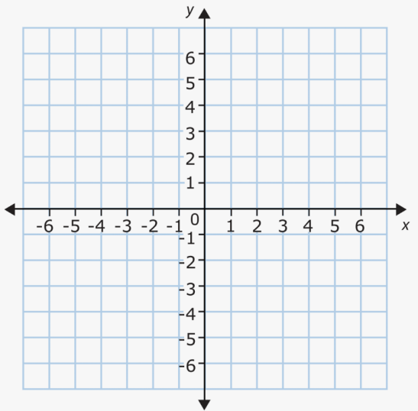
  - Write an equation of the line representing this relationship between $x$and $y$.

SOL 7.10c - Just in Time Quick Check Teacher Notes
Common Errors/Misconceptions and their Possible Indications

- The table of values represents a relationship between $x$and $y$.
$$x$$ | $$y$$
0 | 3
2 | $$5$$
3 | 6
  - Determine the y-intercept of the line that passes through the points represented by the values in this table.
A common misconception is listing zero for the y-intercept. This would indicate that the student is using the x-coordinate for the y-intercept value. Another common error would be to use the change in y-values of the first two ordered pairs in the table to represent the y-intercept resulting in a y-intercept of two. This error indicates the student is confusing how to determine the slope and the y-intercept from a table. A student may benefit from additional practice determining the y-intercept from a table. Refer to the VDOE Algebra Readiness Remediation Plans: Y-Intercept and Additive Relationships.
  - Write an equation of the line that contains each point represented by this table of values.
A common error that a student may make is to use the change in y-values as the y-intercept and writing an equation of $y = x+ 2$. This indicates that a student is confusing the y-intercept with the change in y-values of the first two ordered pairs. A student may benefit from practice writing the equation of additive relationships in the VDOE Algebra Readiness Remediation Plan: Y-Intercept and Additive Relationships.

- A movie theater is offering a coupon for $3 off each regular ticket price.
- Let $x$ represent the regular ticket price.
- Let $y$ represent the discounted ticket price.
Write an equation that represents the relationship between the regular ticket price, $x$, and the discounted ticket price, $y$.
A common error would be to misinterpret the meaning of the coupon and write the equation as $y=x+3$. A student may not understand that a coupon reduces the amount paid. Students may not know how to write the equation for an additive relationship with a negative number and may not understand the difference between $x+(-3)$ and $x+3$or $x-3$. A student may benefit from additional practice with integers. Reference the Journal/Writing Prompts section of the 7.10cd Math Instructional Plan.

- The table of values represents a relationship between $x$and $y$.
$$x$$ | $$y$$
5 | 4
1 | $$0$$
-2 | -3
  - Determine the y-intercept of the line that passes through the points represented by the values in this table.
A common error is a student may identify the y-intercept value as 1. This indicates that a student used the x-intercept value instead of the y-intercept value. A possible strategy would be to graphically represent the points in the table to determine the y-intercept. 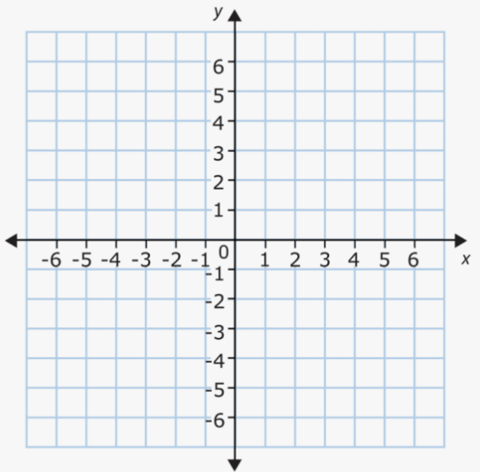

  - Write an equation of the line representing this relationship between x and y.
A student may incorrectly write the equation, $y=x+1$. This indicates a student may not be distinguishing between x- and y-values. A student may benefit additional practice graphing points from a table, writing an equation, and using the values in the table to verify their equations. Refer to VDOE Mathematics Instructional Plans: 7.10cd - Discover y-intercept (b) for additional practice.

