Just In Time Quick Check
Standard of Learning (SOL) 7.10b
Strand: Patterns, Functions, and Algebra

Standard of Learning (SOL) 7.10b
The student will graph a line representing a proportional relationship between two quantities given the slope and an ordered pair, or given the equation in y = mx form where m represents the slope as rate of change.

Grade Level Skills:
- Graph a line representing a proportional relationship, between two quantities given an ordered pair on the line and the slope, m, as rate of change. Slope will be limited to positive values.
- Graph a line representing a proportional relationship between two quantities given the equation of the line in the form y = mx, where m represents the slope as rate of change. Slope will be limited to positive values.
Just in Time Quick Check
Just in Time Quick Check Teacher Notes

Supporting Resources:
- VDOE Mathematics Instructional Plans (MIPS)
  - 7.10ab - Discover Slope (m) (Word) / PDF Version
- VDOE Algebra Readiness Formative Assessments
  - SOL 7.10b (Word) / PDF
- VDOE Algebra Readiness Remediation Plans
  - Slope-Rate of Change in Proportional Relationship (Word) / PDF
- VDOE Word Wall Cards: Grade 7 (Word) | (PDF)
  - Slope
  - Graphing Linear Relationships
  - Proportional Relationship: y=mx
- Desmos Activity
  - Slope Investigation Student Activity
Supporting and Prerequisite SOL: 7.10a, 6.1, 6.8b, 6.12a, 6.12b, 6.12c, 5.18

SOL 7.10b - Just in Time Quick Check
- Graph the line that passes through (-6, -4) and has a slope of$\frac{2}{ 3}$. Plot at least two additional points that lie on the line.
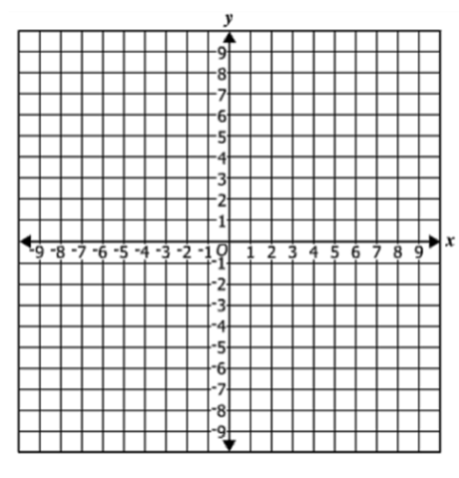
- Graph the line that represents$y=2x$. Plot at least 3 points on this line.

- Graph the line that represents $y=\frac{5}{4}x$. Plot at least 3 points on this line.
4. Write the equation of the line representing the same relationship shown in the graph.

SOL 7.10b - Just in Time Quick Check Teacher Notes
Common Errors/Misconceptions and their Possible Indications

- Graph the line that passes through (-6, -4) and has a slope of $\frac{2}{3}$. List two points that lie on the line.
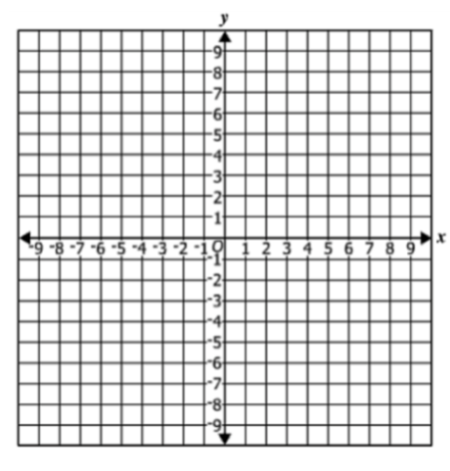
A common error a student may make is to plot the reciprocal slope, $m=\frac{3}{2}$. This indicates that there may be confusion with regards to the meaning of slope as the $\frac{change in y-values}{change in x-values}$. A student may benefit from practice finding slope from two points on a graph or graphing from a table of values. Refer to 6.12c for additional examples of finding the slope between two points. (Math 6 Curriculum Framework)

- Graph the line that represents $y=2x$. Plot at least 3 points on this line.
A student may incorrectly use the slope value of two as the x- and y-intercept values, plotting (0, 2) an (2, 0). This indicates the student may not understand slope as the $\frac{change in y-values}{change in x-values}$. The student may benefit from practice deriving slope from the graph of a line in the form of $y=mx$.

Another common example is students do not include (0, 0) in the graph of the line. This indicates the student does not understand all proportional relationships go through the origin. Students may benefit from a review of the vocabulary associated with proportional relationships, specifically slope and proportional relationship. (see Math 7 Word Wall cards)

- Graph the line that represents $y=\frac{5}{4}x$. Plot at least 3 points on this line.
A common mistake a student may make is to use the numerator and denominator to plot the point (5, 4). This indicates a student may be think slope is a point on a line instead of the $\frac{change in y-values}{change in x-values}$ . A student may benefit from additional practice writing and graphing equations in the form $y=mx$ using the Desmos Activity: 7.10ab – Slope Investigation Student Activity.

4. Write the equation of the line representing the same relationship shown in the graph.
A student may incorrectly represent the line with the equation $y=\frac{1}{3}x$. This indicates that the student has identified the slope of the line as change in $x-values$ over change in $y-values$. The student may benefit from more practice finding the slope from two points on a graph. Refer to 7.10a Quick Check or VDOE Algebra Readiness Formative Assessments: SOL 7.10a for additional practice determining the slope of two points.

