Just In Time Quick Check
Standard of Learning (SOL) 7.7
Strand: Measurement and Geometry

Standard of Learning (SOL) 7.7
The student will apply translations and reflections of right triangles or rectangles in the coordinate plane.

Grade Level Skills:
- Given a preimage in the coordinate plane, identify the coordinates of the image of a right triangle or rectangle that has been translated either vertically, horizontally, or a combination of a vertical and horizontal translation.
- Given a preimage in the coordinate plane, identify the coordinates of the image of a right triangle or a rectangle that has been reflected over the x- or y-axis.
- Given a preimage in the coordinate plane, identify the coordinates of the image of a right triangle or rectangle that has been translated and reflected over the x- or y-axis or reflected over the x- or y-axis and then translated.
- Sketch the image of a right triangle or rectangle that has been translated vertically, horizontally, or a combination of both.
- Sketch the image of a right triangle or rectangle that has been reflected over the x- or y-axis.
- Sketch the image of a right triangle or rectangle that has been translated and reflected over the x- or y-axis or reflected over the x- or y-axis and then translated.
Just in Time Quick Check
Just in Time Quick Check Teacher Notes

Supporting Resources:
- VDOE Mathematics Instructional Plans (MIPS)
  - 7.7 - Translation and Reflection (Word) / PDF Version
- VDOE Algebra Readiness Remediation Plans
  - Reflections (Word) / PDF
  - Transformations (Word) / PDF
  - Translations (Word) / PDF
- VDOE Word Wall Cards: Grade 7 (Word) | (PDF)
  - Reflection
  - Translation
- Other VDOE Resources
  - Translations and Reflections [eMediaVA]
  - Translations and Reflections Activity Sheet [eMediaVA]
- Desmos Activity
  - Polygraph: Transformations
Supporting and Prerequisite SOL: 7.5, 6.8a, 6.8b, 6.9, 5.14a

SOL 7.7 -Just in Time Quick Check

- Complete sections a and b using the coordinate plane below. The vertices of the triangle shown have integral coordinates.
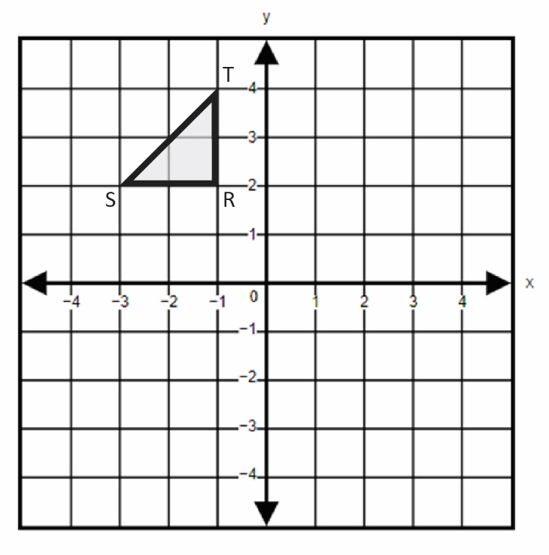
  - Identify the coordinates of the image of triangle RST after a translation 5 units to the right.
  - Identify the coordinates of the image of triangle RST after a reflection over the x-axis.

- Triangle XYZ is shown on the grid. Reflect triangle XYZ across the y-axis and then translate up 4 units. What are the coordinates of Z’?
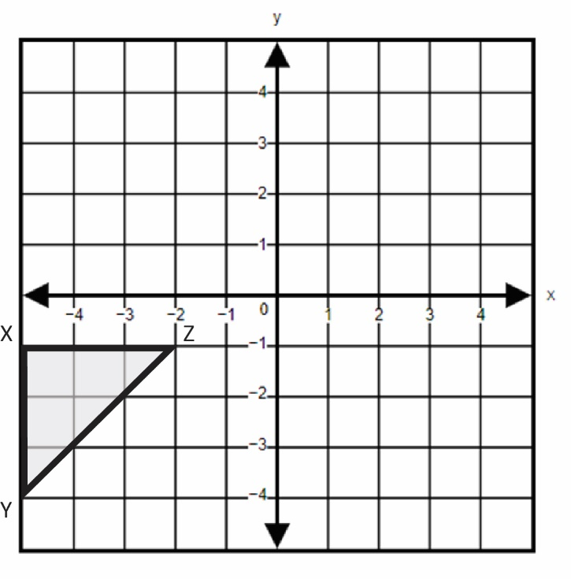
- The vertices of the rectangle shown have integral coordinates. Translate rectangle ABCD 3 units down and 4 units to the left. Graph the image of rectangle ABCD.
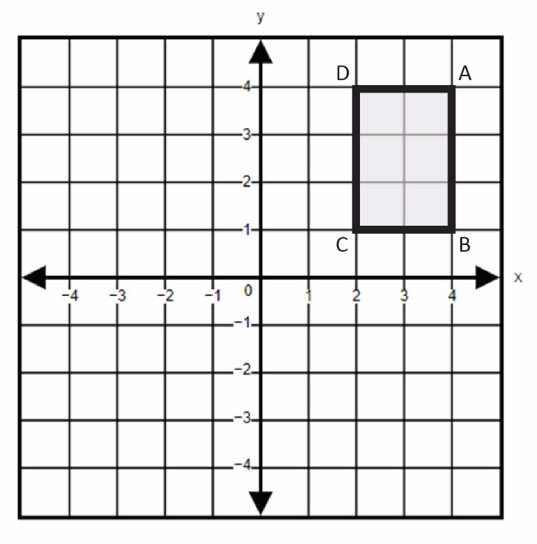

- The vertices of triangle ABC are located at (1, 2), (1, 5), and (5, 2). Graph the image of triangle ABC after a reflection over the x-axis.
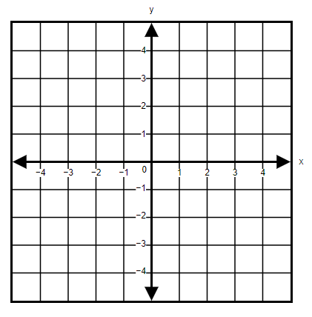
- Describe the transformations that could be applied to figure WXYZ that will result in the figure W’X’Y’Z’.
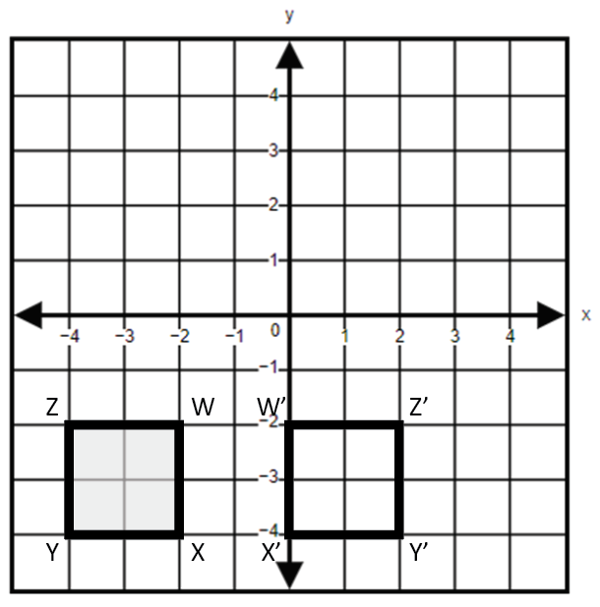

SOL 7.7 - Just in Time Quick Check Teacher Notes
Common Errors/Misconceptions and their Possible Indications

- Complete sections a and b using the coordinate plane below. The vertices of the triangle shown have integral coordinates.
  - Identify the coordinates of the image of triangle RST after a translation 5 units to the right.
A common error students may make is translating the triangle to the left, resulting in coordinates R’(-6, 2), S’(-8, 2), and T’(-6, 4). This may indicate a need to review directional vocabulary associated with translations. When translating a figure in the coordinate plane, it might be helpful for students to draw an arrow in the direction of the translation.
  - Identify the coordinates of the image of triangle RST after a reflection over the x-axis.
A common error a student may make is reflecting the triangle over the y-axis, resulting in coordinates R’(1, 2), S’(3, 2), and T’(1, 4). This may indicate a need to emphasize vocabulary associated with the coordinate plane. When reflecting a figure in the coordinate plane, it might be helpful for students to highlight the axis over which they are reflecting.
A common error students may make is moving the triangle below the x-axis without flipping it. This may indicate a need to emphasize the effects transformations have on given figures. Teachers are encouraged to utilize hands-on examples of reflections, such as a reflective geometry tool.

- Triangle XYZ is shown on the grid. Reflect triangle XYZ across the y-axis and then translate up 4 units. What are the coordinates of Z’?
Common errors that students may make include reflecting over the wrong axis and/or translating in the wrong direction. This may indicate a need to emphasize vocabulary associated with the coordinate geometry. Teachers are encouraged to point out methods to distinguish between vertical and horizontal. For example, the “v” in vertical points down and the horizon is horizontal.
A common error a student may make is either completing the reflection or the translation, but not both. This may indicate that the student does not have an understanding that there are two transformations that need to be performed on this figure. It would be helpful if teachers asked students to describe what each transformation means before graphing the resulting the image. Use of color coding to track the combination of transformations would help students connect the preimage to the image.

- The vertices of the rectangle shown have integral coordinates. Translate rectangle ABCD 3 units down and 4 units to the left. Graph the image of rectangle ABCD.
A common error a student may make is completing only one of the translations. This may indicate a need to emphasize careful interpretation of the question by writing each step described in the question. This may indicate that the student could benefit from writing or explaining what each of the two translations is representing before the student begins graphing.
A common error a student may make is mislabeling the vertices after both translations. Students must understand that the vertices of a figure remain in the same relative location after being translated. This may indicate the need to emphasize the definition of a translation. Teachers are encouraged to demonstrate translations with manipulatives and a coordinate grid.
- The vertices of triangle ABC are located at (1, 2), (1, 5), and (5, 2). Graph the image of triangle ABC after a reflection over the x-axis.
A common error a student may make is incorrectly graphing triangle ABC. A student may reverse the x and y-coordinates, graphing the points A(2, 1), B(5, 1), and C(2, 5). This may indicate a need to review and practice plotting points in the coordinate plane. Refer to the Grade 6 Mathematics Curriculum Framework for essential knowledge and skills related to graphing ordered pairs in a coordinate plane.

A common error a student may make is reflecting the triangle over the y-axis. This may indicate that the student sees the reflection as moving along the x-axis instead of over the x-axis. It might be helpful for students to highlight the axis over which they are reflecting. Teachers should emphasize that the image of the figure will be on the opposite side of the highlighted axis.

- Describe the transformations that could be applied to figure WXYZ that will result in the figure W’X’Y’Z’.
A common error a student may make is incorrectly identifying the image as a translation of the figure 4 units to the right. For indication and strategies, see question 3.
A common error a student may make is incorrectly identifying the image as a reflection over the y-axis. This may indicate that the student does not understand that the pre-image and image of a figure must be equidistant from the axis over which it is reflected. Teachers are encouraged to demonstrate reflections with manipulatives and a coordinate grid.

