Just In Time Quick Check
Standard of Learning (SOL) 7.6b
Strand: Measurement and Geometry

Standard of Learning (SOL) 7.6b
The student will determine unknown side lengths or angle measures of quadrilaterals.

Grade Level Skills:
- Given a diagram, determine an unknown angle measure in a quadrilateral, using properties of quadrilaterals.
- Given a diagram, determine an unknown side length in a quadrilateral using properties of quadrilaterals.
Just in Time Quick Check
Just in Time Quick Check Teacher Notes

Supporting Resources:
- VDOE Mathematics Instructional Plans (MIPS)
  - 7.6b - Quadrilaterals – Measures of Sides and Angles (Word) / PDF Version
- VDOE Word Wall Cards: Grade 7 (Word) | (PDF)
  - Quadrilateral Relationships
  - Parallelogram
  - Rhombus
  - Rectangle
  - Square
  - Trapezoid
Supporting and Prerequisite SOL: 7.5, 7.6a, 6.9, 5.13b

SOL 7.6b - Just in Time Quick Check

- Parallelogram CORK is pictured below. Determine the length of side $\overline{OR}$.

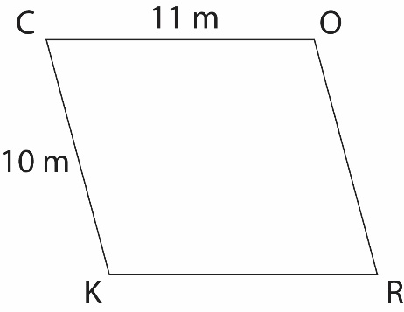
- Trapezoid PARK is isosceles. Determine the measures of angles A, R, and K.

- The diagram below shows quadrilateral FORK. Find the missing angle measurement.
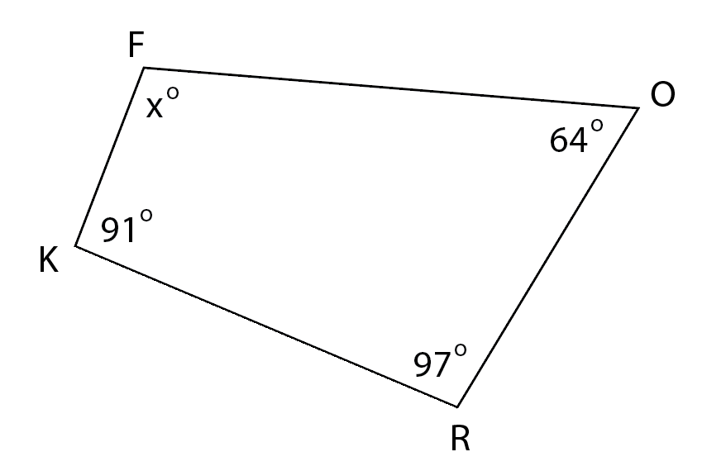
- The length of one side of a rectangular park is 80 feet. The sum of the other three sides is 380 feet. What are the lengths of the other sides?

- A quadrilateral has diagonals that bisect each other at 90$°$ and a perimeter of 84 centimeters. Find the length of each side.

SOL 7.6b - Just in Time Quick Check Teacher Notes
Common Errors/Misconceptions and their Possible Indications

- Parallelogram CORK is pictured below. Determine the length of side$\overline{OR}$.
A common error a student may make is to determine $\overline{OR}=11$. This may indicate that a student believes that adjacent sides of a parallelogram are congruent. Teachers are encouraged to provide a graphic organizer including illustrations, notations, and properties of quadrilaterals. It might be helpful for students to review the Grade 7 Word Wall cards for each type of quadrilateral.
- Trapezoid PARK is isosceles. Determine the measures of angles A, R, and K.
A common error a student may make is to determine$m∠R=100°$. This may indicate that a student is applying the properties of a parallelogram to an isosceles trapezoid. For suggestions and teacher notes, see question 1.

A common error a student may make is determining that there is not information to complete the problem since only one angle measurement is provided. This may indicate a student does not remember the properties of an isosceles trapezoid and that the sum of the interior angles of a quadrilateral is 360$°$. It might be helpful to review common properties for all quadrilaterals. Teachers are encouraged to use manipulatives or technology to prove that the interior angles of all quadrilaterals have a sum of 360$°$.
- The diagram below shows quadrilateral FORK. Find the missing angle measurement.
A common error a student may make is to determine $m∠F=97°$. This may indicate that a student did not consider that the sum of the interior angles equals 360$°$. For suggestions and teacher notes, see question 2.
- The length of one side of a rectangular park is 80 feet. The sum of the other three sides is 380 feet. What are the lengths of the other sides?
A common error a student may make is determining that all sides of the rectangle are 80 feet. This may indicate that a student does not understand the relationship between rectangles and squares. It might be helpful for students to sketch a rectangle and label any information provided. Teachers are encouraged to provide multi-step practical problems that allow students to apply the properties of quadrilaterals to determine unknown side lengths.
Another common error a student may make is dividing 380 feet by three, determining that each of the other three sides is 126.7 feet. This may indicate that a student is not considering the properties of a rectangle. For suggestions and teacher notes, see the previous paragraph.

- A quadrilateral has diagonals that bisect each other at 90$°$ and a perimeter of 84 centimeters. Find the length of each side.
A common error a student may make is dividing 84 centimeters by two, determining that each side is 42 centimeters. This may indicate that a student knows the definition of “bisect” and divided by two. It might be helpful for students to discern necessary information to be used for calculations, apart from properties used to determine a specific quadrilateral. Teachers are encouraged to provide opportunities for recognizing properties of quadrilaterals and exploring associated vocabulary.

