Just In Time Quick Check
Standard of Learning (SOL) 7.6a
Strand: Measurement and Geometry

Standard of Learning (SOL) 7.6a
The student will compare and contrast quadrilaterals based on their properties.

Grade Level Skills:
- Compare and contrast properties of the following quadrilaterals: parallelogram, rectangle, square, rhombus, and trapezoid.
- Sort and classify quadrilaterals, as parallelograms, rectangles, trapezoids, rhombi, and/or squares based on their properties.
Just in Time Quick Check
Just in Time Quick Check Teacher Notes

Supporting Resources:
- VDOE Mathematics Instructional Plans (MIPS)
  - 7.6a - Classifying Quadrilaterals (Word) / PDF Version
- VDOE Algebra Readiness Remediation Plans
  - Quadrilaterals (Word) / PDF
- VDOE Word Wall Cards: Grade 7 (Word) | (PDF)
  - Quadrilateral Relationships
  - Parallelogram
  - Rhombus
  - Rectangle
  - Square
  - Trapezoid
- Other VDOE Resources
  - Geometry Quadrilaterals Lesson 1: Classifying Quadrilaterals Worksheet [eMediaVA]
  - Geometry Quadrilaterals Lesson 1: Classifying Quadrilaterals Worksheet Key [eMediaVA]
- Desmos Activity
  - Polygraph: Advanced Quadrilaterals
Supporting and Prerequisite SOL: 7.5, 6.9

SOL 7.6a - Just in Time Quick Check

- Complete the table below. Use an X if the given property does not apply to the figure. Use a checkmark if the given property applies to the figure. The first row is completed for you.

Property | Parallelogram | Rectangle | Square | Rhombus
All sides are congruent | X | X |  | 
Opposite sides are congruent

Opposite sides are parallel

All angles are congruent

Opposite angles are congruent

Sum of all angles is 360$°$

Diagonals are congruent

Diagonals bisect each other

Diagonals are perpendicular

2. Given the properties of a trapezoid and a parallelogram, identify what is similar and different about these figures using the list below.
Four sides | Four angles
Opposite angles are congruent | Opposite sides are congruent
Opposite sides are parallel | One pair of parallel sides
No lines of symmetry | Diagonals bisect each other
Diagonals are not congruent | Diagonals do not bisect each other at right angles

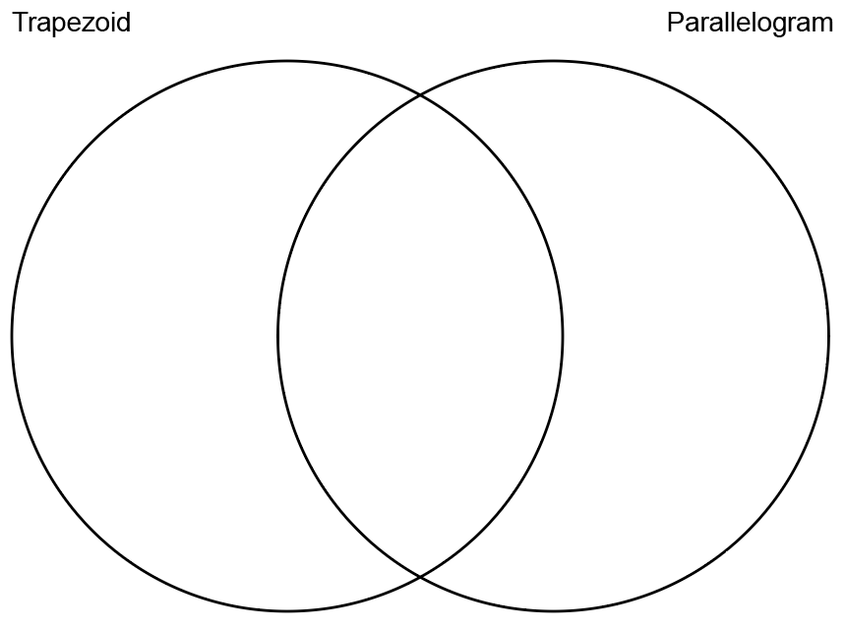
3. Using the quadrilaterals below, draw all lines of symmetry for each figure. If there are no lines of symmetry, leave the figure blank.

Parallelogram Rectangle
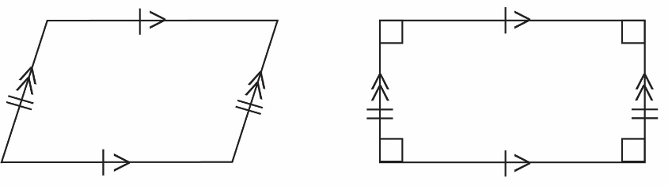
Trapezoid Rhombus
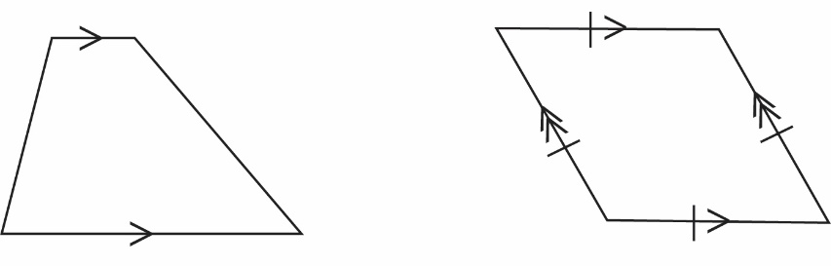
Square
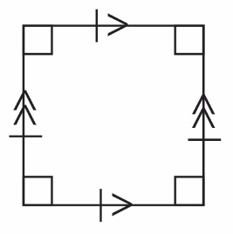

SOL 7.6a - Just in Time Quick Check Teacher Notes
Common Errors/Misconceptions and their Possible Indications

- Complete the table below. Use an X if the given property does not apply to the figure. Use a checkmark if the given property applies to the figure. The first row is completed for you.

Property | Parallelogram | Rectangle | Square | Rhombus
All sides are congruent | X | X |  | 
Opposite sides are congruent

Opposite sides are parallel

All angles are congruent

Opposite angles are congruent

Sum of all angles is 360$°$

Diagonals are congruent

Diagonals bisect each other

Diagonals are perpendicular

A common error a student may make is determining that a parallelogram has one pair of parallel sides, thus indicating that the student has mistaken the properties of a parallelogram with a trapezoid. If a student continues to do this for the parallelogram, then the other three figures would represent the same misconception since the remaining figures are parallelograms. It might be helpful for students to sketch each of the quadrilaterals listed before completing the table. Teachers are encouraged to display a standard-specific word wall and review vocabulary and properties associated with parallelograms.

A common error a student may make is determining that the diagonals of a rhombus are congruent. This may indicate that a student equates a rhombus’ four congruent sides with having congruent diagonals. See suggestions and teacher notes above.
A common error a student may make is determining that the diagonals of a rectangle are perpendicular. This may indicate that a student equates a rectangle’s four right angles with having perpendicular diagonals. See suggestions and teacher notes above.

A common error a student may make is determining that the diagonals of a parallelogram and/or rectangle do not bisect each other. This may indicate that a student believes a quadrilateral must have four congruent sides to have bisecting diagonals. See suggestions and teacher notes above.

- Given the properties of a trapezoid and a parallelogram, identify what is similar and different about these figures using the list below.
Four sides | Four angles
Opposite angles are congruent | Opposite sides are congruent
Opposite sides are parallel | One pair of parallel sides
No lines of symmetry | Diagonals bisect each other
Diagonals are not congruent | Diagonals do not bisect each other at right angles

A common error a student may make is placing “No lines of symmetry” under trapezoid or parallelogram, instead of in the shared set of properties. This may indicate that a student believes that all trapezoids are isosceles or that a parallelogram has one or more lines of symmetry due to its pairs of congruent sides. It might be helpful for students to sketch each shape before placing the properties in the Venn diagram. Teachers are encouraged to provide a graphic organizer including illustrations, notations, and properties of quadrilaterals. Particular attention should be given to properties of diagonals.

A common error a student may make is placing “Diagonals are not congruent” under trapezoid. This may indicate that a student believes that a parallelogram has congruent diagonals due to the parallelogram’s congruent pairs of sides. See suggestions and teacher notes above.

- Using the quadrilaterals below, draw the lines of symmetry. If there are none, leave the figure blank.

Parallelogram Rectangle
A common error a student may make is incorrectly drawing lines of symmetry through the diagonals of the parallelogram and/or rectangle. This may indicate that a student recognizes that the halves are conguent, but does not recognize the halves are not an exact reflection. Teachers are encouraged to utilize pre-cut quadrilaterals for hands-on activities identifying lines of symmetry.
Trapezoid Rhombus
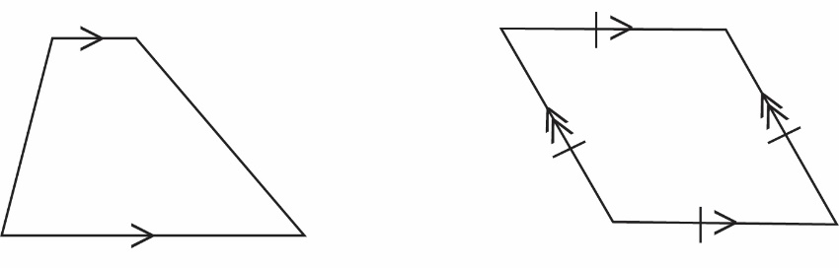
A common error a student may make is incorrectly drawing a vertical line of symmetry through the trapezoid. This may indicate that a student does not recognize the differences between isosceles and scalene trapezoids. See suggestions and teacher notes above.
A common error a student may make is incorrectly drawing a horizontal line of symmetry and/or a line of symmetry parallel to the left and right sides of the rhombus that passes through the midpoint of the top and bottom sides of the rhombus. This may indicate that a student recgonizes that the halves are congruent and thus believes that they are also reflections. See suggestions and teacher notes above.
A common error a student may make is not drawing a line of symmetry through opposite vertices of the rhombus. This may indicate that a student believes all lines of symmetry must be vertical or horizontal. Students are encouraged to rotate their figure when deciding where to place lines of symmetry. See suggestions and teacher notes above.
Square
A common error a student may make is identifying only two of the lines of symmetry. This may indicate that a student either recognizes the diagonal lines of symmetry or the vertical and horizontal lines of symmetry. See suggestions and teacher notes above.

