Just In Time Quick Check
Standard of Learning (SOL) 7.5
Strand: Measurement and Geometry

Standard of Learning (SOL) 7.5
The student will solve problems, including practical problems, involving the relationship between corresponding sides and corresponding angles of similar quadrilaterals and triangles.

Grade Level Skills:
- Identify corresponding sides and corresponding congruent angles of similar quadrilaterals and triangles.
- Given two similar quadrilaterals or triangles, write similarity statements using symbols.
- Write proportions to express the relationships between the lengths of corresponding sides of similar quadrilaterals and triangles.
- Solve a proportion to determine a missing side length of similar quadrilaterals or triangles.
- Given angle measures in a quadrilateral or triangle, determine unknown angle measures in a similar quadrilateral or triangle.
Just in Time Quick Check
Just in Time Quick Check Teacher Notes

Supporting Resources:
- VDOE Mathematics Instructional Plans (MIPS)
  - 7.5 - Similar Figures (Word) / PDF Version
  - 7.5 - Missing Measurements (Word) / PDF Version
- VDOE Algebra Readiness Remediation Plans
  - Congruent or Similar? (Word) / PDF
  - Similarity (Word) / PDF
- VDOE Word Wall Cards: Grade 7 (Word) | (PDF)
  - Similar Figures
  - Similar Figures and Proportions
Supporting and Prerequisite SOL: 6.9, 6.12a, 6.13, 5.13a, 5.14b

SOL 7.5 - Just in Time Quick Check

- Complete sections a through d. Triangle LMN is similar to triangle JKH.
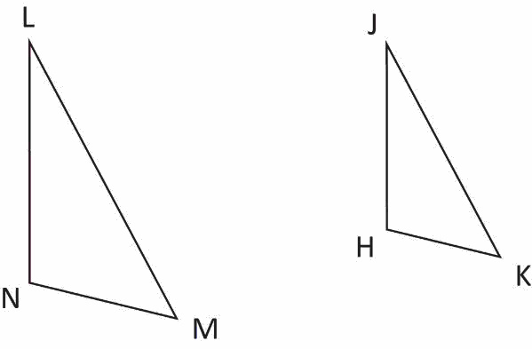
  - Write a similarity statement using symbols.
____________ ~ ____________

  - Complete each statement with the corresponding sides.
$\overline{LM}$ corresponds to ________
$\overline{MN}$ corresponds to ________
$\overline{NL}$ corresponds to ________
  - Complete each statement with the corresponding angles.
$∠L$ corresponds to ________
$∠M$ corresponds to ________
$∠N$ corresponds to ________

  - Complete each proportion to express the relationship between corresponding sides.
$$\frac{\overline{LN}}{\overline{ML}}=\frac{}{}$$
$$\frac{\overline{KH}}{\overline{JH}}=\frac{}{}$$

- Quadrilateral HOME is similar to quadrilateral TRAP. Complete the statements below with the missing angle measures. Show work or explain your answer.

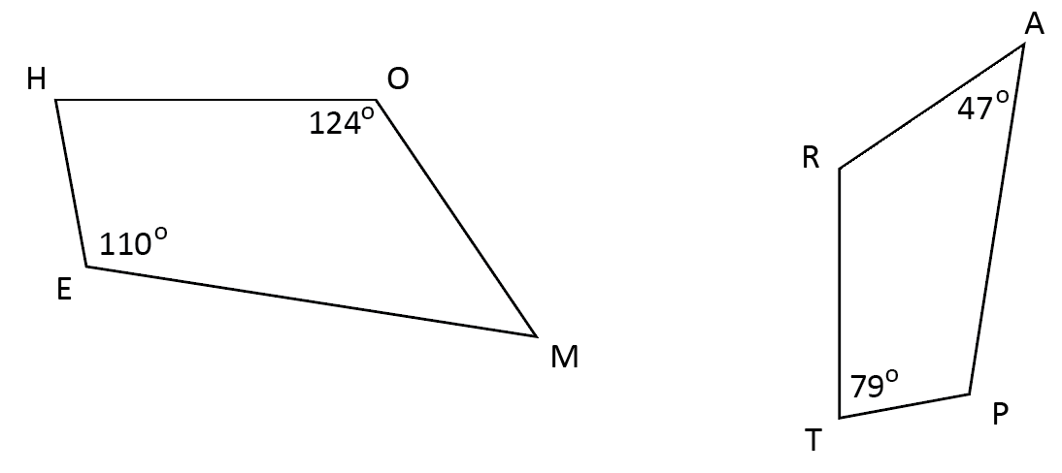

$m∠M$ = ________$°$
$m∠R$ = ________$°$

- Quadrilateral WORD is similar to quadrilateral BANK. What is the length of $\overline{KN}$?
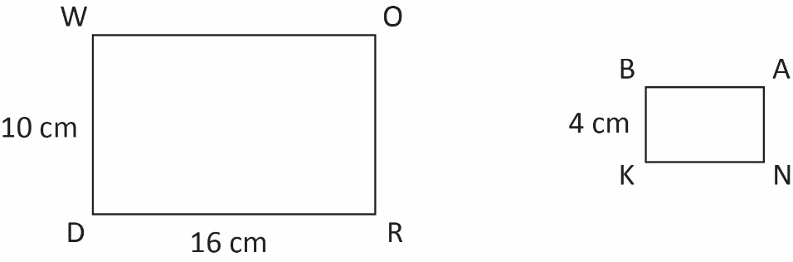

- Given: $∆COT\sim ∆CAN$; $\overline{CN}$ = 21 inches
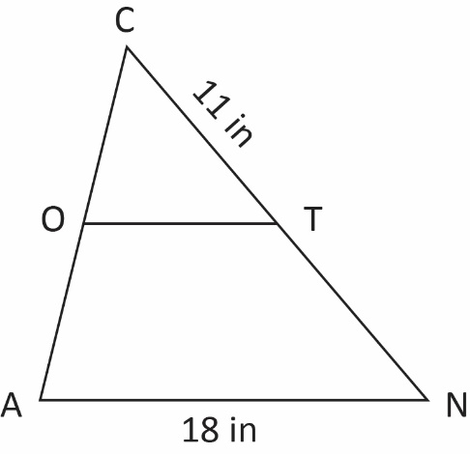

  - Set up a proportion to represent the relationship between the corresponding sides of these triangles to find $\overline{OT}$.
  - What is the length of $\overline{OT}$? Round your answer to the nearest tenths.

SOL 7.5 - Just in Time Quick Check Teacher Notes
Common Errors/Misconceptions and their Possible Indications

- Complete sections a through d. Triangle LMN is similar to triangle JKH.
  - Write a similarity statement using symbols.
____________ ~ ____________
A common error a student may make when writing similarity statements is that the order of the letters naming the triangles are not in matching order. This may indicate that a student does not recognize corresponding angles. Teachers are encouraged to provide additional opportunities for practice, such as 7.5 Similar Figures (MIP).
  - Complete each statement with the corresponding side.
$\overline{LM}$ corresponds to ________
$\overline{MN}$ corresponds to ________
$\overline{NL}$ corresponds to ________
A common error a student may make is incorrectly identifying corresponding sides of similar triangles. This may indicate that a student does not understand corresponding parts of similar triangles. It might be helpful for students to number or color-code the corresponding sides before completing each statement.
  - Complete each statement with the corresponding angle.
$∠L$ corresponds to ________
$∠M$ corresponds to ________
$∠N$ corresponds to ________
A common error a student may make is incorrectly identifying corresponding angles of the similar triangles. This may indicate that a student does not understand corresponding parts of similar triangles. For suggestions and teacher notes, see questions 1a and 1b.

  - Complete each proportion to express the relationship between corresponding sides.
$$\frac{\overline{LN}}{\overline{ML}}=\frac{}{}$$
$$\frac{\overline{KH}}{\overline{JH}}=\frac{}{}$$
A common error a student may make is writing the reciprocal of the second ratio. This may indicate that a student is placing corresponding sides diagonally because they are thinking ahead to cross-multiplication when setting up the proportion. It might be helpful for students to write a similarity statement and number corresponding parts before setting up proportions. Teachers are encouraged to model setting up proportions by following a set pattern, going from the smaller figure to the larger figure or vice versa.
- Quadrilateral HOME is similar to quadrilateral TRAP. Complete the statements below with the missing angle measures. Show work or explain your answer.

$m∠M$ = ________$°$
A common error a student may make is incorrectly identifying the measure of $∠M$ as 79 degrees. This may indicate that a student does not understand how to use a statement of similarity to identify corresponding parts and angle measures. It might be helpful for students to number or color-code the corresponding angles before calculating angle measures. Teachers are also encouraged to review properties of quadrilaterals as well as developing the understanding that similar polygons have corresponding sides that are proportional and corresponding angles that are congruent.
$m∠R$ = ________$°$
A common error a student may make is incorrectly identifying the measure of $∠R$ as 110 degrees. For indications of student weaknesses, suggestions, and teacher notes, see above statements regarding$m∠M$.

- Quadrilateral WORD is similar to quadrilateral BANK. What is the length of $\overline{KN}$?
A common error a student may make is setting the proportion up incorrectly. A student who fails to identify corresponding sides, might get an answer of 40 cm. For indications of student weaknesses, suggestions, and teacher notes, see question 1b.
A common error a student may make is setting up the proportion correctly, but multiplying the numerators and denominators straight across. This may indicate that a student does not understand how to solve a proportion. Teachers are encouraged to review that a proportion is a statement of equality between two ratios and that a proportion can be solved by determining the product of the means and the product of the extremes. Teachers are encouraged to review the Mathematics 7 Curriculum Framework (see SOL 7.3).

- Given: $∆COT\sim ∆CAN$; $\overline{CN}$ = 21 inches

  - Set up a proportion to represent the relationship between the corresponding sides of these triangles to find the length of $\overline{OT}$.

A common error a student may make is incorrectly setting up the proportion by misidentifying corresponding sides. This may indicate that a student is not effectively using the similarity statement to set up the proportion. It might be helpful for students to number the angles given in the similarity statement (see below).
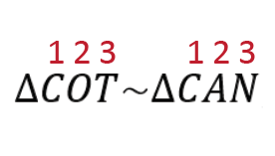
Teachers are encouraged to review and practice finding corresponding parts based solely on a similarity statement.

  - What is the length of $\overline{OT}$?

A common error a student may make is incorrectly presuming that the length of $\overline{OT}$ is half of the length of $\overline{AN}$. This may indicate that a student does not recognize that corresponding sides of similar triangles are proportional. Teachers are encouraged to show multiple examples of similar figures and to explore the relationship between their side lengths.

