Just In Time Quick Check
Standard of Learning (SOL) 7.4b
Strand: Measurement and Geometry

Standard of Learning (SOL) 7.4b
The student will solve problems, including practical problems, involving the volume and surface area of rectangular prisms and cylinders.

Grade Level Skills:
- Determine if a practical problem involving a rectangular prism or cylinder represents the application of volume or surface area.
- Solve practical problems that require determining the surface area of rectangular prisms and cylinders.
- Solve practical problems that require determining the volume of rectangular prisms and cylinders.
Just in Time Quick Check
Just in Time Quick Check Teacher Notes

Supporting Resources:
- VDOE Mathematics Instructional Plans (MIPS)
  - 7.4ab - Volume and Surface Area of Rectangular Prisms and Cylinders (Word) / PDF Version
- VDOE Algebra Readiness Remediation Plans
  - Cones and Square Pyramids (Word) / PDF
  - Ranking Cylinders and Rectangular Prisms (Word) / PDF
  - Real Life Examples (Word) / PDF
  - Relational Solids (Word) / PDF
- VDOE Word Wall Cards: Grade 7 (Word) | (PDF)
  - Rectangular Prism
  - Volume of a Rectangular Prism
  - Surface Area of a Rectangular Prism
  - Cylinder
- VDOE Instructional Videos for Teachers
  - Units of Measure (grades 4-8)
- Other VDOE Resources
  - Area, Volume, and Surface Area: Find the Volume of Rectangles inside Rectangles [eMediaVA]
  - Cylinder Surface Area | School Yourself Geometry [eMediaVA]
Supporting and Prerequisite SOL: 7.4a, 6.7b, 6.7c, 5.8a, 5.8b, 5.10

SOL 7.4b - Just in Time Quick Check

- Consider each situation below. Determine if the situations represent applications of surface area or volume.

- Riccy is filling her fish tank. ______________________________

- Maricella wants to know how much cereal a box will hold. ______________________________

- Kesean is painting a jewelry box for his mother. ______________________________

- Naomi is designing a cereal box and needs to determine how much cardboard she will use. She wants the box to have a height of 10 inches, a length of 7 inches, and a width of 2 inches. How much cardboard will she need?

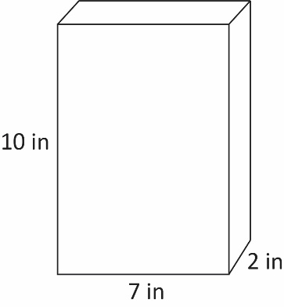

- Hunter is covering a cylindrical shaped speaker with wrapping paper for his sister’s birthday. The speaker is 25 centimeters tall and has a radius of 6.5 centimeters. How much wrapping paper does Hunter need to completely cover the speaker without any overlaps? Round your answer to the nearest whole number.

- A fish tank in the shape of a cube has a side length of 15 inches. How much water does the fish tank hold when completely filled with water?
- The base of a cylindrical water tank has an area of 28 square feet. When the tank is full, it holds 140 cubic feet of water. What is the height, h, of the tank?

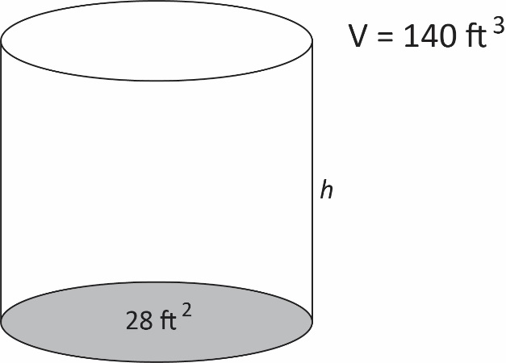

SOL 7.4b - Just in Time Quick Check Teacher Notes
Common Errors/Misconceptions and their Possible Indications

- Consider each situation below. Determine if the situations represent applications of surface area or volume.

- Riccy is filling her fish tank. ______________________________

- Maricella wants to know how much cereal a box will hold. ______________________________

- Kesean is painting a jewelry box for his mother. ______________________________

A common error a student may make is incorrectly identifying applications of surface area and volume. This may indicate a need to emphasize vocabulary associated with surface area and volume. Teachers are encouraged to revisit practical uses for surface area and volume.

- Naomi is designing a cereal box and needs to determine how much cardboard she will use. She wants the box to have a height of 10 inches, a length of 7 inches, and a width of 2 inches. How much cardboard will she need?

A common misconception a student may make is to provide a correct solution for the surface area but without including units or using cubic units. This may indicate a need to emphasize the units for surface area. It might be helpful for teachers to watch the VDOE instructional video for hands-on ideas.
A common error a student may make is incorrectly identifying the length, width, and height of the figure. A student may use one of the numbers more than once, resulting in an incorrect answer. This may indicate a need to emphasize vocabulary associated with three-dimensional figures and a need to revisit the net of a rectangular prism by using concrete objects, nets, or diagrams. Teachers are encouraged to provide students with concrete nets of three-dimensional figures before transitioning to the pictorial representation to support students with misconceptions and errors about the dimensions of such figures. Doing so will support students’ foundational understanding as they transition to the surface area formula (algorithm).
A helpful strategy for students is to label which values to use for length, width, and height. Teachers can incorporate additional practice using the surface area formula by exploring the Desmos scientific calculator capabilities.

- Hunter is covering a cylindrical shaped speaker with wrapping paper for his sister’s birthday. The speaker is 25 centimeters tall and has a radius of 6.5 centimeters. How much wrapping paper does Hunter need to completely cover the speaker without any overlaps? Round your answer to the nearest whole number.

A common error a student may make is substituting the wrong values for height and radius into the surface area formula. This may indicate a need to emphasize vocabulary associated with cylinders and the formula for surface area. When solving for surface area of a cylinder, it might be helpful for the student to label the height and radius. Students should be encouraged to reference the Grade 7 Mathematics Formula Sheet, but to use reasoning and problem solving to justify the formula using nets.

A student may also make an error when following the order of operations. For example, if a student does not apply exponents before multiplication, then a student may square the entire first term and get 2,689 square centimeters (cm²). This may indicate a need to review the order of operations and evaluating expressions by referring to the Grade 7 Mathematics Curriculum Framework. In addition, teachers should allow students to practice evaluating the formula by exploring the capabilities of the Desmos scientific calculator.

- A fish tank in the shape of a cube has a side length of 15 inches. How much water does the fish tank hold when completely filled with water?

A common misconception a student may make is to provide a correct solution for the volume but without including units or using square units. This may indicate a need to emphasize the units for volume. It might be helpful for teachers to watch the VDOE instructional video for hands-on ideas.
A common misconception a student may have is incorrectly using a given measurement. This may indicate that the student does not understand the properties of a cube and that there is a need to emphasize the vocabulary associated with squares and cubes. Students should be encouraged to reference the Grade 7 Mathematics Formula Sheet, but to use reasoning and problem solving to justify the formula by using relational solids. In addition, teachers should allow students to practice evaluating the formula by exploring the capabilities of the Desmos scientific calculator.

- The base of a cylindrical water tank has an area of 28 square feet. When the tank is full, it holds 140 cubic feet of water. What is the height, h, of the tank?

A common error a student may make is incorrectly identifying 28 ft² as the radius. A student that uses 28 as “r” in the formula $V=πr^{2}h$, will calculate the height as 0.1 feet. Teachers should consider providing students with relational solids and demonstrate how to derive the parts of the formula. In the formula $V=πr^{2}h$, students must recognize that $πr^{2}$ is equal to the area of the base. Teachers should consider providing students with relational solids and demonstrate how to derive the parts of the formula.

A student may incorrectly interpret what the problem is asking and attempt to calculate the volume. In this case, a student may substitute 140 cubic feet (ft³) for the height. A student that uses 140 as “h” in the formula $V=πr^{2}h$, will calculate the volume as 3,920 cubic feet (ft³). This error may indicate a need to emphasize vocabulary associated with cylinders and the formula for volume. Students should be encouraged to reference the Grade 7 Mathematics Formula Sheet, but to use reasoning and problem solving to justify the formula using relational solids. Teachers should allow students to practice evaluating the formula by exploring the Desmos scientific calculator capabilities.

