Just In Time Quick Check
Standard of Learning (SOL) 7.4a
Strand: Measurement and Geometry

Standard of Learning (SOL) 7.4a
The student will describe and determine the volume and surface area of rectangular prisms and cylinders.

Grade Level Skills:
- Determine the surface area of rectangular prisms and cylinders using concrete objects, nets, diagrams, and formulas.
- Determine the volume of rectangular prisms and cylinders using concrete objects, diagrams, and formulas.
Just in Time Quick Check
Just in Time Quick Check Teacher Notes

Supporting Resources:
- VDOE Mathematics Instructional Plans (MIPS)
  - 7.4ab - Volume and Surface Area of Rectangular Prisms and Cylinders (Word) / PDF Version
- VDOE Algebra Readiness Remediation Plans
  - Linking Cube Surface Area Volume (Word) / PDF
  - Ranking Cylinders and Rectangular Prisms (Word) / PDF
  - Real Life Examples (Word) / PDF
- VDOE Word Wall Cards: Grade 7 (Word) | (PDF)
  - Rectangular Prism
  - Volume of a Rectangular Prism
  - Surface Area of a Rectangular Prism
  - Cylinder
- Other VDOE Resources
  - Area, Volume, and Surface Area: Find the Volume of Rectangles Inside Rectangles [eMediaVA]
  - Cylinder Surface Area | School Yourself Geometry [eMediaVA]
- Desmos Activity
  - Surface Area of a Rectangular Prism
Supporting and Prerequisite SOL: 6.7b, 6.7c, 5.8a, 5.8b, 5.10

SOL 7.4a - Just in Time Quick Check

- The net below is used to form a rectangular prism. Using the net, determine the surface area of the figure.

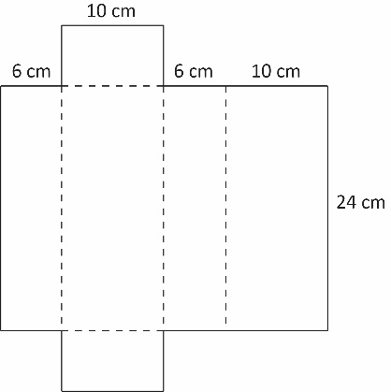

- Find the surface area of a cylinder with a height of 17 feet and a radius of 9 feet. Round your answer to the nearest whole number.
- What is the approximate surface area of the cylinder below? Round your answer to the nearest tenth.

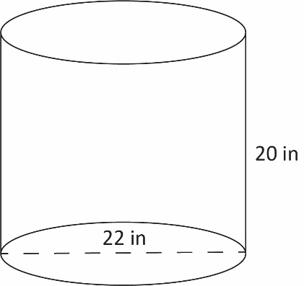

- The edge of a cube measures 5 inches. Find the volume of the cube.
- Find the volume of the cylinder below. Round your answer to the nearest tenth.

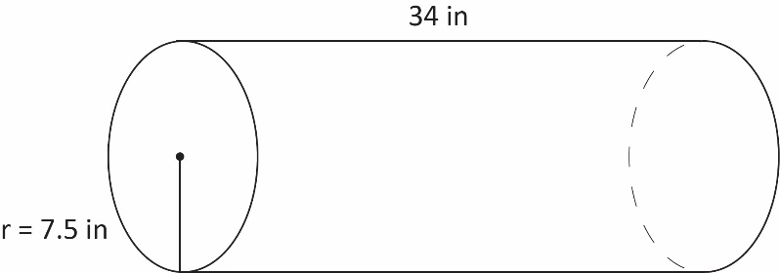

- Find the volume of the rectangular prism below.

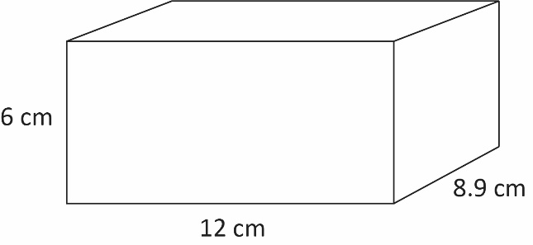

SOL 7.4a - Just in Time Quick Check Teacher Notes
Common Errors/Misconceptions and their Possible Indications

- The net below could be used to form a rectangular prism. Using the net, determine the surface area of the figure.

A common error a student may make is incorrectly identifying the length, width, and height of the figure. They may use one of the numbers more than once, resulting in an incorrect answer. This may indicate a need to emphasize vocabulary associated with rectangular prisms and the formula for surface area. When determining the surface area of a rectangular prism, it might be helpful for the student to label which values they will use as the length, width, and height.

Teachers are encouraged to provide students with concrete nets of three-dimensional figures before transitioning to the pictorial representation to support students with misconceptions and errors about the dimensions of such figures.

- Find the surface area of a cylinder with a height of 17 feet and a radius of 9 feet. Round your answer to the nearest whole number.

A common error a student may make is substituting the wrong values for height and radius into the surface area formula. This may indicate a need to emphasize vocabulary associated with cylinders and the formula for surface area. When calculating the surface area of a cylinder, it might be helpful for the student to label the height and radius. Students should be encouraged to reference the Grade 7 Mathematics Formula Sheet, but to use reasoning and problem solving to justify the formula using nets.

A student may also make an error when following the order of operations. If a student does not evaluate exponents before multiplication, then a student may square the entire first term and get 4159 square feet (ft²). This may indicate a need to review the order of operations and evaluating expressions by referring to the Grade 7 Mathematics Curriculum Framework. In addition, teachers should allow students to practice evaluating the formula by exploring the capabilities of the Desmos scientific calculator.

A student may also make an error when rounding their answer. This may indicate a need to emphasize place value vocabulary and/or the rules of rounding.

- What is the approximate surface area of the cylinder below? Round your answer to the nearest tenth.

A common error a student may make is incorrectly calculating the radius, given the diameter. This may indicate a need to emphasize vocabulary related to circles. Students must understand how to accurately identify and/or calculate the radius of a circle, given the diameter. For example, a student who uses 22 inches as “r” in the formula $SA=2πr^{2}+2πrh$, will calculate the surface area as 5,805.7 square inches (in²). Teachers should allow students to practice evaluating the formula by exploring the capabilities of the Desmos scientific calculator.
A student may also make an error when rounding their answer. This may indicate a need to emphasize place value vocabulary (approximate) and/or the rules of rounding.

- The edge of a cube measures 5 inches. Find the volume of the cube.

A common misconception a student may have is incorrectly using the measurement provided. A student may think that not enough information has been provided to solve the problem. This may indicate that the student does not understand the properties of a cube and that there is a need to emphasize the vocabulary associated with squares and cubes. Students must understand that given the properties of a cube, it is a rectangular prism and as such, the length, width, and height of the given figure are congruent. In addition, teachers should allow students to practice evaluating the formula by exploring the capabilities of the Desmos scientific calculator.

- Find the volume of the cylinder below. Round your answer to the nearest tenth.

A common misconception a student may have while solving this problem is to incorrectly identify 7.5 inches as the height of the cylinder. The student may not understand that the height of a cylinder connects the two circular bases. This may indicate a need to emphasize vocabulary associated with three-dimensional figures and a need to revisit the net of a cylinder by using concrete objects, nets, or diagrams.
A student may also make an error when calculating the square of the radius. When substituting values into the formula $V=πr^{2}h$, students should carefully follow the order of operations. This error may indicate a need to emphasize the meaning of squaring a number by referring to the Grade 7 Mathematics Curriculum Framework. Teachers may consider reviewing the meaning of an exponent (power) by having the student write the expression in expanded form. Further, teachers should allow students to practice evaluating the formula by exploring the Desmos scientific calculator capabilities.
A student may also make an error when rounding their answer. This may indicate a need to emphasize place value vocabulary and/or the rules of rounding.

- Find the volume of the rectangular prism below.

A common error a student may make is incorrectly identifying the length, width, and height of the figure. A student may use one of the numbers more than once, resulting in an incorrect answer. This may indicate a need to emphasize vocabulary associated with three-dimensional figures. Teachers are encouraged to provide students with relational solids of three-dimensional figures before transitioning to the pictorial representation to support students with misconceptions and errors about the dimensions of such figures. Doing so will support students’ foundational understanding as they transition to the volume formula (algorithm).
When solving for volume of a rectangular prism, it might be helpful for the student to label which values they will use as the length, width, and height; and, teachers should allow students to practice evaluating the formula by exploring the Desmos scientific calculator capabilities.

