Just In Time Quick Check

Standard of Learning (SOL) 6.9
Strand: Measurement and Geometry

Standard of Learning (SOL) 6.9
The student will determine congruence of segments, angles and polygons.

Grade Level Skills:
- Identify regular polygons.
- Draw lines of symmetry to divide regular polygons into two congruent parts.
- Determine the congruence of segments, angles, and polygons given their properties.
- Determine whether polygons are congruent or noncongruent according to the measures of their sides and angles.
Just in Time Quick Check
Just in Time Quick Check Teacher Notes

Supporting Resources:
- VDOE Mathematics Instructional Plans (MIPS)
  - Side to Side (Word) / PDF
- VDOE Algebra Readiness Remediation Plans
  - Congruency (Word) / PDF
  - Congruent or Similar? (Word) / PDF
  - Similarity (Word) / PDF
- VDOE Word Wall Cards: Grade 6 (Word) | (PDF)
  - Regular Polygons
  - Congruent Figures
  - Lines of Symmetry
- Desmos Activity
  - Polygraph: Polygons
Supporting and Prerequisite SOL: 5.12, 5.13a, 5.14a, 4.10a, 4.10b, 4.12

SOL 6.9 - Just in Time Quick Check

- Circle all the polygons that are regular polygons.
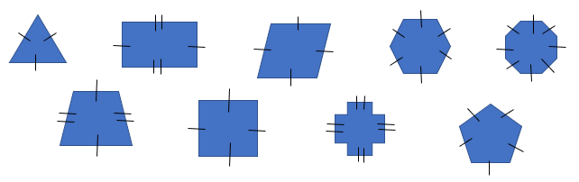
Explain how you determined which polygons to circle.

- Draw all lines of symmetry for each polygon. Fill in the blank with the number of lines of symmetry you drew for each of these polygons.

- Use the triangles below and complete the statements:
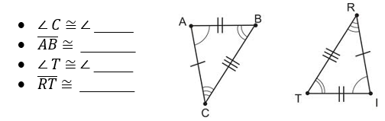
Are the two triangles congruent? Explain your reasoning.

4. Figure KLMN is congruent to figure WXYZ.
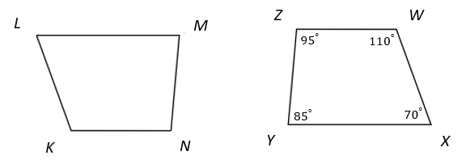
What are the measures of angle K and angle M?

5. Are the two parallelograms congruent? Explain your reasoning.
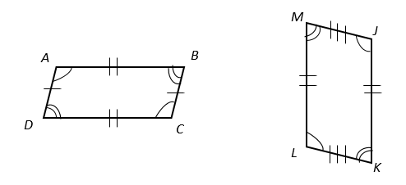

6. Identify which line segments are congruent.

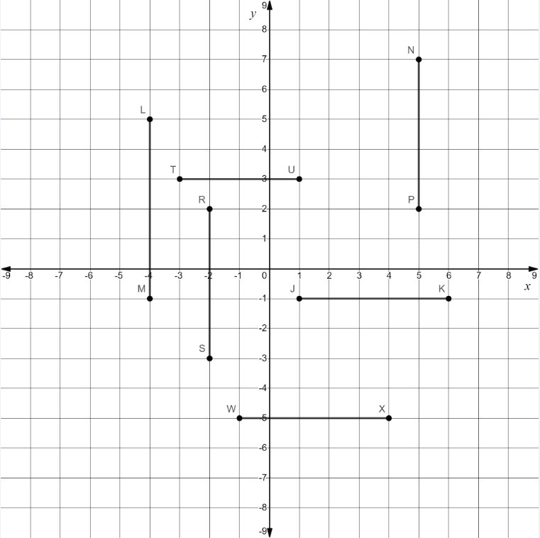

SOL 6.9 - Just in Time Quick Check Teacher Notes
Common Errors/Misconceptions and their Possible Indications

- Circle all the polygons that are regular polygons.
Explain how you determined which polygons to circle.
A common misconception some students may have is to identify polygons as regular based only on the congruency of their sides. This may indicate that a student has overlooked that the interior angles also must be congruent for the polygon to be regular. Completing a sorting activity may be beneficial for struggling students. Provide students with digital or paper copies of these polygons and ask students to compare and contrast the characteristics of the polygons, while also identifying which characteristics are common to all regular polygons.

- Draw all lines of symmetry for each polygon. Fill in the blank with the number of lines of symmetry you drew for each of these polygons.
A common misconception some students may have is that lines of symmetry must be either horizontal or vertical. This may indicate that a student has difficulty visualizing the rotation of the polygon in any other position. Student struggling with drawing the lines of symmetry may need hands on experiences with paper folding to help them conceptualize the two congruent parts created by the line of symmetry. Many times, students see the polygon in only one way, giving them a limited amount of lines of symmetry visible. For example, they draw a line from the top of the triangle to the bottom, not realizing that there are two additional lines if they turn the triangle. Hands on exploration helps them visualize the multiple lines of symmetry. Once students do the exploration with a few regular polygons, they usually discover that the number of lines of symmetry for regular polygons is the same as the number of sides and angles.

- Look at the triangles below and complete the statements:

Are the two triangles congruent? Explain your reasoning.
A common misconception some students may have is visualizing the corresponding congruent sides and angles when shapes are rotated or reflected. This may indicate that a student struggles with spatial relationships and potentially with geometric markings that indicate congruency. Teachers may wish to utilize the word wall cards and/or co-create anchor charts with the students to help solidify this information. Exploring congruent polygons with manipulatives and being able to place them on top of each other may assist students in understanding the characteristics that make them congruent. Students could also be encouraged to color code corresponding sides and angles to assist with determining congruency.

4. Figure KLMN is congruent to figure WXYZ.
What are the measures of angle K and angle M?
A common misconception some students may have is trying to map one of the figures onto the other by using a transformation other than a translation. This may indicate that a student struggles with attempting various transformations such as rotations or reflections. It may be beneficial for a teacher to help a student understand the statement figure KLMN is congruent to figure WXYZ. If the two figures are congruent, then the order (position) of the vertices indicate corresponding congruent parts. Therefore, angle K is congruent to angle W, angle L is congruent to angle X, angle M is congruent to angle Y, and angle N is congruent to angle Z. Students could also be encouraged to color code corresponding sides and angles to assist with determining congruency.

5. Are the two parallelograms congruent? Explain your reasoning.
A common error some students may have is stating these two parallelograms are congruent. This may indicate that a student is basing their decision on the fact that each figure has two sets of congruent angles without regard to the geometric markings indicating that the shorter side lengths of the parallelograms are not denoted with the same congruent markings. Teachers may wish to utilize the word wall cards and/or co-create anchor charts with the students to help solidify this information. Exploring congruent polygons with manipulatives and being able to place them on top of each other may assist students in understanding the characteristics that make them congruent. Students could also be encouraged to color code corresponding sides and angles to assist with determining congruency.

6. Identify which line segments are congruent.

A common error some students may have is only using a mathematical approach to determining the actual length of the line segments and not identifying all of the congruent segments or misidentifying some segments that are not actually congruent. This may indicate that a student is subtracting the endpoints without regard to the sign of the endpoint. For example, some students may determine the length of segment JK by computing 6-1 = 5. Similarly, the same approach may be used to determine the length of segment LM by computing 5 - 1 = 4 in error. It may be beneficial to have students use a geometric approach to avoid these types of computational errors. It might be helpful for students to transpose these line segments onto a number line where all of the segments can be viewed horizontally. Many students might be more familiar with using a number line when trying to determine the lengths of line segments vs. a coordinate grid.

Some students may be able to visually determine that these lines are not congruent while others may need to use a ruler. If a student determines that these lines are congruent, this may indicate that this student needs more hands-on experiences with measuring to the nearest tenth of a centimeter or fraction of an inch.

