Just In Time Quick Check

Standard of Learning (SOL) 6.8b
Strand: Measurement and Geometry

Standard of Learning (SOL) 6.8b
The student will identify the coordinates of a point and graph ordered pairs in a coordinate plane.

Grade Level Skills:
- Graph ordered pairs in the four quadrants and on the axes of a coordinate plane. Ordered pairs will be limited to coordinates expressed as integers.
- Identify ordered pairs represented by points in the four quadrants and on the axes of the coordinate plane. Ordered pairs will be limited to coordinates expressed as integers.
- Relate the coordinates of a point to the distance from each axis and relate the coordinates of a single point to another point on the same horizontal or vertical line. Ordered pairs will be limited to coordinates expressed as integers.
- Draw polygons in the coordinate plane given coordinates for the vertices; use coordinates to determine the length of a side joining points with the same first coordinate or the same second coordinate. Ordered pairs will be limited to coordinates expressed as integers. Apply these techniques in the context of solving practical and mathematical problems.
Just in Time Quick Check
Just in Time Quick Check Teacher Notes

Supporting Resources:
- VDOE Mathematics Instructional Plans (MIPS)
  - 6.8ab - What's the Point? (Word) / PDF Version
- VDOE Co-Teaching Mathematics Instruction Plans (MIPS)
  - 6.8 - Coordinate Plane (Word) / PDF Version
- VDOE Algebra Readiness Remediation Plans
  - Coordinate Plane (Word) / PDF
- VDOE Word Wall Cards: Grade 6 (Word) | (PDF)
  - Coordinate plane
- Desmos Activity
  - The (Awesome) Coordinate Plane Activity
  - Battle Boats
Supporting and Prerequisite SOL: 6.8a, 6.3a, 6.3c, 5.14a

SOL 6.8b - Just in Time Quick Check

- Graph and label the points on the coordinate plane below using the ordered pairs.
- A (3, -5)
- B (0, -2)
- C (-1, -4)
- D (3, 0)
- E (-2, 2)
- F (4, 1)
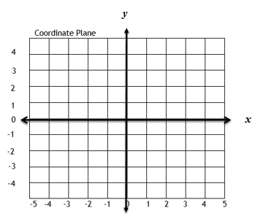

- Identify the ordered pair for each point graphed below on the coordinate plane.

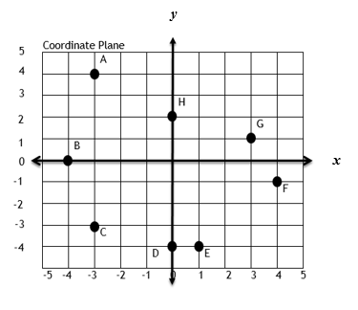

- Using the coordinate plane below, answer the following questions:
- Describe point A in terms of distance from the x- and y-axes.
- Describe point B in terms of distance from the x- and y-axes.
- Describe the distance from point C to point D on their shared horizontal line.
- Describe the distance from point E to point F on their shared vertical line.

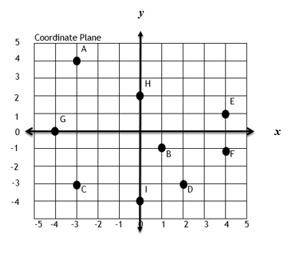

- Parker needs to draw a model of his backyard on the coordinate plane. Use the ordered pairs to draw the model of his backyard.
- A (-2, -3)
- B (4, 0)
- C (4, -3)
- D (-2, 0)

- What is the length of $\overline{AD }$?
- What is the length of $\overline{DB }$?

SOL 6.8b - Just in Time Quick Check Teacher Notes
Common Errors/Misconceptions and their Possible Indications

- Graph the points on the coordinate plane below using the ordered pairs.
    - A (3, -5)
    - B (0, -2)
    - C (-1, -4)
    - D (3, 0)
    - E (-2, 2)
    - F (4, 1)
A common error students make when graphing ordered pairs is confusing the order of the coordinates. They will confuse the x- for the y-coordinate or vice-versa. One way to help students with remembering the order of the coordinates is to make a large model of a coordinate plane with bulletin board paper that students can physically stand and move on. The coordinate plane should be labeled. Have students physically move from the origin to the correct location for a given ordered pair to build that connection with movement. Another method is to have students construct their own coordinate plane and practice in a similar fashion, but with game pieces. To help them remember that x comes before y, remind them of alphabetical order.
- Identify the ordered pair for each point graphed below on the coordinate plane.
A common error when labeling points on the axes is confusing which coordinate should be zero. Another error is incorrectly labeling the negative and positive integers. This may indicate that students need more experiences with horizontal and vertical number lines separately before applying them on a coordinate plane. Teachers may wish to also encourage students to draw and color code lines connecting the point to the x and y axes to correctly identify the corresponding integer.
- Using the coordinate plane below, answer the following questions:
- Describe point A in terms of distance from the x- and y-axes.
- Describe point B in terms of distance from the x- and y-axes.
- Describe the distance from point C to point D on their shared horizontal line.
- Describe the distance from point E to point F on their shared vertical line.
A common error students may make is confusing the x- and y-axis. In this case, they would have difficulty in knowing how to express the number of units a point is above or below the x-axis or to the left or right of the y-axis. To help students remember the x- vs y-axes the teacher could create a larger model of the coordinate plane with labels that students can actively move around in and on to build connections to the correct locations. Following this activity, students could create their own models on geoboards or grid paper to use as a reference.
Another error students may make occurs when describing the distance between two points on a given horizontal or vertical line when the points are in different quadrants. For example, students may look at the location of C as -3 and D as 2 and determine the distance is -1 by completing an equation rather than considering the absolute value of the distance of each point from the y-axis and therefore each other. Teachers may wish to create a larger model of the coordinate plane on the floor with points graphed. Students can then physically walk the distance from one point to another on a shared horizontal or vertical line to see the distance in a more hands-on format. The movement while learning can strengthen the concept as well. After using a larger model, students can transition to smaller models on geoboards or grid paper while still using a physical representation of the points, such as a game token, to “move” across the lines.

- Parker needs to draw a model of his backyard on the coordinate plane. Use the ordered pairs to draw the model of his backyard.
- A (-2, -3)
- B (4, 0)
- C (4, -3)
- D (-2, 0)
- What is the length of $\overline{AD }$?
- What is the length of $\overline{DB }$?

When looking at the length of a line segment between given points, students may add the x- or y-coordinates to determine the distance rather than considering the absolute value of the distance of a point from the x- or y- axes and each other. Teachers may wish to encourage students to trace the length from point A to point D with a colored pencil and count the units as they are tracing. Students should associate this length with how many units each point is away from the axis.

