Just In Time Quick Check

Standard of Learning (SOL) 6.8a
Strand: Measurement and Geometry

Standard of Learning (SOL) 6.8a
The student will identify the components of the coordinate plane.

Grade Level Skills:
- Identify and label the axes, origin, and quadrants of a coordinate plane.
- Identify the quadrant or the axis on which a point is positioned by examining the coordinates (ordered pair) of the point. Ordered pairs will be limited to coordinates expressed as integers.
Just in Time Quick Check
Just in Time Quick Check Teacher Notes

Supporting Resources:
- VDOE Mathematics Instructional Plans (MIPS)
  - 6.8ab - What's the Point? (Word) / PDF Version
- VDOE Co-Teaching Mathematics Instruction Plans (MIPS)
  - 6.8 - Coordinate Plane (Word) / PDF Version
- VDOE Algebra Readiness Remediation Plans
  - Coordinate Plane (Word) / PDF
- VDOE Word Wall Cards: Grade 6 (Word) | (PDF)
  - Coordinate plane
- Desmos Activity
  - Polygraph: Points
Supporting and Prerequisite SOL: n/a

SOL 6.8a - Just in Time Quick Check

- Label the components of the coordinate plane on the blank coordinate plane below. You should include:
- Quadrant I
- Quadrant II
- Quadrant III
- Quadrant IV
- x-axis
- y-axis
- origin

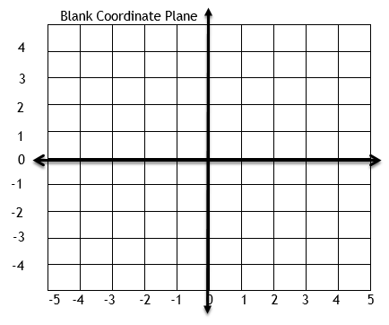

- Describe the direction of the x-axis and y-axis. Which is the horizontal axis and which is the
vertical axis?

- Name the quadrant or axis on which each point is positioned based on the ordered pair for each point.
- (4, -5)
- (0, 3)
- (-1, -6)
- (3, 7)
- (5, 0)
- (-8, 4)
- (0, -2)
- (-6, -5)

- Name the quadrant or axis on which each point is positioned.

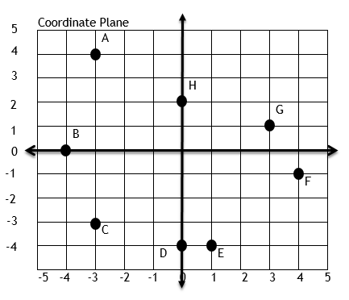

SOL 6.8a - Just in Time Quick Check Teacher Notes
Common Errors/Misconceptions and their Possible Indications

- Label the components of the coordinate plane on the blank coordinate plane below. You should include:
- Quadrant I
- Quadrant II
- Quadrant III
- Quadrant IV
- x-axis
- y-axis
- origin

One common error in labeling the quadrants is that students may go clockwise around the coordinate plane to label the quadrants as I, II, III, and IV rather than counterclockwise. To help students, you can help them create various models of the coordinate plane with labels to make the vocabulary more meaningful. For example, you can label your classroom as a giant coordinate plane by using tape to mark the axes and vocabulary cards to note the key terms. You can label the four corners of your room as the four quadrants and have students play four corners to review which quadrant is which and later which quadrant a given ordered pair belongs to. After modeling the coordinate plane in a large format, have students create their own models with geoboards or grid paper. Consistent review of vocabulary, including horizontal vs. vertical in relation to the axes, will help to keep students aware of terms.

- Describe the direction of the x-axis and y-axis. Which is the horizontal axis and which is the vertical axis?

Students often confuse the x- and y-axes and the terms horizontal and vertical to describe them. Making a large model of the coordinate plane in your classroom and labeling the axes as both x- and y-, as well as horizontal and vertical, can provide a powerful visual to help students distinguish between and identify the axes correctly. After working with a larger model, having students create their own models with geoboards and/or grid paper with labels will provide a concrete example that students may refer to as needed. Additionally, referring to objects in the class and asking students to describe features of the objects as horizontal or vertical will provide real world practice (i.e. Is the bottom edge of a bulletin board running horizontal or vertical?)

- Name the quadrant or axis on which each point is positioned based on the ordered pair for each point.
- (4, -5)
- (0, 3)
- (-1, -6)
- (3, 7)
- (5, 0)
- (-8, 4)
- (0, -2)
- (-6, -5)

A common error made by some students is reversing the order of the ordered pair. For (4, -5), students might think the 4 represents the y coordinate and the -5 as the x coordinate. This would make them think this ordered pair belongs in Quadrant II rather than Quadrant IV. This error also appears when students must determine whether a point is on the x- or y-axis. Making models of the coordinate plane with labels for the quadrants and the signs for the x- and y- coordinates may help students with this concept.

Additionally, students may have difficulty with this task if they do not have a good grasp of horizontal and vertical number lines that contain integers. This may indicate that students need more exposure and experiences with integers and would benefit from hands-on experience with vertical and horizontal number lines.

- Name the quadrant or axis on which each point is positioned.

Some students may incorrectly label points on the x or y axis in one of the four quadrants. It may be beneficial to have a class discussion to discuss why these points would not be considered to be located in a quadrant. Relating it to the idea that quadrant coordinates are always positive and/or negative, while points on the axis include a coordinate that is zero (which is neither positive nor negative) would be beneficial.

